Guide to Termination Amounts
(Post-Commissioning Securities)

What are Termination Amounts?
Termination amounts are the amounts required as security if you disconnect from the transmission system during the period that the transmission assets are chargeable to you.

Why do customers have to provide such security?
The Transmission Owners has invested in assets which generally have a 40-year life span. This long-term commitment must be secured by the user. Should you disconnect from the network the Transmission Owners will not be able to recover the costs of the assets which have been provided for you.

How do customers provide this security?
Customers will generally provide security in one of the following forms:
- A Bank Guarantee
- A bond
- A Letter of Credit
- A Cash payment to be held in a National Grid ESO Escrow Account

If you secure with a Letter of Credit by the 15th February with the credit covering April to March, this will also cover the October to March statement. You will be informed of the amounts but you will not be required to do anything.
If you secure with a Letter of Credit by the 15th February for a 6-month period, you will be required to provide another Letter of Credit by the 15th of July to cover October to March.
If the user secures with a Cash payment by the 15th February (for April to March), they are not required to do anything further when the July statement is issued. If they so wish, they are entitled to request a partial refund of securities after they’ve paid their September invoice, to the value of 6 months’ connection charges. This would leave in place the security required to be in place for October to March, as shown on the statement issued in July.”

What is the process?
Bi-annually, National Grid has a CUSC obligation to provide the customer with 75 days’ notice of the amounts it needs to secure for the forthcoming 6 or 12-month period as follows:
- By 15th January – amounts due for the 12 months April to March of the following financial year. The customer must lodge security with National Grid ESO at least 45 days prior to 1st April, that is by 15th February. The amounts will be calculated using the indicative Site Specific Maintenance (SSM) charge. This can be found in your Indicative Connection Charges sent to you in December.

- By 15th July – amounts due for the 6 months October to March of the current financial year. The customer must lodge security with National Grid ESO at least 45 days prior to 1st October, that is by 15th August. The amounts will be calculated using the Final Site Specific Maintenance (SSM) Charge. This can be found in your Final Connection Charges sent to you in January.

How are the amounts calculated?
The amounts are calculated based on the End of Year NAV (Net Asset Value) + 6 or 12 months of connection charges.

Example: April to March
£1,000,000.00 (NAV) + £106,102.56 (12 months connection charge) = £1,106,102.56 (Termination Amount)

Example: October to March
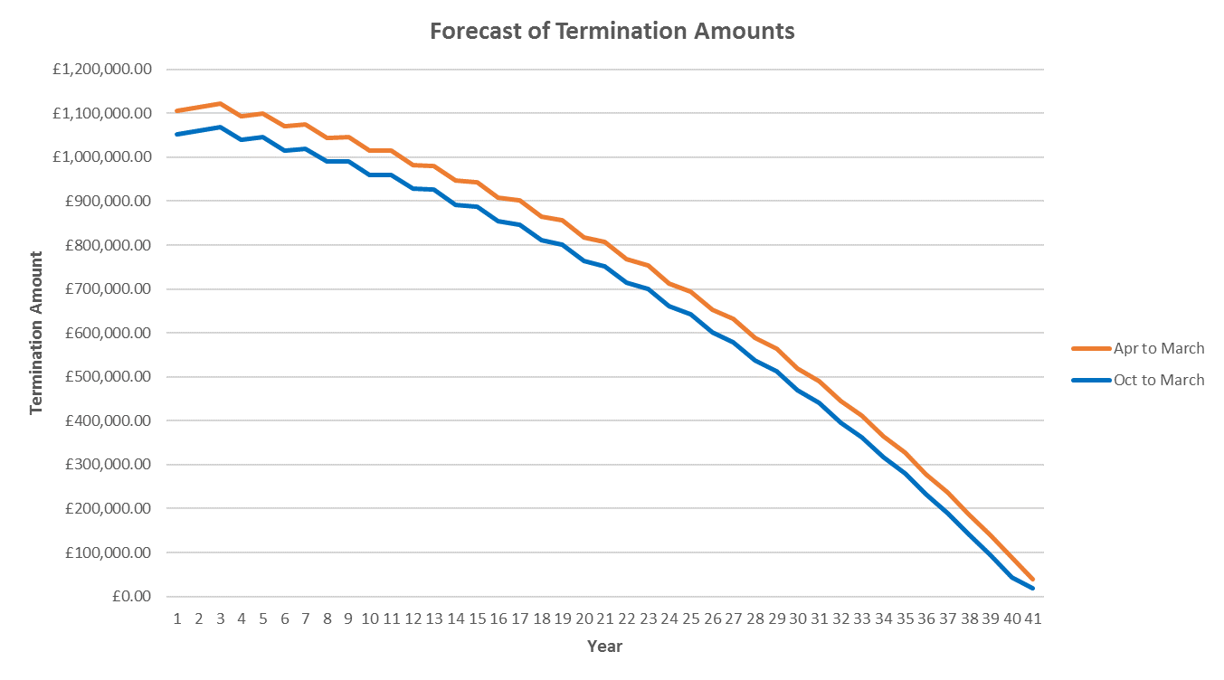
£1,000,000.00 (NAV) + £53,051.28 (6 months connection charge) = £1,053,051.29 (Termination Amount)

Figure 1: How the Termination Amounts vary over time assuming an initial GAV of £1,025,641.03 with constant inflation 1.33%, SSM of 0.45% and TRC of 1.47%. After the 40 year depreciation, there is no capital charge.

