Susana Neves e Brooks
Electricity Customer Connections Senior Manager
National Grid ESO
Faraday House
Gallows Hill
Warwick
CV34 6DA

susana.nevesebrooks@nationalgrideso.com
Mobile: +44 (0)7855 131422

nationalgrideso.com

30 November 2022
Extended: Transmission Entry Capacity (TEC) Amnesty Expression of Interest and CUSC Modification
Dear Customer,
On the 22nd of September 2022 the ESO (in partnership with the TO’s and Ofgem) launched the first TEC (Transmission Entry Capacity) Amnesty since 2013 giving customers the opportunity to Terminate or reduce TEC with a reduced or no cost.
Please see a copy of the original letter to industry here.
Following industry feedback, we have decided to extend the expression of interest window for the TEC Amnesty from the 30th November 2022 to the 30th April 2023 to enable for further progress in the activities listed below as well as help drive our ambition to meet net zero:
- Completion of HND1 contract update
- Further progress on the Construction and Planning Assumptions optimisation exercise
- Completion of interconnector Cap and Floor review
- CMP376: Introduction of Queue Management milestones to connections contracts
- Conclusion of latest Capacity Market Auction
This is the first step towards improving the connections process via a number of reforms as set out in our Business Plan 2 ambitions.
Please note we will adhere to the previous timescales for all applications received prior to the 30th of November 2022 and will continue to review all applications on a rolling monthly basis therefore customers will not have to wait until July for a decision to be made if the application is made before April.

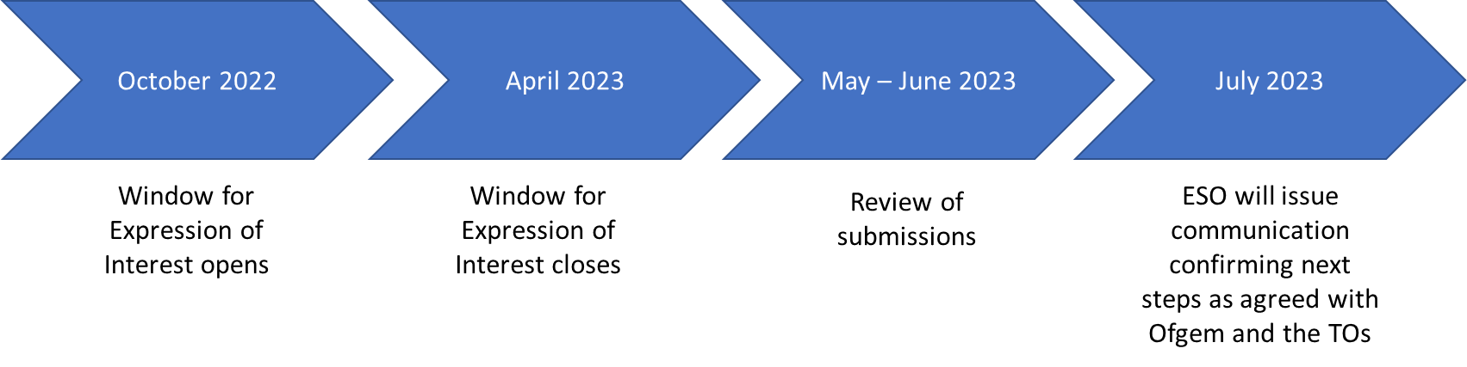
Overview of Timescales

- September 2022 - TEC Amnesty Expression of Interest letter released to industry
- 1 October - 30 April 2023 - TEC Amnesty expression of interest window is open
- 1 May 2023 - 30 June 2023 - Review of submissions
- 31 July 2023 - ESO will issue communications confirming next steps and communicate with customers
We’re introducing a TEC Amnesty to run from 1 October - 30 April 2023.
To encourage projects which are not progressing and holding capacity on the register to leave, we’re running a TEC amnesty so we can try and connect projects as quickly as possible.
Those on the register who are unlikely to reach delivery are being given the opportunity to leave the queue (or reduce TEC) without associated termination costs. As such, the TEC Amnesty is the last opportunity for Customers to leave the queue on potentially more favourable terms than will be afforded under CMP 376.

The ESO, Transmission Owners (TOs) and Ofgem have worked together to agree how to carry out a TEC Amnesty event, with all parties keen to ensure that the contracted queue is reflective of the contracted connections that are ready to connect.
We are inviting Transmission contracted Customers as well as projects with a Bilateral Embedded Generation Agreement (BEGA) to come forward with expressions of interest to either:
- terminate Connection Agreements if the associated Cancellation Charges were waived or reduced; or
- reduce TEC if the associated Cancellation Charges were waived or reduced.
The NGESO, TOs and Ofgem will use this information to:
- understand the number of projects in the connection queue that would like to leave or amend their future TEC through the Amnesty;
- develop a process that best facilitates the termination / reduction in TEC in a way that is in consumers’ interests.
Please note, only parties that have expressed their interest will be able to participate in subsequent stages of the amnesty. Customers that express the wish to terminate or reduce TEC will also have the option to ask to pause any works on their project whilst this process is being undertaken. The request to pause works is voluntary and will be considered on a case by case to ensure no other customers are adversely affected.
Expression of Interest Process
Attached to this letter (Appendix A) is an application form that will be used as your formal expression of interest and whether you would like work on your Connection Agreement to be paused. This application form must be submitted within the period identified above in order to be included in the process.
Upon receipt of the application form, a review of each project with the relevant TO will be undertaken to understand the costs associated with termination and impact to other connections and enabling projects. NGESO and the TOs reserve the right to reject any applications. This includes, but is not limited to, those that have a detrimental impact on existing contracted customers or wider investment plans. The outcome of this analyses will be shared with Ofgem ahead of communicating to Customers our decision on expressions of interest to terminate/reduce TEC. Customers will then be able to choose whether or not to go ahead with the termination/reduction in TEC. Please note if the application is not successful then QM milestones may be added to your agreement subject to the outcome of CMP 376.
All completed expression of interest forms should be sent by e-mail to Kavita.patel@nationalgrideso.com between 1st October 2022-30th April 2023.
For more information on TEC Amnesty please visit our website where you shall find a recording and slides from the Customer Connections Agora from August 2022 (Connections Agora Slides August 2022). We will continue to hold webinars throughout the Expression of Interest Window to support customers through this process.
In the meantime, if you have any queries in respect of this letter or would like to discuss, then please feel free to contact Kavita or myself.
Yours faithfully,
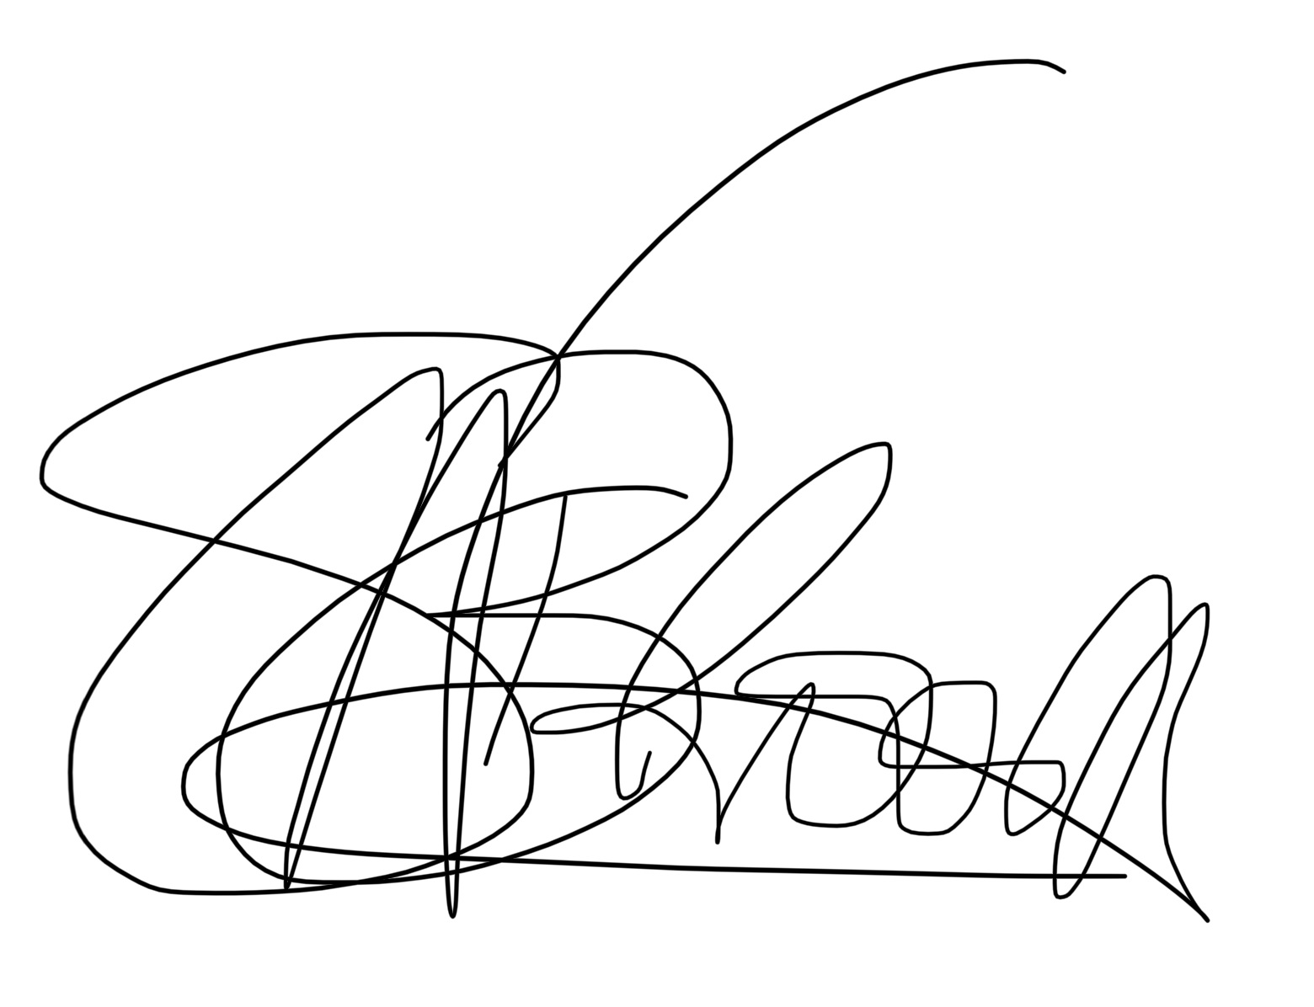

SUSANA NEVES E BROOKS
HEAD OF CONNECTIONS
NG ELECTRICITY SYSTEM OPERATOR

Appendix A – Expression of interest form
I hereby request a Termination review or review of reduction of TEC to the Connection Agreement detailed below under the terms outlined in the National Grid open letter dated 22 September 2022.

Closing date for an Expression of Interest is 30th April 2023, please send to Kavita.patel@nationalgrideso.com
Company Name
Company Address
Agreement Reference
Agreement Date
Current Contracted TEC
Proposed TEC
Contracted Connection Date
Please indicate if your expression of interest is for Termination or reduction of TEC

Directors Signature Date
…………………………… ……………………………..

Customers that hold a Bilateral Embedded Generation Agreement (BEGA) can also come forwards to express their interest to terminate or reduce TEC, however the TEC Amnesty doesn’t cover any process and costs associated with the termination of connection contracts between Customer and the relevant Distribution Network Operator

