Susana Neves e Brooks
Electricity Customer Connections Senior Manager
National Grid ESO
Faraday House
Gallows Hill
Warwick
CV34 6DA

susana.nevesebrooks@nationalgrideso.com
Mobile: +44 (0)7855 131422

nationalgrideso.com

22 September 2022
Transmission Entry Capacity (TEC) Amnesty Expression of Interest and CUSC Modification
Dear Customer,
As the Electricity System Operator (ESO) we believe it is vital to work together to build a clean, secure and fair energy system for Great Britain.
Decarbonisation, decentralisation and rapid changes in technology mean that faster, more efficient approaches are needed for those wanting to connect to the transmission system.
The current connections processes were designed at a time when a small number of large fossil fuel generators were connecting. Today we currently have over 310GW of projects contracted seeking to connect to the transmission system, with 237GW in the pipeline to connect between now and 2036.
The growth of the queue is leading to delays to connection dates, we are working with stakeholders to improve the connections process for new generation and demand to connect to the transmission network, both in the short and long term.
Improving the electricity transmission capacity queue for connections
We have been working closely with Ofgem and the three Transmission Owner’s (TO’s), we understand the concerns that stakeholders have raised about the connections queue and the need to implement more effective Queue Management (QM) arrangements. Improving queue management will deliver value to consumers by better optimising the investments required to connect Customers, as well as helping deliver Government’s decarbonisation policies.
Against this background, NGESO has raised a code modification, CMP 376, under the Connection and Use of System Code (CUSC), to formally introduce QM arrangements. We recognise that the CUSC process to implement QM is subject to an industry working group and will require Ofgem’s approval to implement.
Queue management will ultimately mean that projects which are ready to connect can do so ahead of those customer projects that may have applied earlier but are not ready or able to progress, currently we are unable to prioritise the queue based on readiness to connect.
At the simplest level, if implemented, QM will introduce contractual milestones that Customers must meet to retain their place in the connection queue and avoid termination of their connection contract, which will benefit everyone.
We’re introducing a TEC Amnesty to run from 1 October - 30 November 2022.
To encourage projects which are not progressing and holding capacity on the register to leave, we’re running a TEC amnesty so we can try and connect projects as quickly as possible.
Those on the register who are unlikely to reach delivery are being given the opportunity to leave the queue (or reduce TEC) without associated termination costs. As such, the TEC Amnesty is the last opportunity for Customers to leave the queue on potentially more favourable terms than will be afforded under CMP 376.

The ESO, Transmission Owners (TOs) and Ofgem have worked together to agree how to carry out a TEC Amnesty event, with all parties keen to ensure that the contracted queue is reflective of the contracted connections that are ready to connect.
We are inviting Transmission contracted Customers as well as projects with a Bilateral Embedded Generation Agreement (BEGA) to come forward with expressions of interest to either:
- terminate Connection Agreements if the associated Cancellation Charges were waived or reduced; or
- reduce TEC if the associated Cancellation Charges were waived or reduced.

The NGESO, TOs and Ofgem will use this information to:
- understand the number of projects in the connection queue that would like to leave or amend their future TEC through the Amnesty;
- develop a process that best facilitates the termination / reduction in TEC in a way that is in consumers’ interests.
Please note, only parties that have expressed their interest will be able to participate in subsequent stages of the amnesty. Customers that express the wish to terminate or reduce TEC will also have the option to ask to pause any works on their project whilst this process is being undertaken. The request to pause works is voluntary and will be considered on a case by case to ensure no other customers are adversely affected.

TEC Amnesty Timeline
1st October
Window for expression of interest opens
1st December to 31stJanuary
Review of submissions²
22nd September
TEC Amnesty Letter issued to Industry and ESO Customers
30th November
Window for expression of interest closes
1st February
ESO will issue communication confirming next steps as agreed with Ofgem and the TO’s.

Expression of Interest Process
Attached to this letter (Appendix A) is an application form that will be used as your formal expression of interest and whether you would like work on your Connection Agreement to be paused. This application form must be submitted within the period identified above in order to be included in the process.
Upon receipt of the application form, a review of each project with the relevant TO will be undertaken to understand the costs associated with termination and impact to other connections and enabling projects. NGESO and the TOs reserve the right to reject any applications. This includes, but is not limited to, those that have a detrimental impact on existing contracted customers or wider investment plans. The outcome of this analyses will be shared with Ofgem ahead of communicating to Customers our decision on expressions of interest to terminate/reduce TEC. Customers will then be able to choose whether or not to go ahead with the termination/reduction in TEC. Please note if the application is not successful then QM milestones may be added to your agreement subject to the outcome of CMP 376.
All completed expression of interest forms should be sent by e-mail to Kavita.patel@nationalgrideso.com between 1st October 2022-30th November 2022.
For more information on TEC Amnesty please visit our website where you shall find a recording and slides from the Customer Connections Agora from August 2022 (Connections Agora Slides August 2022). We will also be holding two Q&A Sessions in October and November 2022, we will communicate information on how to sign up to these events shortly.
In the meantime, if you have any queries in respect of this letter or would like to discuss, then please feel free to contact Kavita or myself.
Yours faithfully,
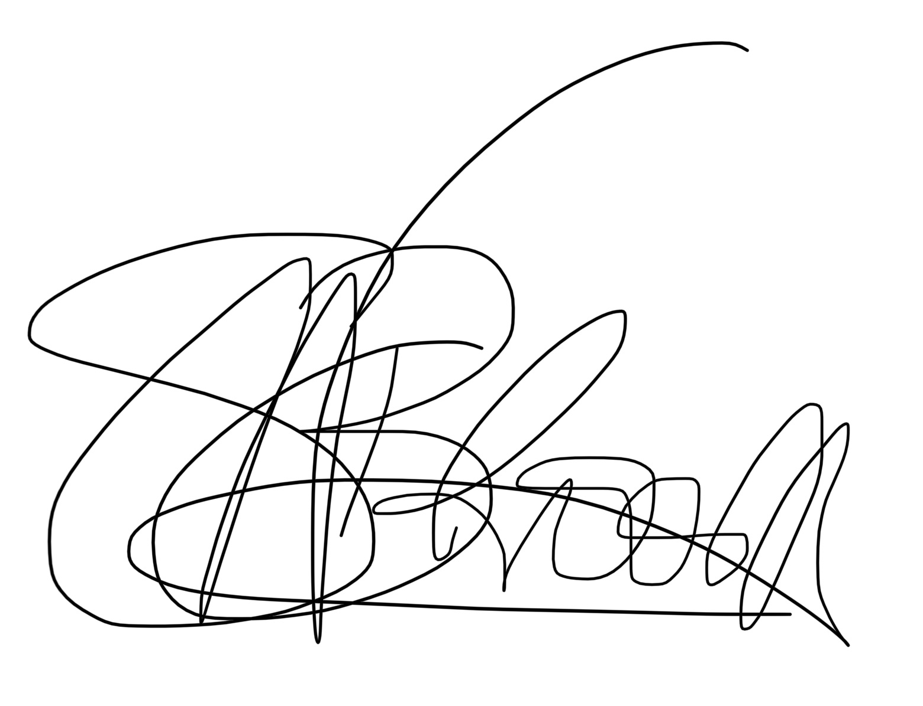
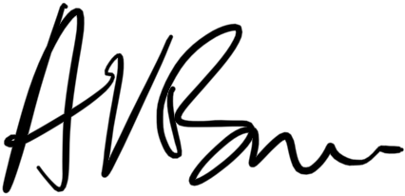
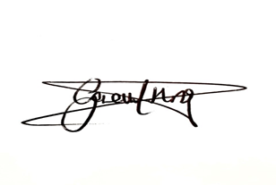
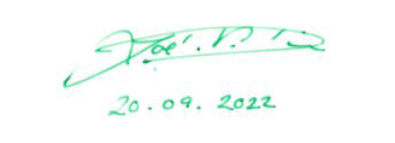
ADAM BROWN
COMMERCIAL STRATEGY MANAGER
NGET
GARETH HISLOP
HEAD OF CONNECTIONS
SPT
ZOE DICK
HEAD OF CUSTOMER
EXPERIENCE
SSEN TRANSMISSION
SUSANA NEVES E BROOKS
HEAD OF CONNECTIONS
NG ELECTRICITY SYSTEM OPERATOR

Appendix A- Expression of Interest Form
I hereby request a Termination review or review of reduction of TEC to the Connection Agreement detailed below under the terms outlined in the National Grid open letter dated 22 September 2022.
Company Name

Company Address
Agreement Reference
Agreement Date

Current Contracted TEC
Proposed TEC
Contracted Connection Date
Please indicate if your expression of interest is for Termination or reduction of TEC
Would you like all works to be paused on your project whilst the TEC Amnesty Expression of interest process is run?
Closing date for an Expression of Interest is 30th November 2022, please send to Kavita.patel@nationalgrideso.com
Directors Signature Date
…………………………… ……………………………..

Customers that hold a Bilateral Embedded Generation Agreement (BEGA) can also come forwards to express their interest to terminate or reduce TEC, however the TEC Amnesty doesn’t cover any process and costs associated with the termination of connection contracts between Customer and the relevant Distribution Network Operator
2 The length of the review period shall be confirmed following the expression of interest window, to allow confirmation as to whether ESO, TOs and Ofgem have the capacity to undertake all relevant assessments within the proposed timescale. This could mean an increase or decrease to the timescale.

