Electricity System Restoration Assurance Framework 2022/23

Executive Summary
The Department for Business, Energy and Industrial Strategy (“BEIS”) released a Policy Statement setting out the need to strengthen the current regulatory framework by introducing a legally binding target for the restoration of electricity supplies in the event of a National Electricity Transmission System (“NETS”) failure. BEIS’ new policy is called the Electricity System Restoration Standard (“ESRS”).
Under the Special Condition 2.2 Electricity System Restoration Standard, NGESO, as the licenced GB Electricity System Operator (ESO), is required to produce an Electricity System Restoration Assurance Framework for approval by Ofgem to demonstrate how the ESO will comply with the Electricity System Restoration Standard

Contents
Executive Summary 1
Background 3
Vision 4
Assurance Framework Sections 5
1. Strategy 5
RESTORATION APPROACH 6
I. Regulatory year – 2022/23 8
II. Next 2 regulatory years – 2023 - 24 11
III. Subsequent Regulatory years – 2025-2026 12
Procurement Approach and Provision of Restoration services 12
2. Monitoring compliance 13
3. Review of Restoration Times model (Ex-ante and ex-post modelling) 14
4. Details of methodology and data within ESR Model 15
Appendix 1 – Consultation Questions 17

Background
Electricity System Restoration (ESR) is the procedure to recover from a Total or Partial National Power Outage (NPO) of the NETS, which has caused an extensive loss of supplies. NGESO has a Grid Code obligation (CC6.3.5) to ensure that ESR Capability is available to enable the NETS to be re-energised in the event of a Total or Partial NPO. A Total NPO leading to an ESR is a High Impact, Low Probability (HILP) event. Whilst an unlikely event, the consequences would have significant societal and economic impacts. Therefore, NGESO must demonstrate that the ESR Capability procured maintains an acceptable level of provision, but at a cost which is economic and efficient.
In 2017, in accordance with the then National Grid Electricity Transmission plc’s (National Grid) Special Condition 4G, “Black Start Strategy and Procurement Methodology” set out the strategy the ESO will use to determine and procure Restoration Capability onto the NETS on an ongoing basis in an economic and efficient manner, ensuring system security.
BEIS has set a national standard (ESRS) for the GB electricity industry to establish an industry framework for the management of future electricity system restoration capability. It should ensure that future restoration capability can restart the system in line with Government approved timescales and to minimise the impact to society. The scheduled implementation date no later than December 2026, giving the industry time to prepare and invest accordingly. The ESRS seeks to ensure that an appropriate economic balance is achieved between the on-going preparatory costs to society and potential impact risk of an event as we transition to zero carbon networks.
The ESRS will require the ESO to have sufficient capability and arrangements in place to meet the following Restoration Time as agreed with Ofgem and BEIS:
• Restore 60% of each Restoration Region’s daily peak demand within 24 hours.
• Restore 100% of each Restoration Region’s daily peak demand within 5 days.
This Assurance Framework is presented with four distinct sections:
- Strategy
- Monitoring Compliance
- Review of Restoration Times model (Ex-ante and ex-post modelling)
- Details of Methodologies and data within ESR Model
This Assurance Framework will be effective from 1st April 2022. Prior to the acceptance of this Assurance Framework by Ofgem, all decisions made will be in line with the previous agreed Restoration Strategy and Procurement Methodology approved on 10 May 2021.
Any evolvement of the Assurance Framework is also dependent on the review of the Future role of the System Operator.

Vision
Our vision is that by the mid-2020s, we will be running fully competitive restoration procurement processes wherever advantageous, with submissions from a wide range of technologies connected at different voltage levels on the network, with Transmission Owners (TO) and Distribution Network Operators (DNO) playing a more active role in the Restoration Approach.
We are committed to meeting this vision, and shall continue to:
- improve transparency around Restoration services, including service requirements and costs,
- reduce barriers to entry to allow improved market access to a broader range of potential technologies and participants, including interconnectors, wind, distributed energy resources and storage.
- Explore and evolve alternative methods for procuring Restoration services, to enable a more flexible approach to meeting service requirements.
The RIIO-2 Business Plan 2021-23 (published in December 2020), further sets out our vision. This includes:
- Providing the control centre with fully trained resource capability, processes, plans and tools to support incident management and disaster recovery
- Developing and maintaining restoration plans for Great Britain with the necessary stakeholders, ensuring these are validated and supported
- Engaging and collaborating with industry to plan and develop the new ESRS, including the annual Assurance Framework, consistent with our licence obligations.
- Implementing ESRS as part of our transformational proposals.
- Providing advice and oversight of Restoration strategy for the future.
BEIS, on behalf of the Secretary of State, issued a direction to NGESO in relation to ESRS on 19th October. The new license condition was effective from 19th October 2021 and the ESO will need to be fully compliant with ESRS by 31 December 2026. NGESO Consultation on the ESRS implementation was launched on 10 November 2021 for 30 days

Assurance Framework Sections
- Strategy
A ‘full’ Electricity System Restoration (ESR) service is defined as a provider, or a combination of providers who can meet the three basic requirements for ESR:
- To start-up (following a Total NPO or Partial NPO) independently of external supplies;
- To be able to energise part of the network; and
- To be able to provide block loading of local demand.
With the changing generation mix, there are an increased number, and type of providers who can assist with restoration during an ESR event. This Assurance Framework aims to enable the identification of new technologies that can contribute to restoration and potentially become new ESR providers. However, not all generators will be able to meet the minimum technical requirements for ESR and therefore they may play a part in later stages of the Restoration Approach rather than delivering ESR service.
In addition to securing sufficient economic restoration services from providers, the Assurance Framework seeks to ensure suitable resilience measures are in place such that effective deployment and operation is possible for credible scenarios. This extends to factors such as control capability, dispatch systems, local plans, telecommunications, network operability, resources and training. A broad review of current capability and any future enhancements will be key to longer term compliance and provision stability.
To maintain restoration capability in an economic, secure and efficient manner the restoration approach, as outlined in this Assurance Framework, will be developed, considering the network infrastructure, ESR providers’ capabilities, new technologies and ways of working. Confidence, liquidity and competition are required in the ESR market to make this vital service an attractive prospect for providers.
We are working towards our ESO 2025 vision, where we will be able to operate the system carbon free (for periods of time). We will be looking at all elements of the restoration process, The Restoration Capability (in which technologies are able to form Power Islands), Restoration approach (how we energise the system), Network design enabling more efficient energisation, Secondary Generation (readiness of this generation and capability to join a restoration – wind, batteries, solar, EV’s/ V2G, smart demand, efficient control system and expanding the resilience of the industry.
The ability to maintain ESR Capability is an ongoing requirement and as such the competition and transparency of ESR provision needs to evolve. Below are the proposed activities over various regulatory year timeframes to build confidence in the ESR market, as well as evolve and develop Restoration Approaches, new provider technology options and network infrastructure
The evolution of the system Restoration Approach, the development of new technology options and network infrastructure to provide ESR Capability are interlinked and a development in one may trigger both a need and an opportunity in the other.

RESTORATION APPROACH
The changing nature of the generation mix and market conditions within GB has led to rising operational costs for current conventional restoration providers. Alternative approaches to restoration techniques, and restoration provider technologies are being actively considered and developed through the Distributed Re-start project, which we expect will lead to an evolution in system Restoration Approach and technical requirements.
Currently, our Restoration Approach uses a number of self-starting providers to restore local demand, to energise networks in line with a pre-agreed Local Joint Restoration Plan (LJRP) and create a small power island.
Power Islands are developed in line with LJRPs which are agreed alongside a restoration contract and set out the activities and steps that the restoration provider, relevant TO, DNO and ESO will carry out during an ESR event. It is a contractual obligation for the restoration provider to have an agreed LJRP in place when the ESR service goes live.
The number of LJRPs that each TO and DNO area can deploy at any one time is continually reviewed for changes in Restoration providers and LJRPs. The duration of switching actions and available Control Room resources may to limit restoration progress more than provider availability. During an ESR event, not all contracted providers may be able to restore and a spread of LJRPs across TO and DNO areas is therefore a consideration for resource management during an event.
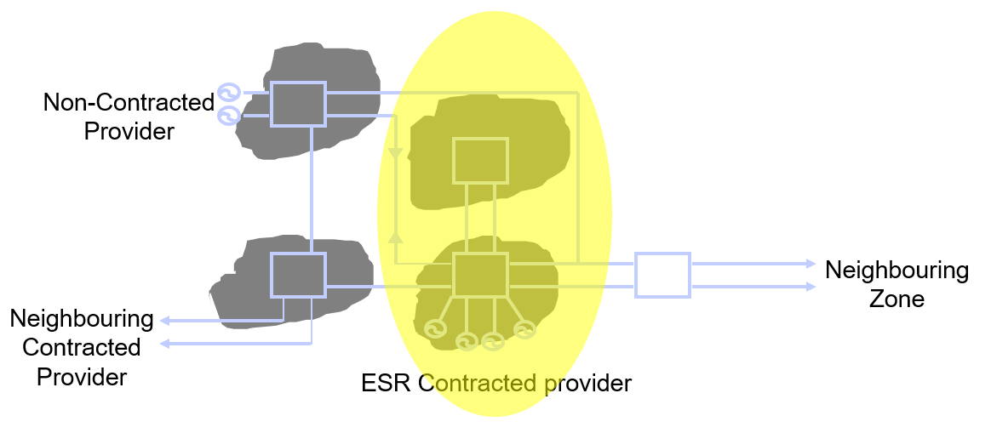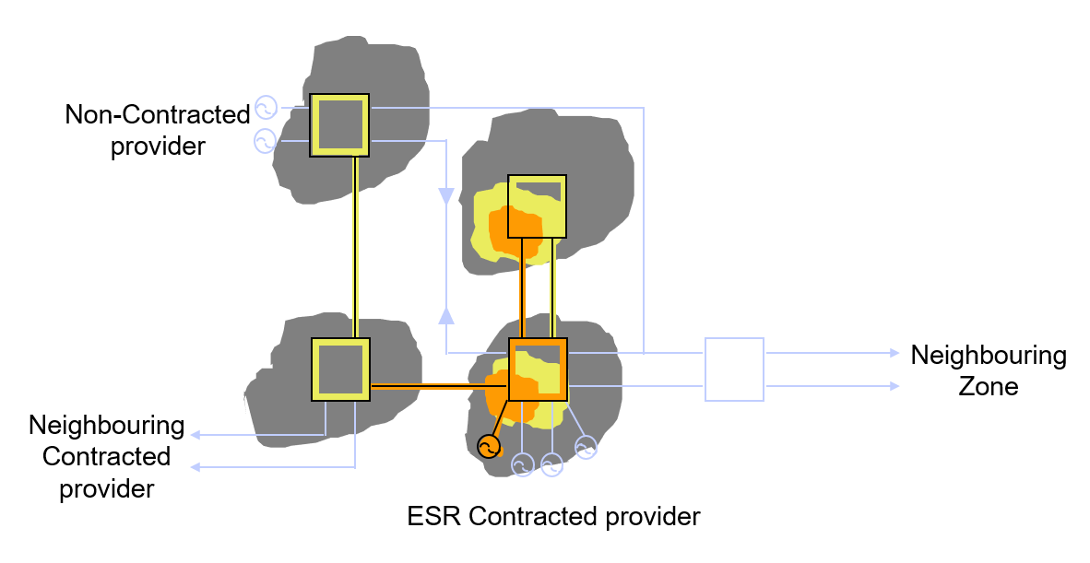

Figure 1: Initial Restoration
The current GB Restoration Approach aims to create a skeletal version of the NETS – called the skeleton network. This has the benefit of extending auxiliary supplies to non-Restoration providers sooner. This enhances the restoration as it provides greater resilience to the system and the sooner these providers can start up, the sooner they can contribute to restoring the national demand and the remaining Transmission network.
The skeleton network Restoration Approach adds flexibility to provider diversity and locational considerations. Here the focus shifts from the number of parties within a geographical region, to the impact that a provider (or combination of providers) has on Restoration Time within a region and on GB.
This Restoration Approach also identifies the importance of providing start up supplies to non-Restoration providers in a timely fashion to reduce delay to the overall restoration. In some areas, the Restoration Capability is supplemented with additional restoration services to enable non-Restoration providers with significant restoration capabilities to be contracted and committed to the system restoration under certain scenarios.
The Restoration Approach will be continually reviewed to align with any significant network infrastructure change or significant change in providers’ characteristics.
Outcomes from the Distributed Re-Start project (NIC funded), when it concludes in June 2022 will feed into development of the Restoration Approach. Design proposals build on the current approach through using a distribution level power island with co-located DER resources (Distribution Restoration Region) to act as a virtual service provider at transmission level supporting the wider skeleton network approach. However, for cases where there is not sufficient reactive capability within a restoration region to enable outward energisation, there may be value to restoration timelines in restoring local demand at distribution level only whilst the wider skeleton network is grown.
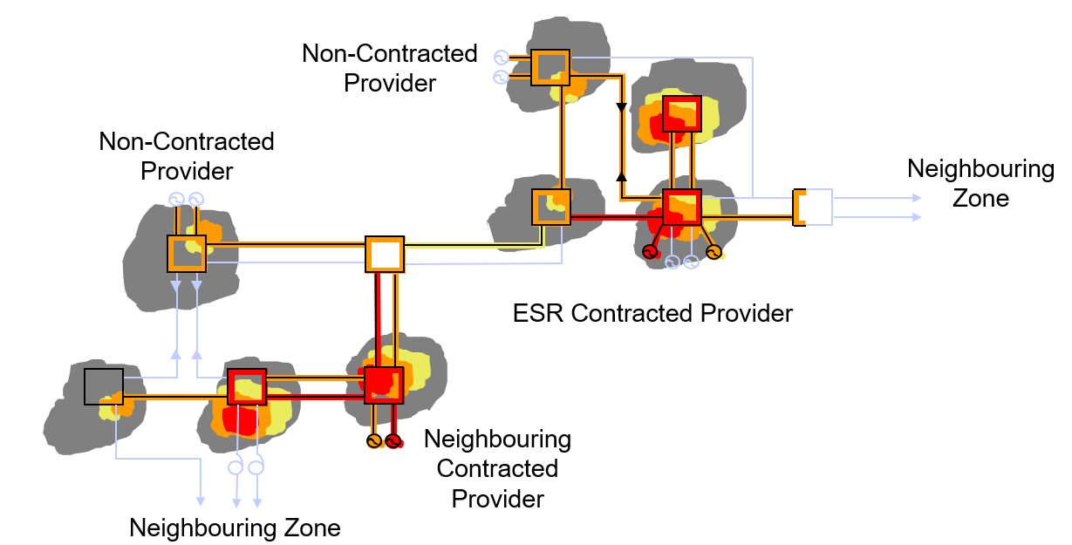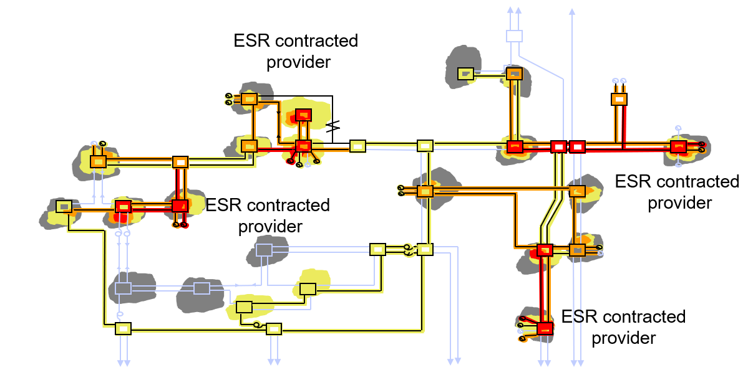
Figure 2: Skeleton Network
To deliver this Restoration Approach procurement of Restoration service provision is currently carried out across six regions within the GB network.
The use of GB regions for contracting:
- Ensures the split of Restoration providers is reasonably spread over DNO licence areas to share the resourcing of enacting LJRPs and demand loading.
- Ensures that most non-Restoration stations are within reach of a Restoration provider and therefore auxiliary supplies are provided as the skeleton network is established.
- Creates a relatively uniform restoration of the NETS along the skeleton network.
Additional flexibility and resilience for providers is allowed by the nature of a skeleton network approach as there are no fixed boundaries for contracting regions. These can evolve and change as the transmission system and Restoration provider locations change and develop over time. Multiregional capability should also promote competition as greater participation would be expected and therefore more commercial benefits are realised. A provider would be more inclined to consider participating if there are more opportunities.
Although service availability is a requirement for a Restoration provider there may be instances when an operational decision is taken by NGESO to make a provider available, when it is not currently – i.e. to take actions to warm (if appropriate) and run a provider to reinstate as Restoration available to maintain the Minimum Service Level. Moreover, the number of providers available at any time can be monitored and revised with the changing demand throughout the year to ensure the Restoration Time is met.
ESO will provide an outline plan to map the key milestones for ESRS implementation in the final version of this Assurance Framework.

Regulatory year – 2022/23
NGESO is committed to progress the work presented in this document but notes the possibility of disruption associated with an unforeseen event (e.g. national emergency, pandemic). Wherever practical NGESO will progress current regulatory year work whilst fully respecting any restrictions in place. Consequently, the precise rate of delivery is uncertain but will be monitored and reported. Some short-term activities are more prone to disruption owing to staffing overheads and wider system and market implications, e.g. assurance activities. Care will be taken to prioritise activities throughout the year.
The ESRS has been determined by BEIS and is designed to provide an economic balance between cost of provision and potential impact. The proposed targets are challenging and ahead of where modelling results indicate the industry is currently at. Consequently, various enhancements will be required to address the performance gap and encompass factors spanning the entire end-to-end delivery chain, starting with service provision, through deployment and control to full restoration.
The Restoration Approach will be adapted to allow for flexibility of provider technologies to be further explored. This approach will unlock new potential to provide a faster Restoration Time to be met with a wider pool of providers and with appropriate support tools and functionality for effective delivery. This necessitates greater consideration for the entire network, across all restoration regions.
In the regulatory year 2022/23, there will be transition from the current strategy to the ESRS. The main objective is improving the Restoration time, whilst broadening participation for ESR services. In the current strategy, NGESO aims to achieve 60% GB demand within 24 hours. To achieve the ESRS, the services must be procured and maintained to achieve 60% demand in all regions within 24hrs. More specifically, we aim to continue to provide transparency around technical requirements and guidance for service opportunities for providers of all technology types in a clear and consistent manner. This will increase both the market awareness of the service and open the service to a wider range of providers, enabling competition.
In the ESRS consultation published on 10 November, it was stated that NGESO will categorise providers’ capability according to their contribution to different phases of restoration. This will be further reviewed, evolved and enhanced as the industry workgroups (formed to deliver ESRS implementation) are progressed.
Furthermore, it is equally imperative to have sufficient secondary level of generation available for an efficient and sustainable restoration following the initial stages. This means better engagement in order to ascertain better information about the secondary level of generation.
Commercial Service Providers | Restart Time
Phase 1 ESR Service Provider | Within 2hrs
Phase 2 ESR Service Provider | 2-24hrs
Phase 3 ESR Service Provider | 24-72hrs
Phase 4 ESR Service Provider | 72-120hrs
Non-Commercial Service Providers
Secondary ESR Service Provider | Up to 120hrs

We will continue to monitor Restoration Time in real time and take necessary actions e.g. warming of additional units to ensure Restoration Time is achieved. The requirement and assessment criteria will be reviewed in order to better suit the Standard requirement. Going forward, Restoration Time will be monitored via Restoration tool as per RIIO2 business plan. Initial discussions on this tool commenced in October 2021 with an expectation to further develop from early 2022.
Over the previous years, NGESO contracting process has been adapted to integrate several alternate solutions, including combined services, islanding or Trip to House Load, and interconnectors. NGESO will continue to drive benefit for the end consumer by deploying these options where possible and appropriate to meet our requirement.
Periodic reviews of ESR requirements, that may arise due to contracts expiring or new requirements being established, will continue to be carried out to ensure that actions within this regulatory year are building market competition and enabling new technologies to participate within the ESR market.
Providers who were awarded contracts in the tenders for SW & Midlands and the Northern Tender will now be delivering services in this timeframe.
A full tender for the South East (SE) region will be launched from Q1 2022/23; Having already launched two tenders previously, there are experiences and learning points to be drawn. By around the time the SE tender is launched, it is expected to have the results from the Distributed Restart project and will therefore need to consider how these can be integrated into the SE tender. It is expected to involve lot more stakeholder engagement, in order to understand the interaction and liquidity of generation and demand at both transmission and distribution level as well as revision of the restoration approach.
In this timeframe we shall also aim to begin a competitive process in October 2022 focussing on services from the Northern regions and Distributed Restart, (as well as wind and interconnectors if appropriate to do so) for services starting April 2026. This needs to be staggered for delivery after the SE tender, to account for resourcing, but also to apply lessons learned from this tender as it happens.
This may mean that we either renew existing incumbent providers or consider contracting from Distributed restart, Wind and Interconnectors and perform a combined assessment of renewals, to contract for the overall best value combination to bridge the gap between 2025 and 2026.
To maintain a flexible, fit for purpose restoration plan ESO has sought to enable varied technology restoration solutions. This will reduce the reliance on any individual solution for restoration and will increase competition in this area. New provider technologies identified to be ESR capable will be progressed, as required.
We will also review the Restoration regions in order to ensure restoration providers are strategically dispersed, not just nationally but also within each restoration regions in order to meet the ESRS Restoration time.
We are continuing to engage with the wind industry to understand their capability in more detail. This enhances our knowledge and skill base to be able to use more wind generation within the initial restoration phase. It is now clearer to us where the most significant entry-to-market barriers are e.g. combined technology, service availability, resilience of supply, contribution to inertia, etc. These are expected to be addressed for the SE competitive procurement event. With better information on the technology and depending on the liquidity, there is also an opportunity to explore competitive procurement event for Wind. ESRS Implementation will build the framework that will address and solve these challenges, not just for Wind but all other technologies.
The Distributed Restart project is underway and due to conclude in June 2022. Following the conclusion of the project, outcomes will be handed into business as usual teams for implementation. Further details of the project are available at its website.
Due to variation in demand and generation in different regions in the country, for efficiency and relevance, a regional strategy may be considered. This will become even more vital once the Restoration Standard is implemented. This may require revision of current framework
Ongoing industry collaboration to implement the ESRS alongside the obligations in the Network Code on Emergency & Restoration (NCER). NGESO will continue to work on the implementation of the NCER, with further changes being made to Grid Code, SO-TO Code Procedures (STCP), potential expansion of SGUs (Significant Grid User) to ensure a more resilient restoration and updates to the electrical standards for Control and System telephony. NCER code amendments are also reviewed due to Brexit. This is expected to be completed in December 2022.
Over this timescale, the ESR service providers will also undergo a programme of tests and exercises to assure their competence and provide assurance against their contracted position. The test scope will be increasingly evolved, as possible, to better test and prove the capability of not just the providers, but the network infrastructure. Article 43 states the general principles for compliance testing of capabilities for SO, TOs, DNOs and SGU s. Articles 44 to 49 describe the testing requirements and are summarised in the System Restoration Plan and System Defence Plan.
Following activities have already commenced in preparation for ESRS implementation.
- Three days Webinars conducted in October 2021
- ESRS Consultation launched on 10th November.
- Six months of Industry workgroup meetings for ESRS Implementation

Next 2 regulatory years – 2023 - 24
NGESO will continue to explore new provider technologies and innovative Restoration Approaches to improve the efficiency of the service. NGESO will continue its active engagement with both the industry working groups to implement the ESRS.
This will include, but is not limited to:
  - Whole System Approach: Any future Restoration Approach needs to consider future trends in generation and network design, and the ability to adapt to new technologies whilst maintaining reliance of restoration. In some areas, further network investment may be required to enable alternative restoration methods.
  - Alternate Restoration Approach: Depending on the network infrastructure and ESR Service provider capabilities, this Restoration Approach of energising a single energy corridor during restoration may be explored.
  - Distributed Re-Start: The project will conclude in June 2022, if proven feasible and viable, the outcomes will be passed to business as usual teams for implementation. The procurement for Distributed Re-Start will be aligned with current ESR procurement tenders and contracts. Required code changes for Distributed Re-Start will also be implemented, through the different code modification processes.
  - Results from Competitive Procurement event: More Providers who were awarded contracts in the tenders for SW & Midlands and the Northern Tender will now be delivering services in this timeframe.
  - Further progress and engagement with the industry workgroup for ESRS implementation will continue. The industry will then make changes to their code and infrastructure to implement the ESRS.
If the Restoration Standard is in force by this timeframe imposed, then this will be implemented, and a suitable Restoration Approach derived, otherwise previous year expectation will be reviewed and amended if required.

Subsequent Regulatory years – 2025-2026
There will be continued exploration into Restoration Approaches with the intention of moving towards a more suitable Restoration Approach for GB, encompassing both TO and DNO approach. New emerging technology types, such as storage will also be continually explored to understand how these can contribute to restoration and whether a commercial service is appropriate.
The Restoration Approach will be reviewed at an annual basis, to ensure that ESR Capability procured keeps pace with all relevant technologies and network infrastructure. Any significant network infrastructure change or providers’ geographical dispersion will also trigger a review of Restoration Approach.
If the Restoration Standard is in force by this timeframe imposed, then this will be implemented, and a suitable Restoration Approach derived, otherwise previous year expectation will be reviewed and amended if required. However, by this regulatory period, workgroups would have made significant progress for ESRS implementation.

Procurement Approach and Provision of Restoration services
As part of our procurement of Restoration Services, we will continue to follow our over-arching Procurement Guidelines as prescribed in condition C16 of ESO transmission licence.
We shall also be guided by our general principles for procuring any Balancing services being:
- A clear and transparent requirement.
- Enabling competition, where appropriate.
- Reducing and removing barriers to entry to enable broader participation
Principle 1
The NGESO commits to sharing, where it is appropriate and possible to do so, when and where there is a requirement, and sufficient information about that requirement to enable potential providers to assess whether they could contribute Restoration services including opportunities to align requirements from Distributed Restart. This may not be possible for all requirements, but as and when it is in the interests of the end consumer, this is the approach the ESO will aim to use.

Principle 2

The NGESO will assess the level of competition in relation to meeting a requirement and to determine whether a Market Mechanism, Bilateral Negotiation in the case of a specific locational need or a combination of the two is most appropriate to deliver the best outcome for the end consumer.
Where the NGESO determines that a bilateral contract is the most economic and efficient approach, we shall ensure that any Restoration costs will be assessed in accordance with the value provided to the system.

Principle 3

The NGESO has adapted the standard contracting process, terms and revised the technical requirements so that all technology types can participate in providing Restoration services which the ESO observed in the competitive procurement events in 2019 and 2020. We will continue to adapt our processes as and when we are confident that an appropriate technology readiness level for restoration contribution has been met, and that the risk to end consumers in sufficiently reduced.
We shall continue to review the process, terms and technical requirements through a learn by doing approach for consideration of future competitive events.
Although the NGESO remains technology neutral in our approach to the technical requirements, we will draw on the outcomes of the Distributed Restart project as and when they are available to support diversification of technology types.
- Monitoring compliance
The ESR restoration process is complex, and achieving a successful restoration is reliant on the whole electricity industry’s ability to assist. Factors that have a significant impact on the speed of restoration include, but are not limited to:
- the number of available ESR providers (and their MW capacity),
- the time for ESR providers to reconnect and export following a NPO,
- the time for non-ESR providers to reconnect and export following a NPO,
- network design, network condition and demand availability,
- all network operators’ ability to manage several power islands, and
- the resilience and reliability of communications and other critical tools/facilities across all key stakeholders (Providers, ESO, DNOs, TOs, BEIS, Ofgem)
As stated in the Restoration Strategy in previous years, NGESO has maintained the planning assumption for Restoration Time, in line with historic expectations; this means planning to achieve restoration of 60% of national demand within 24 hours, provided the procurement of this capability can be demonstrated to be economic. Calculation of the Restoration Time requires a probabilistic assessment of NPO scenarios, reflecting the range of severity of events, to determine likely timescales for differing stages of restoration.
Whilst there will inevitably be regional variations to this Restoration Time the aim is to create a broadly consistent rate of restoration, reflecting the regional nature of civil contingency planning. During restoration, demand would be gradually restored by establishing a skeleton transmission network. Any selected Restoration Timeframe strikes a balance between a realistically achievable level of network energisation against an economic level of service provision. This timescale is informed by current industry expectations and enables the civil contingency community to plan accordingly.
Once capability has been procured to meet the Restoration Time, it may be necessary to take operational actions (e.g. issuing of warming instructions to maintain ESR Capability) due to provider outages or individual provider running patterns. These actions will ensure that the Minimum Service Level is always maintained.
The Minimum Service Level sets out a minimum Restoration Time that is deemed acceptable for restoration should the planning assumption prove uneconomic to procure, or to maintain in real time operations.
The Minimum Service Level for the period 1 April 2022 to 31 March 2023 has been determined as a Restoration Time which will allow for variations of number of available providers across GB. Should there be a situation where the Minimum Service Level cannot be maintained, either through lack of ESR Capability or a significant increase in costs to maintain the Minimum Service Level, NGESO will inform both BEIS and Ofgem of this and demonstrate the actions that have been taken to reduce the impact to system restoration and detail the changes being proposed to the level of provision. This situation may arise due to extreme unforeseen circumstances, for example a type fault on an asset class. The Minimum Service Level will continually be reviewed as we move closer to ESRS Implementation.
NGESO will maintain and continue with the current process of monitoring Restoration capability for the short term. For the future and as part of the ESRS implementation, a real -time Restoration tool will be developed to monitor Restoration compliance.
It is expected that there will be an increased number of providers with various technologies providing the Restoration service, due to more competitive procurement events and results from Distributed Restart projects. Therefore, it is imperative to evolve our process of conducting assurance activities. This will form part of the discussion in the Assurance Activities Workgroup for ESRS implementation.
- Review of Restoration Times model (Ex-ante and ex-post modelling)
Although ESO has ambitions to develop a monitoring system to provide a live feed on restoration preparedness in collaboration with key stakeholders, the system is not available yet as it will take time to develop. In the absence of this system we have our existing annual modelling tool which gives a holistic view which we track year-to-year.
As part of our Restoration service tender evaluation, a series of studies were conducted which projected future scenarios (ex-ante) and restoration capability. These took account of forecast plant closures and service losses, changing generation availability and potential new or replacement restoration services. The detail of these studies was documented and led to a number of new service investments across GB. Precise details are confidential and the tender appraisal was subject to external auditing and regulatory oversight.
Currently, ESO attention has been focussed on preparing the groundwork for implementation of the Standard and so Ex-post assessment has not been completed. However, it is hoped that this will be achievable early 2022 as we assess that year too.
- Details of methodology and data within ESR Model
A mathematical probabilistic model has been developed by NGESO using @Risk software on behalf of the wider industry. The model uses Monte Carlo methods to explore a range of possible outcomes across the year. This model takes the jointly agreed and electrically validated LJRP restoration routes along with other input parameters to create a statistical picture of Restoration times at a national level and at a regional level. Network parameters (for example reactive power) are therefore not explicitly modelled since this is inherent in the LJRP designs, however the impact of resource limitations, faults, network failure and the time of day are considered.
The model outputs are used as a performance measure for various combinations of contracted service, resilience investments, market conditions and wider scenarios
It should be noted that where necessary the model is subject to further developments and therefore associated results may vary as the model is improved. Decisions that are taken for ESR provision and procurement will be made in reference to this baseline, to demonstrate improvements and to show that value is being delivered.
Restoration Time stated in this Assurance Framework is based on the Central case, which is deemed as a credible balanced scenario, representing a more typical, and perhaps more likely, set of circumstances. It is a balanced view based on restoration requirements across the year with some support from renewable sources. It reflects a general belief that restoration is unlikely to go precisely to plan - as suggested by the various options and in-built flexibility within LJRPs, as there will be mild difficulties and obstacles throughout the restoration process. The model results provide statistical measures of restoration performance and can be based on several factors. The proposed introduction of ESRS for restoration performance relies on a process to track year-on-year changes coupled with a measurement tool to account for these changes, translating them into a set of statistical results.
A year-on-year review of the following factors will be undertaken to provide annual updates. These factors have the greatest influence on restoration performance: -
- The generation fleet in GB (capacity, availability, fuel type and technical parameters)
- National and regional demand levels
- Design of Network, electrical and geographical
- ESR Providers capability and Local Joint Restoration Plans
- Wider regional / strategy plans
- Seasonal levels of warmth in generation and quantity of generation connections able to join a restoration.
- Other related systems such as telecoms, network resilience, substation resilience, SCADA etc.
- Operational limitations and staffing.
- Interconnector characteristics
- Other major external influences such as weather, pandemics, and potential network damage.
- Legislative and Regulatory changes, such as review of the FRSO or governmental policy.

Revisions to these factors will be made with reference to market related data, operational data, feedback from the Assurance Framework activity or other pertinent source. Necessary changes will follow a change control process to manage the activity, otherwise data will remain unaltered to preserve year-to-year consistency.

The modelling tool proposed for the measurement task is based on the same structure and methodology developed by ESO on behalf of the Electricity Emergency Executive Committee (E3C), Black Start Task Group (BSTG). This is a probabilistic model which used Monte-Carlo simulation techniques to map the spectrum of possible outcomes. The results are typically histograms showing likely performance outcomes which allow confidence levels to be derived. Results will be based on National and regional statistics.

It is anticipated that successive restoration performance results will provide important trend indicators on where pinch-points occur. This will help focus resources to preserve a defined Standard to the extent that options exist. This could require additional investment, new service provision, changes to industry processes or other measures to preserve a strategic capability to meet a Standard.
The exercise relies on engagement from a wide range of industry parties, NGESO modelling expertise and oversight by BEIS/Ofgem and/or independent verification of process.

Appendix 1 – Consultation Questions
- As this is the first time ESO is publishing the Assurance Framework under new license condition, do you think the level of detail in here is appropriate?
- What additional information, as appropriate, would be useful to be included in this Assurance Framework regarding modelling?
- We currently procure ESR services through a market mechanism if there is sufficient liquidity, do you believe there are any barriers to entry for market participants or should we consider another approach for procurement?
- Are there any areas that are not covered in ESRS consultation that you’d like to be included in this Assurance Framework?

Currently referred as Black Start in the grid code
https://www.nationalgrideso.com/balancing-services/system-security-services/black-start?technical-requirements
Secondary level of generation is non-Black Start providers who receive supplies from the Black Start service provider and forms second layer in the restoration.
https://www.nationalgrideso.com/innovation/projects/distributed-restart
https://www.nationalgrideso.com/document/135211/download
https://www.nationalgrideso.com/document/135226/download

