Distributed ReStart

Appendix 3 – Event Feedback Form

Procurement and Compliance
2 August 2021

Table of Contents

1 Purpose of this feedback form 3
1.1 What’s inside? 3
1.1.1 Instructions 3
2 General feedback 4
2.1 Provider details 4
2.2 Overall experience 4
3 Appendix 1 – Mock Tender Requirements Document 7
4 Appendix 2 – Mock Tender Submission Template 10

Purpose of this feedback form

What’s inside?
This is a feedback form to capture your comments, as a participant of the Test Procurement Event, on the content of the mock tender documents shared as part of this process.
It is important for us that all participants fill in this form as we will use this feedback to make further improvements to the future procurement process for Distributed ReStart. This is your opportunity to co-create with us on our final procurement design recommendations.
The feedback we are seeking is on the content of the following documents, which you will need to familiarise yourself with first, before completing any of the sections in this feedback form:
Invite to Test Procurement Event (information)
Appendix 1 – Mock Tender Requirements Document (information)
Appendix 2 – Mock Tender Submission Template (to be completed)
The purpose of this Event Feedback Form is to:
understand if the information shared as part of this test event made sense and participants were able to make informed decisions on which services to tender for
understand which sections participants struggled to provide information on and their reasons why
capture general feedback, for example on the proposed timelines of the procurement process
note any concerns and areas requiring more clarity or simply not clear at all
see if participants had a preference on some of the key decisions still required as we develop our thinking.
We are open to your challenges on our proposals. With your feedback we can address gaps and develop a future procurement process that is fit for purpose and stakeholder endorsed.

Instructions
Save a copy of this form and complete the sections below directly in the tables or spaces provided.
Any mandatory sections will be marked with *.
Once complete, please email a Word copy of this document to Roopkamal.Phull@nationalgrideso.com and Hannah.Rochford1@nationalgrideso.com by Monday 6 September 2021 09:00
There will be an opportunity on 18 August for a ‘mid-way’ webinar to ask the Distributed ReStart project team any questions around this Test Procurement Event. Details to join will be emailed closer to the date. In the meantime, if you have any urgent queries, please contact us by email:
Roopkamal.Phull@nationalgrideso.com and Hannah.Rochford1@nationalgrideso.com

General feedback

Provider details
Provider name*
Site / asset / project Name*

Overall experience
- On a scale of 1 to 10, with 10 being great, how did you find participating this Test Procurement Event? *

- Was the Test Procurement Event process clear to follow, were you able to use the instructions and information shared, to make an informed decision about what services to bid for? Yes/No/To an extent *

- Please share comments to support your answer to Q2.

- Can you rate the documents shared as part of the Test Procurement Event below by adding a Y in the appropriate column and sharing the reason to support your decision?

Document | Most helpful | Helpful | Least helpful | Comments – why?
Invite to Test Procurement Event
Appendix 1 – Mock Tender Requirements Document
Appendix 2 – Mock Tender Submission Template

- Was there any more information or support that you would have liked to support your participation in this Test Procurement Event?

- We are seeking feedback on the overall procurement process and the timelines as shown below, please let us know any comments, are the timelines feasible for you to be able to meet or not, does the process make sense? Please indicate the reasons to support your answer.
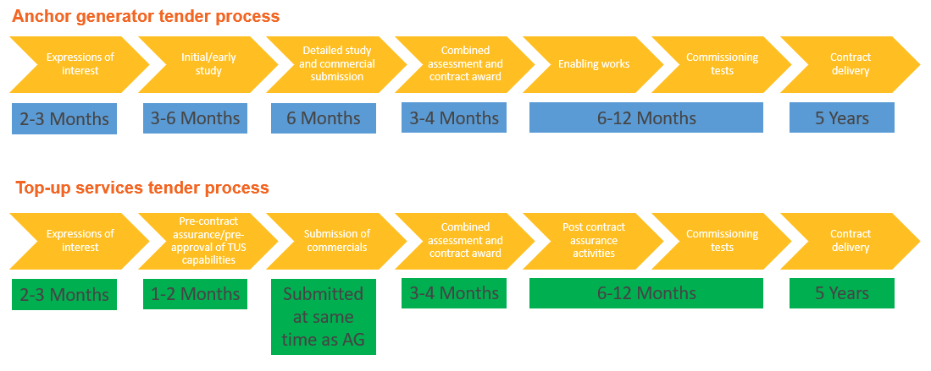

For more detail on the proposed procurement process map, please see here and a recording explaining it is here.

- Have you any preference for who the lead procurement party should be for contracting with DER providers for this future Black Start service? Should it be the Electricity System Operator (ESO), or the relevant area Distribution Network Operator (DNO), or a combination?

- Tied in with Q7, do you have any thoughts on how the payment structure should work best for you as a potential future DER Black Start service provider? Should it come from the ESO or from the DNO/DSO?

- Do you have any comments about the information shared in the Invite to Test Procurement Event document?

- Please share any general feedback or suggestions you might have regarding all/any of the Procurement and Compliance information shared to date?

Appendix 1 – Mock Tender Requirements Document
This section is to get more specific feedback on the information shared in Appendix 1 – Mock Tender Requirements Document.

- Were the information and instructions provided in Appendix 1 clear and easy to follow? Yes/No. Please support your answer with more comments as to why.

- What informed your decision on which service to tender in for? What would influence future decisions?

- In most other tenders, you would only be assessed/considered for the service that you had entered. In our current proposed design of a distribution restoration service, the aim is to develop a feasible and effective DRZ from the submissions received. In the assessment phase, it could be that multiple anchor generator options have tendered in and only one is required to be the anchor, but the other assets would still provide value as top-up services.

For example, if you tendered to be an anchor generator but your asset’s capabilities provided more value being a top-up service provider, would you consider changing your submission? We are wanting to understand, from an industry perspective, how this would potential impact investment decisions to tender in to provide a distribution restoration service?

- Section 1.1 Anchor generator functional requirements – please fill in this information if you chose to bid for this service or chose not to bid for this service due to the current design.
Do you feel that the essential requirements to be an anchor generator are feasible based on your asset’s capabilities?

In the table below, please add your comments regarding the proposed functional requirements, highlight any issues, where you struggled to provide information or would not find feasible to meet. Please offer alternative suggestions where you can.
Requirement | Minimum | Comments
Time to Connect | ≤ 8 hours
Service Availability | ≥ 90 %
Resilience of Supply - Availability to start up | ≥ 120 hours
Resilience of Supply - Service delivery | ≥ 72 hours up to 120h
Sequential Black Starts | ≥ 3
Reactive Capability (Voltage Control) | Minimum of 0.95 leading and 0.95 lagging power factor at the point of connection.  Ability to provide continuous steady state control of the voltage with a set point and slope characteristic.
Frequency Control | Fast-acting proportional frequency control-is required.
Block Loading Size | ≥ 2 MW  (site specific depending on DRZ)
Short-circuit infeed | ≥ 1 x DER MVA rating (at t≥1s)

- Section 1.2 Top-up service functional requirements – please fill in this information if you chose to bid for any of these services or chose not to bid for any of these services due to the current design.

Do you feel that the requirements for the top-up services are feasible based on your asset’s capabilities?

In the table below, please add your comments regarding the proposed functional requirements, highlight any issues, where you struggled to provide information or would not find feasible to meet. Please offer alternative suggestions where you can.
Requirement | Minimum | Comments
Fast MW control | <200ms provide available MW, sustained for at least 15 minutes with gradual reduction toward preferred operating position,  and/or  <200ms provide available MW, sustained for at least 10 seconds with gradual reduction toward preferred operating position,  and/or  Active power output reduction in response to a change in system frequency above a certain value (value and required rate of reduction to be confirmed)  and/or  Active power output increase in response to a system frequency below a certain value (value and required rate of increase to be confirmed). This will only be required if output has been constrained below the maximum output power.
Inertia | There is no minimum requirement for individual generators/resources, but the service provider should state what inertia is available.
Frequency Control | Provide frequency sensitive control of active power.
Reactive Capability (Voltage Control) | Provide continuous steady state control of the voltage at point of connection.  Compliant with Engineering Recommendation G99 requirements on reactive capabilities.
Short Circuit infeed | ≥ 1 x DER MVA rating
Energy (MWh) | Generate or consume MW on instruction from an external control system, deliver within 10 seconds of request.
Resilience of Supply - Availability of communications | ≥ 72 hours
Resilience of Supply - Service delivery | ≥ 72 hours
Service Availability | ≥ 90 %

- Are there any requirements that you think impact this procurement process being technology agnostic?

- Section 2 Draft assessment criteria – what are your thoughts on our proposed assessment criteria? Are there any areas where you disagree or have feedback on?

- Section 3 Draft feasibility assessment process – Do you have any concerns or comments on the high-level summary described? Do you have any thoughts on the proposed funding for the different feasibility stages?

- Section 4 Draft contract principles – have you any comments on the draft principles shared? Are there any areas you might have expected to see covered in here, or areas that were covered that you didn’t expect?

Appendix 2 – Mock Tender Submission Template
This section is to get more specific feedback on the information shared in Appendix 2 – Mock Tender Submission Template.

- Was the information and instructions provided in Tab 1 in Appendix 2 clear and easy to follow? Yes/No. Please support your answer with more comments as to why.

- In the Technical submission tab, were you able to provide information against the anchor generator or top-up service(s) functional requirements, based on information you already know about your asset’s capability?

- Were you able to provide estimated costs? Yes/No/Mostly. Please support your answer with more comments as to why.

- Which requirement(s) across both anchor generator and/or top-up service(s) was most difficult for you to provide information and/or costs against?

- In the Commercial submission tab, what categories were most difficult to supply a price/cost for?

- Do you think that the proposed contract duration of 5 years is suitable? If not, what do you suggest is an acceptable period?

- Where there any other costs that you felt ought to be included in here that we may have missed out?

- Any other comments on Appendix 2? Overall how did you find filling in the submission template?

