Frequency Response Auction Trial
Appendix C – Low Frequency Static (LFS) Service
Testing Certificate

Appendix C
Please use this test certificate format and submit to NGESO, along with the test data and CV of the ITE employed by the prospective response provider.

Prospective Response Provider Company Details
Prospective Response Provider Company name
Companies House number
Primary contact name(s)
Contact number(s)
Email address(es)

Contract Details
Unique ID Code (provided by NGESO)
Service type | LFS
Asset owner
Asset owner Companies House number
Asset name
Asset type: Generation/Demand/Both?
Asset technology, e.g. diesel generator, battery etc
Unit make up, e.g. single or aggregated
Aggregation methodology (if appropriate)
Address (including post code)
Export/Import PAN/MPAN
Asset contact details
Test date
Effective from date

Static Service Details
Contracted response time | 1 second
Contracted duration | 30 mins
Trigger Frequency Setting | 49.6Hz

Test Results
Pass Criteria | Pass / Fail | Comment
An acceptable frequency injection profile is used. | Pass / Fail
The relay operating point of the plant/unit(s) occurs at the correct contracted trigger frequency and within the permitted tolerance (±0.01Hz). | Pass / Fail | See Figure 1 for sample showing close up of the frequency at which relay operates
The response is sustained for 30 minutes. | Pass / Fail
The standard deviation of active power error over a 30 minute period does not exceed 2.5% of the contracted active power change. | Pass / Fail | Insert test SD value here
Response volume is assessed as the minimum response observed from 1 second to 30 minutes following relay trigger | Pass / Fail | Can be shown in Figure 2 below.
Overall Test Result | Pass / Fail | <Confirm volume validated by test>

Figure 1 – Relay Operation (sample, to be replaced with test data)
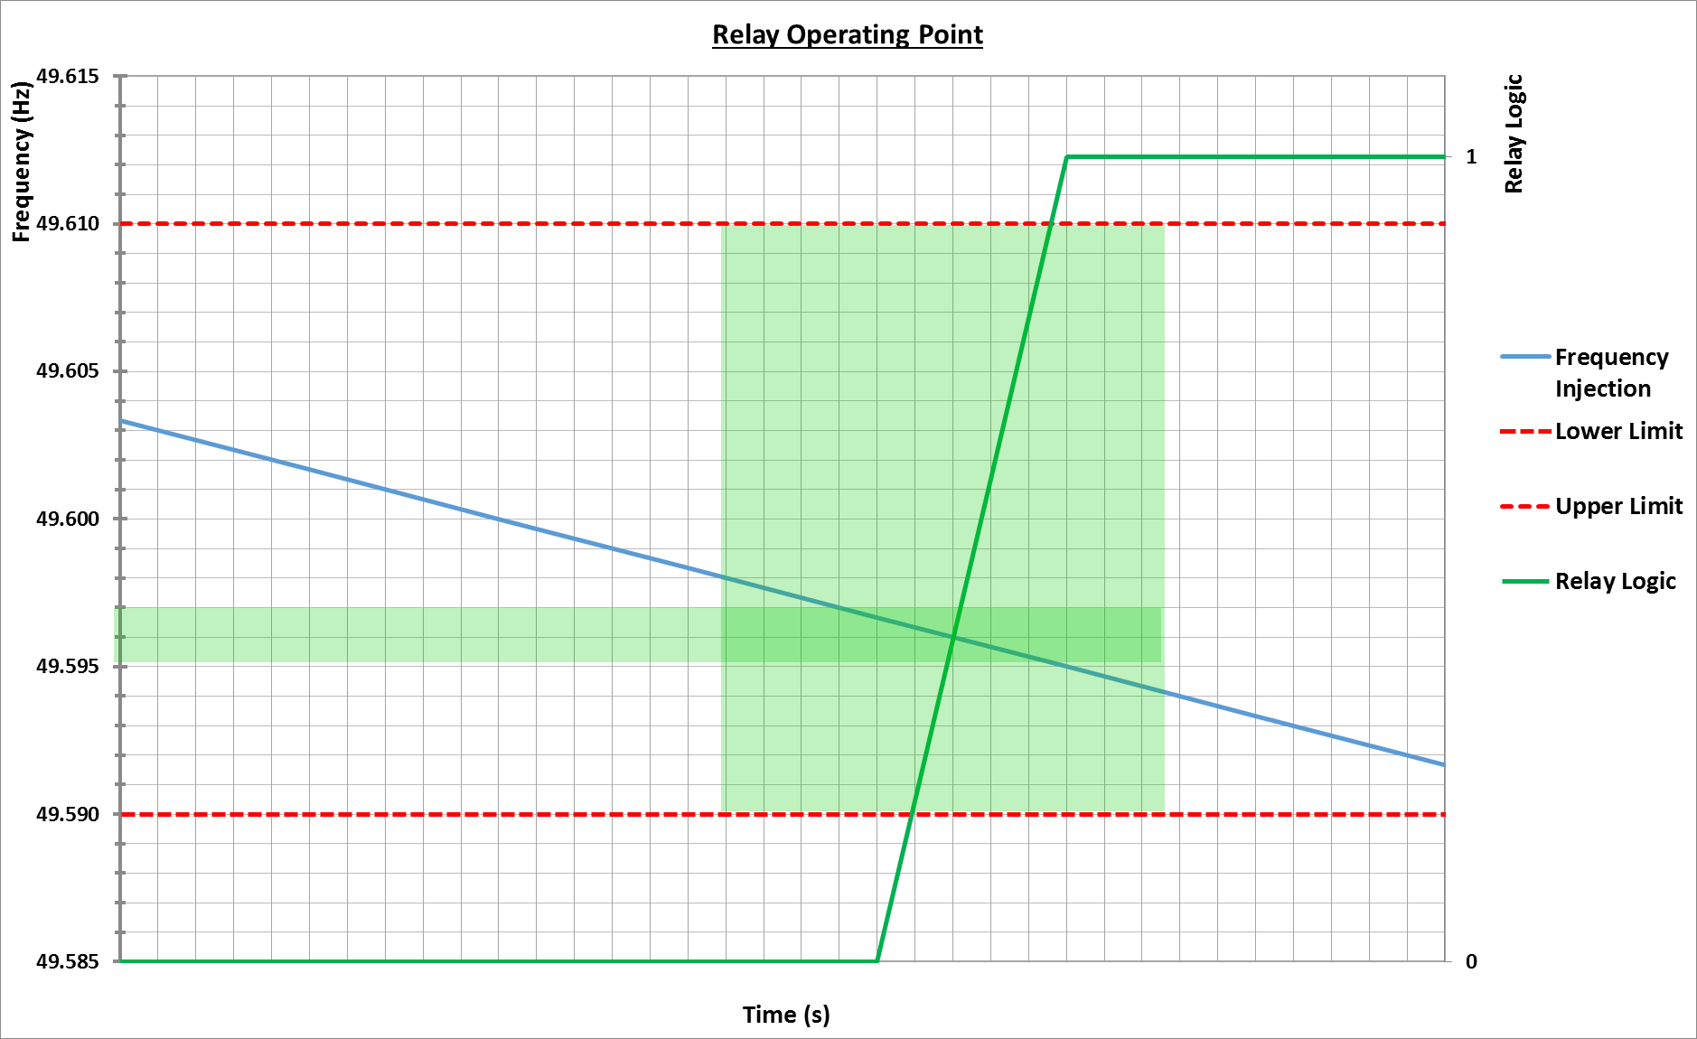

Figure 2 – Overall Response (sample, to be replaced with test data)
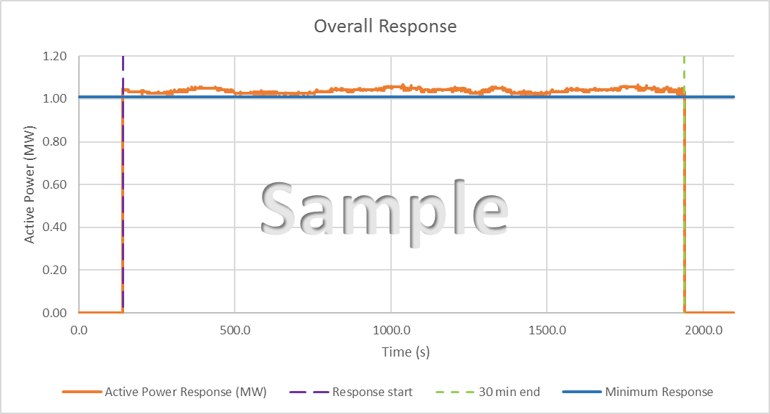

Independent Technical Expert (ITE) Details
Company name
Primary contact name
Contact number /s
Email address
I / We confirm that I / We the following:
- I/We am a/are Independent Technical Expert(s) (as defined in Appendix B of the NGESO’s prevailing Testing Guidelines;
- I/We have carried out an assessment of the [asset] described above in accordance with the testing guidelines set out in the Testing Guidelines;
- the above details are, to my/our best knowledge and belief, true, accurate, complete and not misleading; and
- the CV attached of my/our experience is to my/our best knowledge and belief, true, accurate, complete and not misleading.
Signed:

