FFR Service Test Report
Sample Non-Dynamic Report Template
Author: | ITE
Date: | 15/07/2019

Prospective Response Provider Company Details
Prospective Response Provider Company name
Primary contact name
Contact number /s
Email address

Contract Details
Contract ID
Service type
Asset type, e.g. diesel generator, battery etc
Unit make up, e.g. single or aggregated
Aggregation methodology (if appropriate)
Unit location / ID
Test date

Static Service Details
Contracted MW | 1MW
Contracted response time | 30 second
Contracted duration | 30 mins
Trigger Frequency Setting | 49.7Hz

Test Results
Pass Criteria | Pass / Fail | Comment
An acceptable frequency injection profile is used. | Pass
The relay operating point of the plant/unit(s) occurs at the correct contracted trigger frequency and within the permitted tolerance (±0.01Hz). | Pass | See Figure 1 for sample showing close up of the frequency at which relay operates
The response is sustained for 30 minutes. | Pass | See Figure 2
The standard deviation of active power error over a 30 minute period does not exceed 2.5% of the contracted active power change. | Pass | The standard deviation over the secondary response period was 0.95% of the observed response of 1MW
Response volume is assessed as the minimum response observed from 30 second to 30 minutes following relay trigger. |  | The blue line in Figure 2 below shows a minimum response of 1MW.
Overall Test Result | Pass | 1MW validated

Figure 1 – Relay Operation
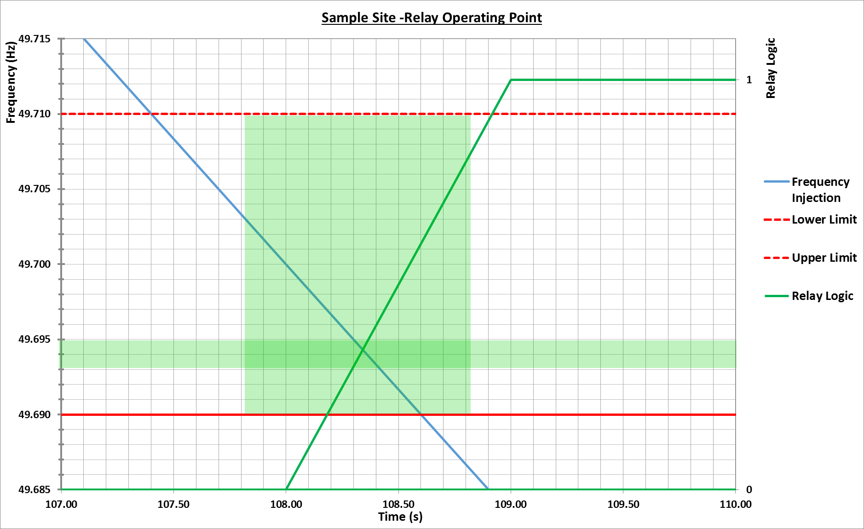

Figure 2 – Overall Response
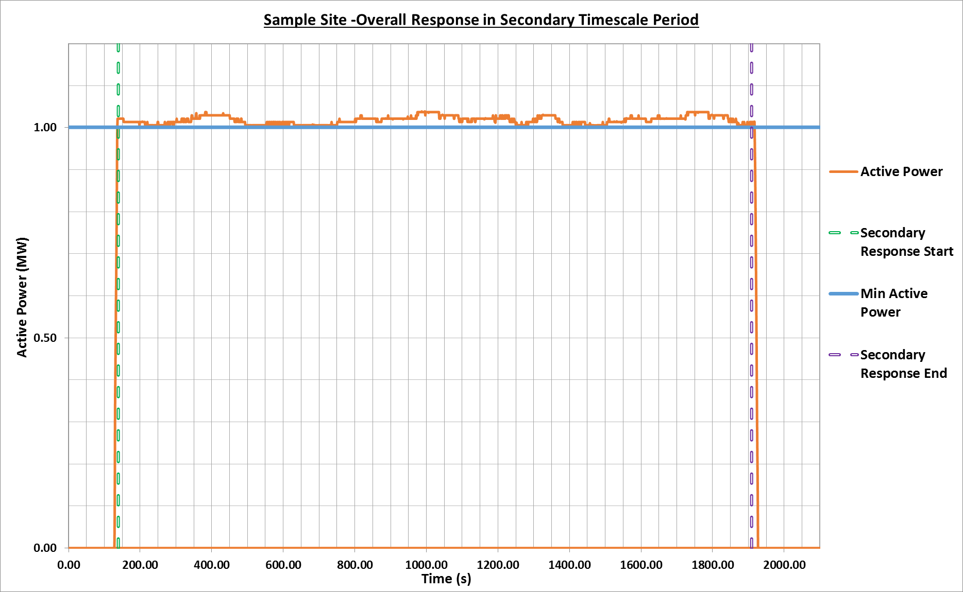

Independent Technical Expert (ITE) Details
Company name
Primary contact name
Contact number /s
Email address
I / We confirm that I / We the following:
- I/We am a/are Independent Technical Expert(s) (as defined in Appendix A of the NGESO’s prevailing Testing Guidelines);
- I/We have carried out an assessment of the [asset] described above in accordance with the testing guidelines set out in the Testing Guidelines;
- the above details are, to my/our best knowledge and belief, true, accurate, complete and not misleading; and
- the CV attached of my/our experience is to my/our best knowledge and belief, true, accurate, complete and not misleading.
Signed:
Date:

