FFR Service Test Report
Sample Report Template
Author: | ITE
Date: | 15/07/2019
Prospective Response Provider Company Details
Contracted company name
Primary contact name
Contact number /s
Email address

Contract Details
Contract ID
Service type, e.g. Static or Dynamic | Dynamic
Asset type, e.g. diesel generator, battery etc
Unit make up, e.g. single or aggregated | This sample test includes new 1MW asset (‘NewVol1’) to be assessed as part of a 5MW Unit. The existing 4MW was tested previously on <date> and is currently contracted in the FFR market.
Aggregation methodology (if appropriate)
Unit location / ID | NewVol1 <address>  <existing 4MW Unit details>
Contract signed date
Service start date
Test date

Dynamic Service Details (example here is for a 5MW Unit)
Deadband | ±0.015Hz
Primary response MW | 5
Secondary response MW | 5
High response MW | 5

Test Results
Further relevant test description/commentary here

Table 1 – Contracted vs Actual Response Values
Frequency Deviation (Hz) | Tolerance | Primary (MW) |  | Secondary (MW) |  | High (MW)
 |  | Contracted | Actual | Contracted | Actual | Contracted | Actual
0.1Hz | 5%/-4% | 1.0 | 1.0 | 1.0 |  | -1.0 | -1.0
0.2Hz | 5%/-3% | 2.0 | 2.0 | 2.0 |  | -2.0 | -2.0
0.3Hz | 5%/-2% | 3.0 | 3.0 | 3.0 |  | -3.0 | -3.0
0.4Hz | 5%/-1% | 4.0 | 4.0 | 4.0 |  | -4.0 | -4.0
0.5Hz | 5%/-0% | 5.0 | 5.0 | 5.0 | 5.0 | -5.0 | -5.0
(Actual values populated from results of Test 1 and Tests 2a, b and c)

Test | Pass Criteria | Pass/Fail | Comment
Single Asset which will be assessed as part of an aggregated facility.
1 | Record the minimum of the sampled values of active power response within primary, secondary and high frequency timescales (i.e. the minimum response achieved within each timescale). | N/A | NewVol1 – See Figures 1 and 2  Primary 1MW  Secondary 1MW  High 1MW
1 | Record how long is the response sustained | N/A | NewVol1 response was sustained for 30minutes for both Tests 1.1 and 1.2.
Pass criteria for Unit level (single asset or aggregation)
1 | The sum of the minimum of the sampled values of active power response within primary, secondary and high frequency timescales constitute the total volume of the FFR unit. (i.e. the minimum total response achieved within each timescale). | Pass | The actual response values for a 0.5Hz frequency deviation are shown in Table 1 and match the contracted values within the allowed tolerances.  See Figures 3 and 4.
1 | Delay in response of active power due to a change in frequency is no greater than 2 seconds. | Pass | A response was observed within 2 seconds of the frequency change.  This is illustrated in Figure 5
1 | The Unit should progressively change to its maximum response. | Pass | See Figure 5.
1 | The standard deviation of load error at steady state over a 30 minute period must not exceed 2.5% of the maximum contracted active power response. | Pass | For Tests 1.1 and 1.2 the standard deviation was less than 2.5%.  (Standard deviation is assessed from 10 seconds until 30 minutes after the frequency step, unless the contracted values for primary and secondary are different. In this case, standard deviation is assessed from 30 seconds until 30 minutes after the frequency step.)
1 | Sustain response for 30 minutes. | Pass
2.1a  2.2a | A noticeable change in power in the correct direction is observed. | Pass | See Figure 6 and 7 for Tests 2.1 and 2.2.  From 30s – 60s the unit responds in the correct direction to a small frequency deviation outside the deadband.
2.1,2.2  b,c,d | For ±0.1Hz, ±0.2Hz and steps ±0.6Hz steps, the primary/high response values achieved are proportional. | Pass | For each 30 second step the minimum response from 10-30seconds are shown in Table 1 and are within the allowed tolerance.
2.1e  2.2e | Active power response is within the allowed tolerances. | Pass | See figures 8 and 9.
3 | Provide an active power response consistent with the contracted performance within Primary, Secondary and/or High frequency response timescales. | Pass | Figure 10 shows the active power response ‘following’ frequency as expected. When the frequency moves inside the deadband the active power response moves to zero.  In figure 8, the frequency axis has been reversed and both vertical axes (response and frequency) have been scaled to be consistent with the contract table.
 | Overall Test Result | PASS

Test Result Graphs
Plot frequency injection and active power response vs time for each test.
Figure 1 – Test 1.1 Single Asset
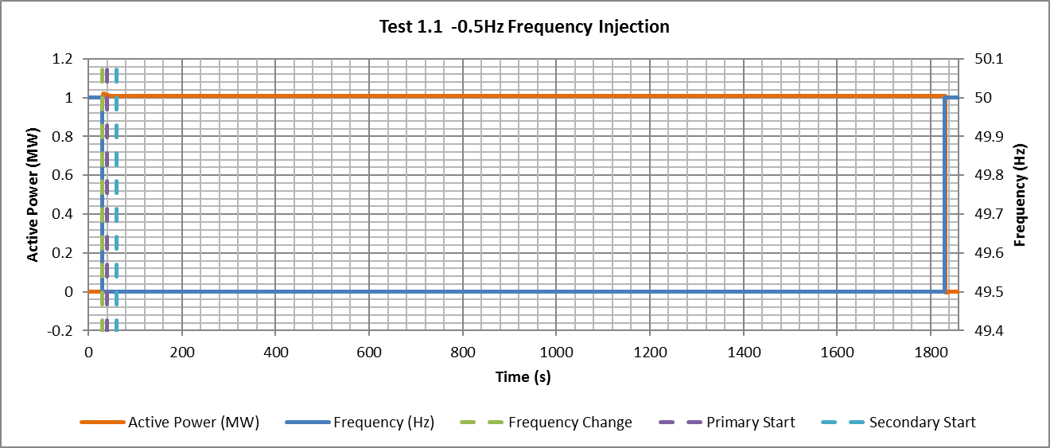
Figure 2 – Test 1.2 Single Asset
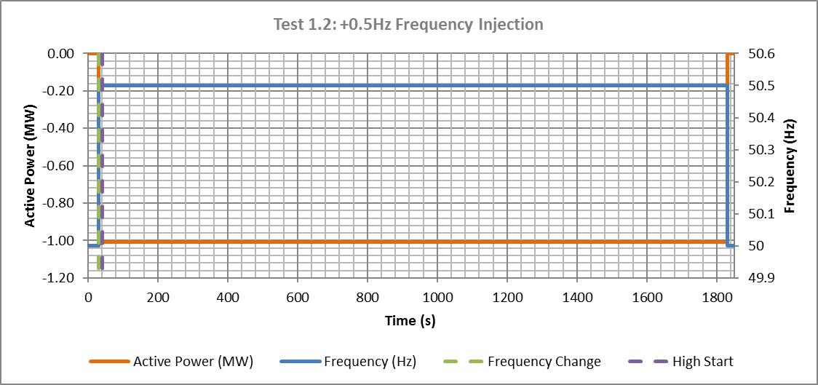
Figure 3 – Test 1.1 Total Unit
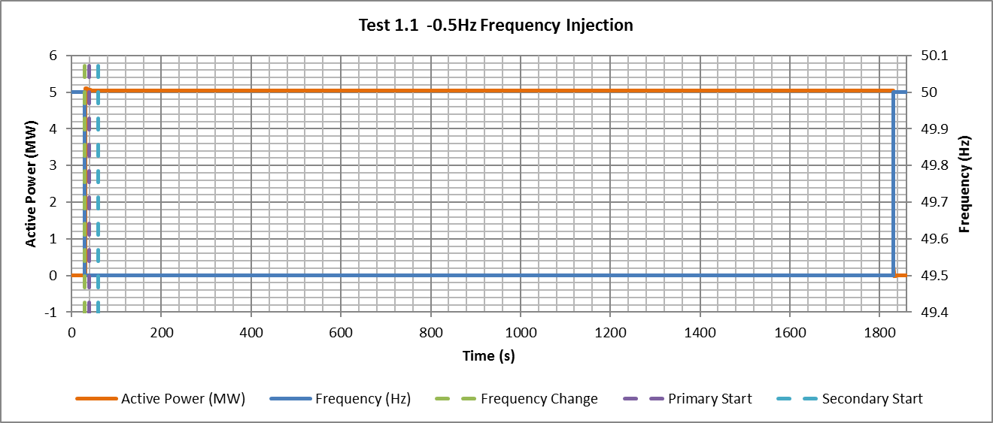
Figure 4 – Test 1.2 Total Unit
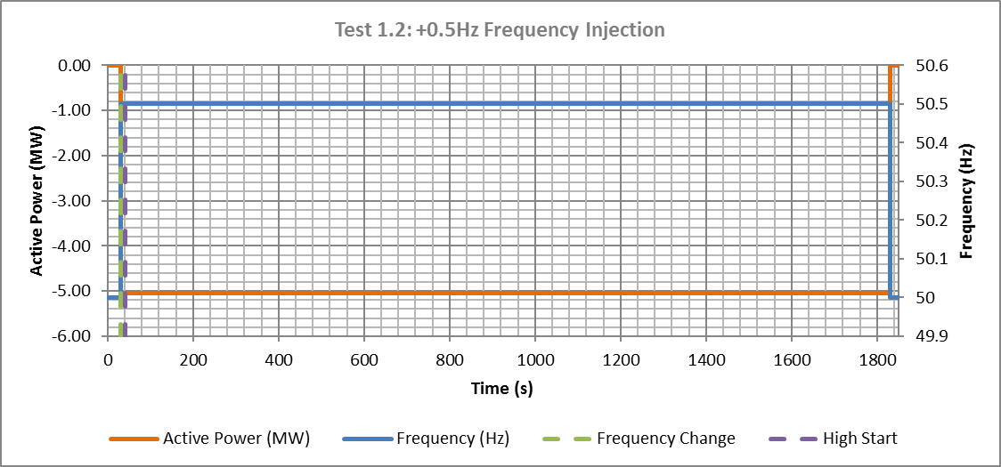
Figure 5 – Test 1.2 Delay
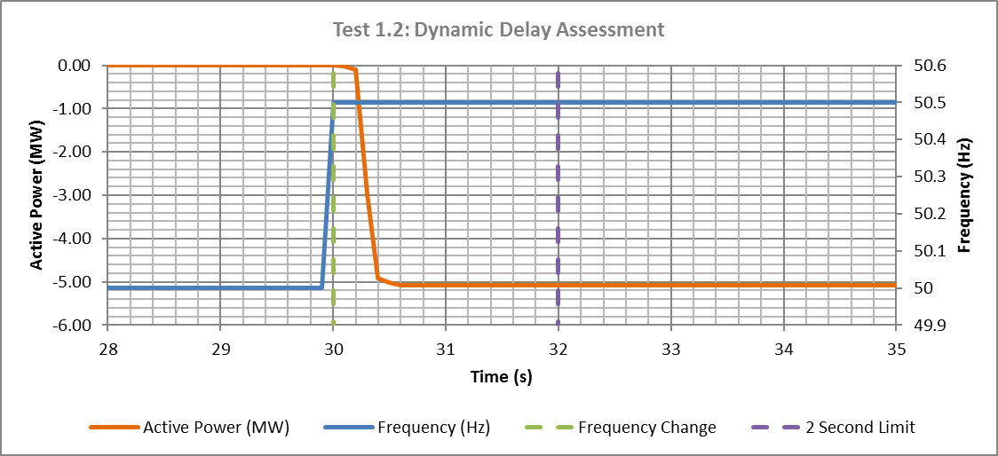
Figure 6 – Test 2.1
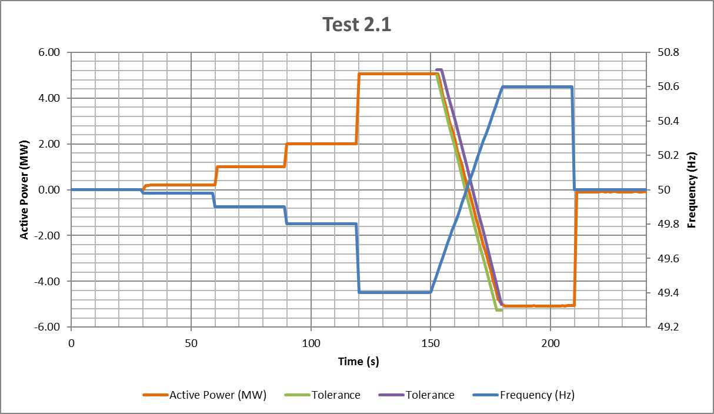
Figure 7 – Test 2.2
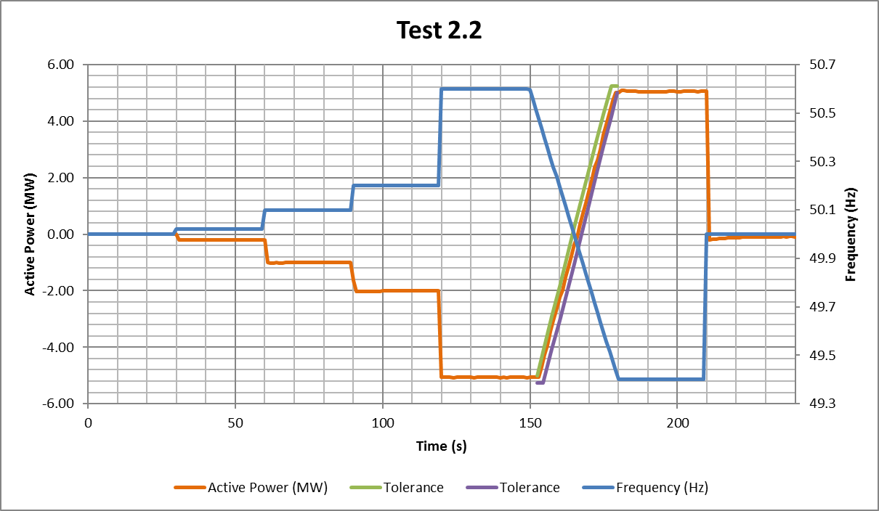

Figure 8 – Test 2.1e
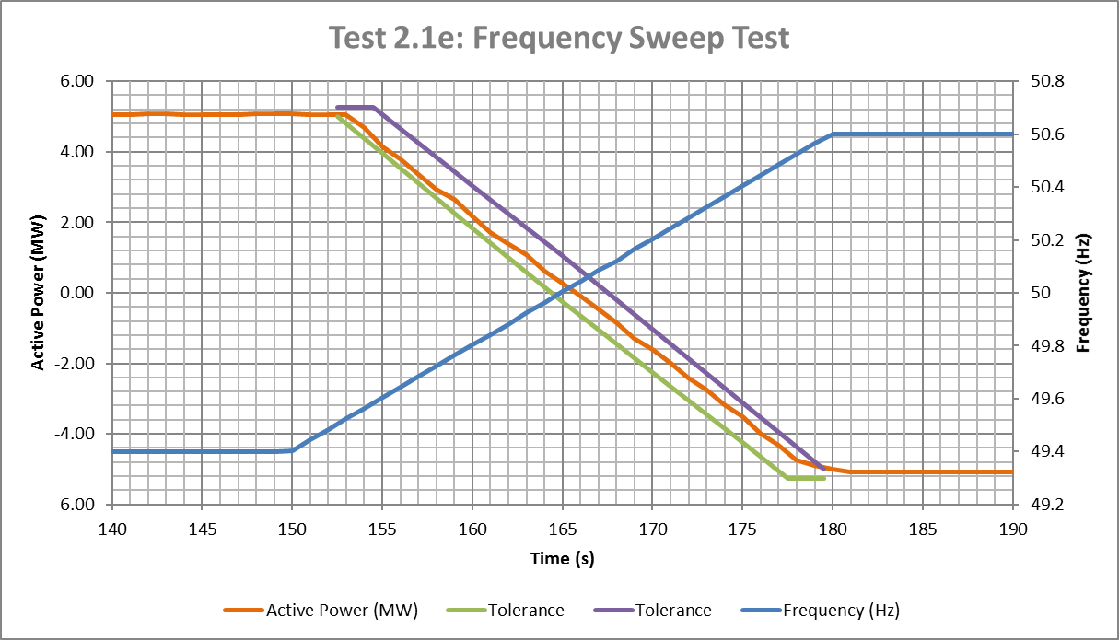
Figure 9 – Test 2.2e
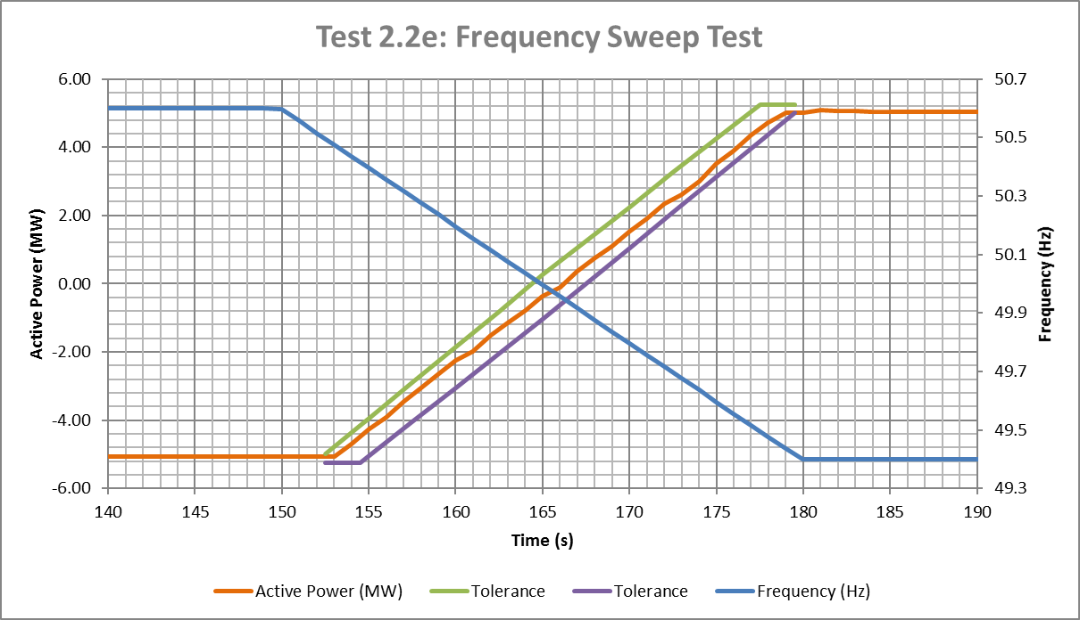

Figure 10 – Test 3
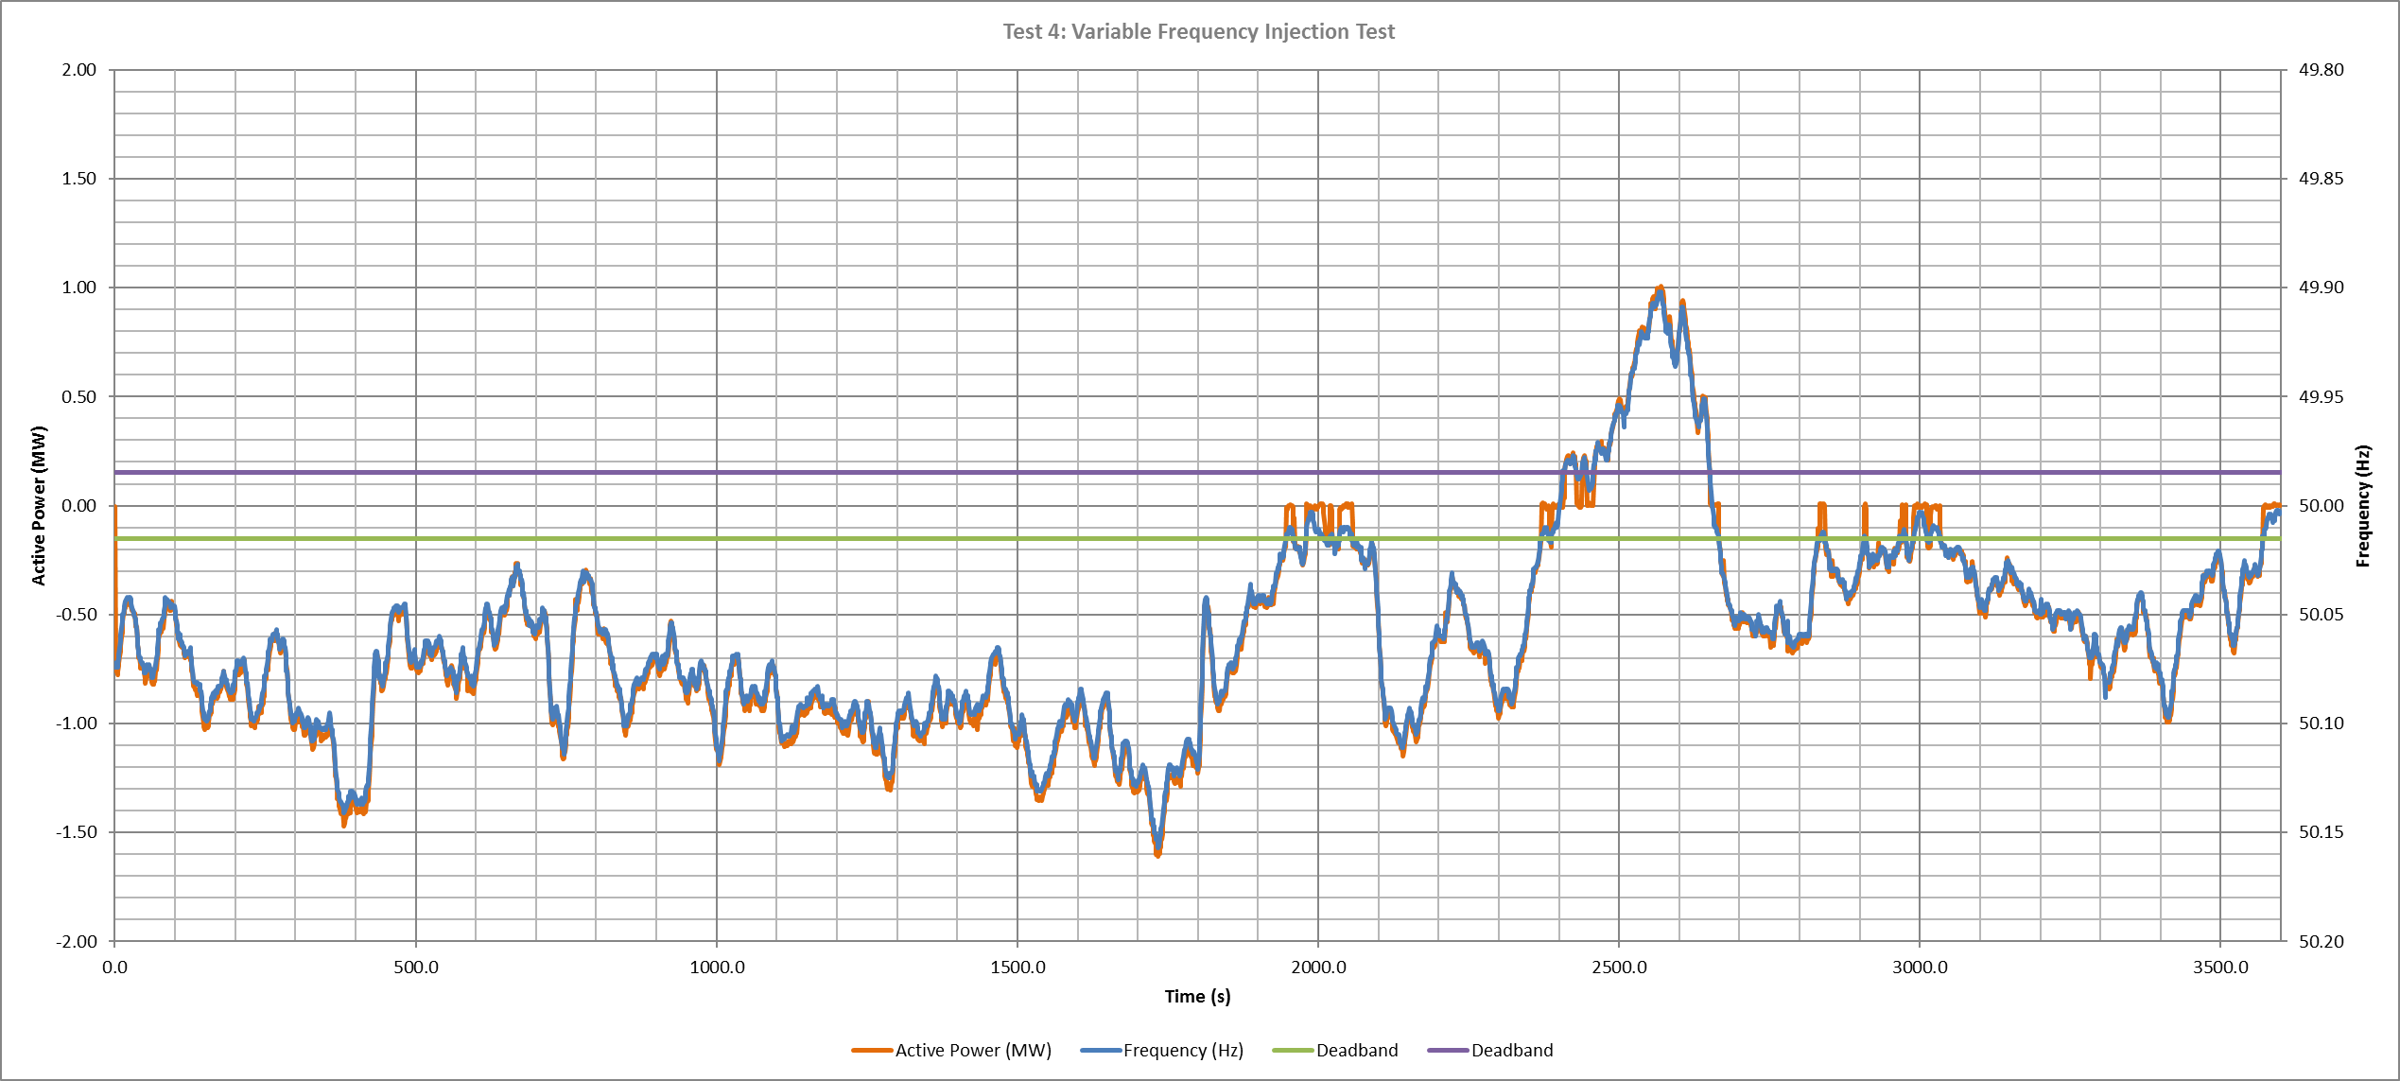
Independent Technical Expert (ITE) Details
Company name
Primary contact name
Contact number /s
Email address
I / We confirm that I / We the following:
- I/We am a/are Independent Technical Expert(s) (as defined in Appendix A of the NGESO’s prevailing Testing Guidelines);
- I/We have carried out an assessment of the [asset] described above in accordance with the testing guidelines set out in the Testing Guidelines;
- the above details are, to my/our best knowledge and belief, true, accurate, complete and not misleading; and
- the CV attached of my/our experience is to my/our best knowledge and belief, true, accurate, complete and not misleading.
Signed:
Date:

