**CONNECTION CONDITIONS**

**(CC)**

**CONTENTS**

(This contents page does not form part of the Grid Code)

Paragraph No/Title Page Number

CC.1 INTRODUCTION 2

CC.2 OBJECTIVE 2

CC.3 SCOPE 2

CC.4 PROCEDURE 4

CC.5 CONNECTION 4

CC.6 TECHNICAL, DESIGN AND OPERATIONAL CRITERIA 6

CC.7 SITE RELATED CONDITIONS 45

CC.8 ANCILLARY SERVICES 50

APPENDIX 1 - SITE RESPONSIBILITY SCHEDULES 52

PROFORMA FOR SITE RESPONSIBILITY SCHEDULE 56

APPENDIX 2 - OPERATION DIAGRAMS 60

PART 1A - PROCEDURES RELATING TO OPERATION DIAGRAMS 60

PART 1B - PROCEDURES RELATING TO GAS ZONE DIAGRAMS 63

PART 2 - NON-EXHAUSTIVE LIST OF APPARATUS TO BE INCLUDED ON OPERATION DIAGRAMS 64

APPENDIX 3 - MINIMUM FREQUENCY RESPONSE REQUIREMENT PROFILE AND OPERATING RANGE FOR NEW POWER STATIONS AND DC CONVERTER STATIONS 66

APPENDIX 4 - FAULT RIDE THROUGH REQUIREMENTS 71

APPENDIX 4A 71

APPENDIX 4B 77

APPENDIX 5 - TECHNICAL REQUIREMENTS LOW FREQUENCY RELAYS FOR THE AUTOMATIC DISCONNECTION OF SUPPLIES AT LOW FREQUENCY 83

APPENDIX 6 - PERFORMANCE REQUIREMENTS FOR CONTINUOUSLY ACTING AUTOMATIC EXCITATION CONTROL SYSTEMS FOR ONSHORE SYNCHRONOUS GENERATING UNITS 85

APPENDIX 7 - PERFORMANCE REQUIREMENTS FOR CONTINUOUSLY ACTING AUTOMATIC VOLTAGE CONTROL SYSTEMS FOR ONSHORE NON-SYNCHRONOUS GENERATING UNITS, ONSHORE DC CONVERTERS, ONSHORE POWER PARK MODULES AND OTSDUW PLANT AND APPARATUS AT THE INTERFACE POINT 89

CC.1 INTRODUCTION

CC.1.1 The **Connection Conditions** ("**CC**") specify both:

(a) the minimum technical, design and operational criteria which must be complied with by:

(i) any  **GB Code User** connected to or seeking connection with the **National Electricity Transmission System**, or

(ii) **GB Code Users** in respect of **GB** **Generators** (other than in respect of **Small Power Stations**) or **GB Code User’s** in respect of **DC Converter Station** owners connected to or seeking connection to a **User's System** which is located in **Great Britain** or **Offshore**, and

(b) the minimum technical, design and operational criteria with which **The Company** will comply in relation to the part of the **National Electricity Transmission System** at the **Connection Site** with **GB Code**  **Users**. In the case of any **OTSDUW Plant and Apparatus**, the **CC** also specify the minimum technical, design and operational criteria which must be complied with by those **GB Code**  **Users** when undertaking **OTSDUW**.

(c) For the avoidance of doubt, the requirements of these **CC’s** do not apply to **EU Code User’s** for whom the requirements of the **ECC’s** shall apply.

CC.2 OBJECTIVE

CC.2.1 The objective of the **CC** is to ensure that by specifying minimum technical, design and operational criteria the basic rules for connection to the **National Electricity Transmission System** and (for certain **GB Code**  **Users**) to a **User's System** are similar for all **GB Code**  **Users** of an equivalent category and will enable **The Company** to comply with its statutory and **Transmission Licence** obligations.

CC.2.2 In the case of any **OTSDUW** the objective of the **CC** is to ensure that by specifying the minimum technical, design and operational criteria the basic rules relating to an **Offshore Transmission System** designed and constructed by an **Offshore Transmission Licensee** and designed and/or constructed by an **GB Code**  **User** under the **OTSDUW Arrangements** are equivalent.

CC.2.3 Provisions of the **CC** which apply in relation to **OTSDUW** and **OTSUA**, and/or a **Transmission Interface Site**, shall (in any particular case) apply up to the **OTSUA Transfer Time**, whereupon such provisions shall (without prejudice to any prior non-compliance) cease to apply, without prejudice to the continuing application of provisions of the **CC** applying in relation to the relevant **Offshore Transmission System** and/or **Connection Site**. It is the case therefore that in cases where the **OTSUA** become operational prior to the **OTSUA Transfer Time** that a **GB** **Generator** is required to comply with this **CC** both as it applies to its **Plant** and **Apparatus** at a **Connection Site\Connection Point** and the **OTSUA** at the **Transmission Interface Site/Transmission Interface Point** until the **OTSUA Transfer Time** and this CC shall be construed accordingly.

CC.2.4 In relation to **OTSDUW**, provisions otherwise to be contained in a **Bilateral Agreement** may be contained in the **Construction Agreement**, and accordingly a reference in the **CC** to a relevant **Bilateral Agreement** includes the relevant **Construction Agreement**.

CC.3 SCOPE

CC.3.1 The **CC** applies to **The Company** and to **GB Code**  **Users**, which in the **CC** means:

(a) **GB** **Generators** (other than those which only have **Embedded** **Small Power Stations**), including those undertaking **OTSDUW**;

(b) **Network Operators**;

(c) **Non-Embedded Customers**;

(d) **DC Converter Station** owners; and

(e) **BM Participants** and **Externally Interconnected System Operators** in respect of CC.6.5 only.

CC.3.2 The above categories of **GB Code**  **User** will become bound by the **CC** prior to them generating, distributing, supplying or consuming, as the case may be, and references to the various categories should, therefore, be taken as referring to them in that prospective role as well as to **GB Code**  **Users** actually connected.

CC.3.3 **Embedded Medium Power Stations** not subject to a **Bilateral Agreement** and **Embedded DC Converter Stations** not subject to a **Bilateral Agreement** Provisions.

The following provisions apply in respect of **Embedded Medium Power Stations** not subject to a **Bilateral Agreement** and **Embedded DC Converter Stations** not subject to a **Bilateral Agreement**.

CC.3.3.1 The obligations within the **CC** that are expressed to be applicable to **GB** **Generators** in respect of **Embedded Medium Power Stations** not subject to a **Bilateral Agreement** and **DC Converter Station** Owners in respect of **Embedded DC Converter Stations** not subject to a **Bilateral Agreement** (where the obligations are in each case listed in CC.3.3.2) shall be read and construed as obligations that the **Network Operator** within whose **System** any such **Medium Power Station** or **DC Converter Station** is **Embedded** must ensure are performed and discharged by the **GB** **Generator** or the **DC Converter Station** owner. **Embedded Medium Power Stations** not subject to a **Bilateral Agreement** and **Embedded DC Converter Stations** not subject to a **Bilateral Agreement** which are located **Offshore** and which are connected to an **Onshore GB Code Users System** will be required to meet the applicable requirements of the Grid Code as though they are an **Onshore GB Generator** or **Onshore DC Converter Station Owner** connected to an **Onshore User System Entry Point**.

CC.3.3.2 The **Network Operator** within whose **System** a **Medium Power Station** not subject to a **Bilateral Agreement** is **Embedded** or a **DC Converter Station** not subject to a **Bilateral Agreement** is **Embedded** must ensure that the following obligations in the **CC** are performed and discharged by the **GB** **Generator** in respect of each such **Embedded Medium Power Station** or the **DC Converter Station** owner in the case of an **Embedded DC Converter Station**:

CC.5.1

CC.5.2.2

CC.5.3

CC.6.1.3

CC.6.1.5 (b)

CC.6.3.2, CC.6.3.3, CC.6.3.4, CC.6.3.6, CC.6.3.7, CC.6.3.8, CC.6.3.9, CC.6.3.10, CC.6.3.12, CC.6.3.13, CC.6.3.15, CC.6.3.16

CC.6.4.4

CC.6.5.6 (where required by CC.6.4.4)

In respect of CC.6.2.2.2, CC.6.2.2.3, CC.6.2.2.5, CC.6.1.5(a), CC.6.1.5(b) and CC.6.3.11 equivalent provisions as co-ordinated and agreed with the **Network Operator** and **GB** **Generator** or **DC Converter Station** owner may be required. Details of any such requirements will be notified to the **Network Operator** in accordance with CC.3.5.

CC.3.3.3 In the case of **Embedded Medium Power Station**s not subject to a **Bilateral Agreement** and **Embedded DC Converter Stations** not subject to a **Bilateral Agreement** the requirements in:

CC.6.1.6

CC.6.3.8

CC.6.3.12

CC.6.3.15

CC.6.3.16

that would otherwise have been specified in a **Bilateral Agreement** will be notified to the relevant **Network Operator** in writing in accordance with the provisions of the **CUSC** and the **Network Operator** must ensure such requirements are performed and discharged by the **GB** **Generator** or the **DC Converter Station** owner.

CC.3.4 In the case of **Offshore** **Embedded Power Stations** connected to an **Offshore** **GB Code**  **User’s System** which directly connects to an **Offshore Transmission System**, any additional requirements in respect of such **Offshore** **Embedded Power Stations** may be specified in the relevant **Bilateral Agreement** with the **Network Operator** or in any **Bilateral Agreement** between **The Company** and such **Offshore** **Embedded Power Station**.

CC.3.5 In the case of a **GB** **Generator** undertaking **OTSDUW** connecting to an **Onshore** **Network** **Operator’s** **System**, any additional requirements in respect of such **OTSDUW Plant and Apparatus** will be specified in the relevant **Bilateral Agreement** with the **GB** **Generator**. For the avoidance of doubt, requirements applicable to **GB** **Generators** undertaking **OTSDUW** and connecting to a **Network** **Operator’s** **~~User~~** **System**, shall be consistent with those applicable requirements of **GB** **Generators** undertaking **OTSDUW** and connecting to a **Transmission** **Interface Point**.

CC.4 PROCEDURE

CC.4.1 The **CUSC** contains certain provisions relating to the procedure for connection to the **National Electricity Transmission System** or, in the case of **Embedded** **Power Stations** or **Embedded DC Converter Stations**, becoming operational and includes provisions relating to certain conditions to be complied with by **GB Code** **Users** prior to and during the course of **The Company** notifying the **GB Code**  **User** that it has the right to become operational. The procedure for a **GB Code** **User** to become connected is set out in the **Compliance Processes**.

CC.5 CONNECTION

CC.5.1 The provisions relating to connecting to the **National Electricity Transmission System** (or to a **User's System** in the case of a connection of an **Embedded Large Power Station** or **Embedded Medium Power Station** or **Embedded DC Converter Station**) are contained in:

(a) the **CUSC** and/or **CUSC Contract** (or in the relevant application form or offer for a **CUSC Contract**);

(b) or, in the case of an **Embedded Development**, the relevant **Distribution Code** and/or the **Embedded Development Agreement** for the connection (or in the relevant application form or offer for an **Embedded Development Agreement**),

and include provisions relating to both the submission of information and reports relating to compliance with the relevant **Connection Conditions** for that **GB Code**  **User**, **Safety Rules**, commissioning programmes, **Operation Diagrams** and approval to connect (and their equivalents in the case of **Embedded Medium Power Stations** not subject to a **Bilateral Agreement** or **Embedded DC Converter Stations** not subject to a **Bilateral Agreement**). References in the **CC** to the "**Bilateral Agreement**”and/or“**Construction Agreement**" and/or “**Embedded Development Agreement**” shall be deemed to include references to the application form or offer therefor.

CC.5.2 Items For Submission

CC.5.2.1 Prior to the **Completion Date** (or, where the **GB** **Generator** is undertaking **OTSDUW**, any later date specified) under the **Bilateral Agreement** and/or **Construction Agreement**, the following is submitted pursuant to the terms of the **Bilateral Agreement** and/or **Construction Agreement**:

(a) updated **Planning Code** data (both **Standard Planning Data** and **Detailed Planning Data**), with any estimated values assumed for planning purposes confirmed or, where practical, replaced by validated actual values and by updated estimates for the future and by updated forecasts for **Forecast Data** items such as **Demand**, pursuant to the requirements of the **Planning Code**;

(b) details of the **Protection** arrangements and settings referred to in CC.6;

(c) copies of all **Safety Rules** and **Local Safety Instructions** applicable at **Users' Sites** which will be used at the **Transmission/User** interface (which, for the purpose of **OC8**, must be to **The Company’s** satisfaction regarding the procedures for **Isolation** and **Earthing**. **The Company** will consult the **Relevant Transmission Licensee** when determining whether the procedures for **Isolation** and **Earthing** are satisfactory);

(d) information to enable the preparation of the **Site Responsibility Schedules** on the basis of the provisions set out in Appendix 1;

(e) an **Operation Diagram** for all **HV** **Apparatus** on the **User** side of the **Connection Point** as described in CC.7;

(f) the proposed name of the **User Site** (which shall not be the same as, or confusingly similar to, the name of any **Transmission Site** or of any other **User Site**);

(g) written confirmation that **Safety Co-ordinators** acting on behalf of the **User** are authorised and competent pursuant to the requirements of **OC8**;

(h) Such **RISSP** prefixes pursuant to the requirements of **OC8**.Prefixes shall be circulated utilising a proforma in accordance with **OC8**;

(i) a list of the telephone numbers for **Joint System Incidents** at which senior management representatives nominated for the purpose can be contacted and confirmation that they are fully authorised to make binding decisions on behalf of the **User**, pursuant to **OC9**;

(j) a list of managers who have been duly authorised to sign **Site Responsibility Schedules** on behalf of the **User**;

(k) information to enable the preparation of the **Site Common Drawings** as described in CC.7;

(l) a list of the telephone numbers for the **Users** facsimile machines referred to in CC.6.5.9; and

(m) for **Sites** in Scotland and **Offshore** a list of persons appointed by the **User** to undertake operational duties on the **User’s System** (including any **OTSDUW** prior to the **OTSUA Transfer Time**) and to issue and receive operational messages and instructions in relation to the **User’s System** (including any **OTSDUW** prior to the **OTSUA Transfer Time**); and an appointed person or persons responsible for the maintenance and testing of **User’s Plant** and **Apparatus**.

CC.5.2.2 Prior to the **Completion Date** the following must be submitted to **The Company** by the **Network Operator** in respect of an **Embedded Development**:

(a) updated **Planning Code** data (both **Standard Planning Data** and **Detailed Planning Data**), with any estimated values assumed for planning purposes confirmed or, where practical, replaced by validated actual values and by updated estimates for the future and by updated forecasts for **Forecast Data** items such as **Demand**, pursuant to the requirements of the **Planning Code**;

(b) details of the **Protection** arrangements and settings referred to in CC.6;

(c) the proposed name of the **Embedded Medium Power Station** or **Embedded** **DC Converter Station Site** (which shall be agreed with **The Company** unless it is the same as, or confusingly similar to, the name of other **Transmission Site** or **User Site**);

CC.5.2.3 Prior to the **Completion Date** contained within an **Offshore Transmission Distribution Connection Agreement** the following must be submitted to **The Company** by the **Network Operator** in respect of a proposed new **Interface Point** within its **User System**:

(a) updated **Planning Code** data (both **Standard Planning Data** and **Detailed Planning Data**), with any estimated values assumed for planning purposes confirmed or, where practical, replaced by validated actual values and by updated estimates for the future and by updated forecasts for **Forecast Data** items such as **Demand**, pursuant to the requirements of the **Planning Code**;

(b) details of the **Protection** arrangements and settings referred to in CC.6;

(c) the proposed name of the **Interface Point** (which shall not be the same as, or confusingly similar to, the name of any **Transmission Site** or of any other **User Site**);

CC.5.2.4 In the case of **OTSDUW Plant and Apparatus** (in addition to items under CC.5.2.1 in respect of the **Connection Site**), prior to the **Completion Date** (or any later date specified) under the **Construction Agreement** the following must be submitted to **The Company** by the **GB** **Code** **User** in respect of the proposed new **Connection Point** and **Interface Point**:

(a) updated **Planning Code** data (**Standard Planning Data**, **Detailed Planning Data** and **OTSDUW Data and Information**), with any estimated values assumed for planning purposes confirmed or, where practical, replaced by validated actual values and by updated estimates for the future and by updated forecasts for **Forecast Data** items such as **Demand**, pursuant to the requirements of the **Planning Code**;

(b) details of the **Protection** arrangements and settings referred to in CC.6;

(c) information to enable preparation ofthe **Site Responsibility Schedules** at the **Transmission Interface Site** on the basis of the provisions set out in Appendix 1.

(d) the proposed name of the **Interface Point** (which shall not be the same as, or confusingly similar to, the name of any **Transmission Site** or of any other **User Site**);

CC.5.3 (a) Of the items CC.5.2.1 (c), (e), (g), (h), (k) and (m) need not be supplied in respect of **Embedded Power Stations** or **Embedded DC Converter Stations**,

(b) item CC.5.2.1(i) need not be supplied in respect of **Embedded Small Power Stations** and **Embedded Medium Power Stations** or **Embedded DC Converter Stations** with a **Registered Capacity** of less than 100MW, and

(c) items CC.5.2.1(d) and (j) are only needed in the case where the **Embedded Power Station** or the **Embedded DC Converter Station** is within a **Connection Site** with another **User**.

CC.6 TECHNICAL, DESIGN AND OPERATIONAL CRITERIA

CC.6.1 National Electricity Transmission System Performance Characteristics

CC.6.1.1 **The Company** shall ensure that, subject as provided in the **Grid Code**, the **National Electricity Transmission System** complies with the following technical, design and operational criteria in relation to the part of the **National Electricity Transmission System** at the **Connection Site** with a **GB Code** **User** and in the case of **OTSDUW Plant and Apparatus**, a **Transmission Interface Point** (unless otherwise specified in CC.6) although in relation to operational criteria **The Company** may be unable (and will not be required) to comply with this obligation to the extent that there are insufficient **Power Stations** or **User Systems** are not available or **Users** do not comply with **The Company's** instructions or otherwise do not comply with the **Grid Code** and each **GB Code**  **User** shall ensure that its **Plant** and **Apparatus** complies with the criteria set out in CC.6.1.5.

Grid Frequency Variations

CC.6.1.2 The **Frequency** of the **National Electricity Transmission System** shall be nominally 50Hz and shall be controlled within the limits of 49.5 - 50.5Hz unless exceptional circumstances prevail.

CC.6.1.3 The **System** **Frequency** could rise to 52Hz or fall to 47Hz in exceptional circumstances. Design of **GB Code** **User's Plant** and **Apparatus** and **OTSDUW Plant and Apparatus** must enable operation of that **Plant** and **Apparatus** within that range in accordance with the following:

|  |  |
| --- | --- |
| Frequency Range | Requirement |
| 51.5Hz - 52Hz | Operation for a period of at least 15 minutes is required each time the Frequency is above 51.5Hz. |
| 51Hz - 51.5Hz | Operation for a period of at least 90 minutes is required each time the Frequency is above 51Hz. |
| 49.0Hz - 51Hz | Continuous operation is required |
| 47.5Hz - 49.0Hz | Operation for a period of at least 90 minutes is required each time the Frequency is below 49.0Hz. |
| 47Hz - 47.5Hz | Operation for a period of at least 20 seconds is required each time the Frequency is below 47.5Hz. |

For the avoidance of doubt, disconnection, by frequency or speed based relays is not permitted within the frequency range 47.5Hz to 51.5Hz, unless agreed with **The Company** in accordance with CC.6.3.12.

Grid Voltage Variations

CC.6.1.4 Subject as provided below, the voltage on the 400kV part of the **National Electricity Transmission System** at each **Connection Site** with a **GB Code** **User** (and in the case of **OTSDUW Plant and Apparatus**, a **Transmission Interface Point**) will normally remain within ±5% of the nominal value unless abnormal conditions prevail. The minimum voltage is -10% and the maximum voltage is +10% unless abnormal conditions prevail, but voltages between +5% and +10% will not last longer than 15 minutes unless abnormal conditions prevail. Voltages on the 275kV and 132kV parts of the **National Electricity Transmission System** at each **Connection Site** with a **User** (and in the case of **OTSDUW Plant and Apparatus**, a **Transmission Interface Point**) will normally remain within the limits ±10% of the nominal value unless abnormal conditions prevail. At nominal **System** voltages below 132kV the voltage of the **National Electricity Transmission System** at each **Connection Site** with a **User** (and in the case of **OTSDUW Plant and Apparatus**, a **Transmission Interface Point**) will normally remain within the limits ±6% of the nominal value unless abnormal conditions prevail. Under fault conditions, voltage may collapse transiently to zero at the point of fault until the fault is cleared. The normal operating ranges of the **National Electricity Transmission System** are summarised below:

|  |  |
| --- | --- |
| National Electricity Transmission System Nominal Voltage | Normal Operating Range |
| 400kV | 400kV ±5% |
| 275kV | 275kV ±10% |
| 132kV | 132kV ±10% |

**The Company** and a **GB Code** **User** may agree greater or lesser variations in voltage to those set out above in relation to a particular **Connection Site**, and insofar as a greater or lesser variation is agreed, the relevant figure set out above shall, in relation to that **GB Code** **User** at the particular **Connection Site**, be replaced by the figure agreed.

Voltage Waveform Quality

CC.6.1.5 All **Plant** and **Apparatus** connected to the **National Electricity Transmission System**, and that part of the **National Electricity Transmission System** at each **Connection Site** or, in the case of **OTSDUW Plant and Apparatus**, at each **Interface Point**, should be capable of withstanding the following distortions of the voltage waveform in respect of harmonic content and phase unbalance:

(a) Harmonic Content

The **Electromagnetic Compatibility Levels** for harmonic distortion on the **Onshore Transmission System** from all sources under both **Planned Outage** and fault outage conditions, (unless abnormal conditions prevail) shall comply with the levels shown in the tables of Appendix A of **Engineering Recommendation** G5/4. The **Electromagnetic Compatibility Levels** for harmonic distortion on an **Offshore Transmission System** will be defined in relevant **Bilateral Agreements**.

**Engineering Recommendation** G5/4 contains planning criteria which **The Company** will apply to the connection of non-linear **Load** to the **National Electricity Transmission System**, which may result in harmonic emission limits being specified for these **Loads** in the relevant **Bilateral Agreement**. The application of the planning criteria will take into account the position of **GB Code** and **EU Code Users’ Plant** and **Apparatus** (and **OTSDUW Plant and Apparatus**) in relation to harmonic emissions. **GB Code** **Users** must ensure that connection of distorting loads to their **User Systems** do not cause any harmonic emission limits specified in the **Bilateral Agreement**, or where no such limits are specified, the relevant planning levels specified in **Engineering Recommendation** G5/4 to be exceeded.

(b) Phase Unbalance

Under **Planned Outage** conditions, the weekly 95 percentile of **Phase (Voltage) Unbalance,** calculated in accordance with IEC 61000-4-30 and IEC 61000-3-13, on the **National Electricity Transmission System** for voltages above 150kV should remain, in England and Wales, below 1.5%, and in Scotland, below 2%, and for voltages of 150kV and below, across GB below 2%, unless abnormal conditions prevail and **Offshore** (or in the case of **OTSDUW**, **OTSDUW Plant and Apparatus**) will be defined in relevant **Bilateral Agreements**.

The Phase Unbalance is calculated from the ratio of root mean square (rms) of negative phase sequence voltage to rms of positive phase sequence voltage, based on 10-minute average values, in accordance with IEC 61000-4-30.

CC.6.1.6 Across GB, under the **Planned Outage** conditions stated in CC.6.1.5(b) infrequent short duration peaks with a maximum value of 2% are permitted for **Phase (Voltage) Unbalance**, for voltages above 150kV, subject to the prior agreement of **The Company** under the **Bilateral Agreement** and in relation to **OTSDUW**, the **Construction Agreement**. **The Company** will only agree following a specific assessment of the impact of these levels on **Transmission Apparatus** and other **Users Apparatus** with which it is satisfied.

Voltage Fluctuations

CC.6.1.7 Voltage changes at a **Point of Common Coupling** on the **Onshore Transmission System** shall not exceed:

1. The limits specified in Table CC.6.1.7 with the stated frequency of occurrence, where:

|  |  |  |
| --- | --- | --- |
| %ΔVsteadystate = │100 x | ΔVsteadystate | │ |
| V0 |

(i)

and

|  |  |  |
| --- | --- | --- |
| %ΔVmax =100 x | ΔVmax | ; |
| V0 |

## 

## (ii) V0 is the initial steady state system voltage;

(iii) Vsteadystate is the system voltage reached when the rate of change of system voltage over time is less than or equal to 0.5% over 1 second and ΔVsteadystate is the absolute value of the difference between Vsteadystate andV0;

(iv) ΔVmax is the absolute value of the maximum change in the system voltage relative to the initial steady state system voltage of V0;

(v) All voltages are the root mean square of the voltage measured over one cycle refreshed every half a cycle as per IEC 61000-4-30;

(vi) The voltage changes specified are the absolute maximum allowed, applied to phase to ground or phase to phase voltages whichever is the highest change;

(vii) Voltage changes in category 3 do not exceed the limits depicted in the time dependant characteristic shown in Figure CC.6.1.7;

(viii) Voltage changes in category 3 only occur infrequently, typically not planned more than once per year on average over the lifetime of a connection, and in circumstances notified to **The Company,** such as for example commissioning in accordance with a commissioning programme, implementation of a planned outage notified in accordance with **OC2** or an **Operation** or **Event** notified in accordance with **OC7**; and

(ix) For connections with a **Completion Date** after 1st September 2015 and where voltage changes would constitute a risk to the **National Electricity Transmission System** or, in **The Company’s** view, the **System** of any **GB Code**  **User**, **Bilateral Agreements** may include provision for **The Company** to reasonably limit the number of voltage changes in category 2 or 3 to a lower number than specified in Table CC.6.1.7 to ensure that the total number of voltage changes at the **Point of Common Coupling** across multiple **Users** remains within the limits of Table CC.6.1.7.

|  |  |  |
| --- | --- | --- |
| Category | Maximum number of Occurrences | %ΔVmax & %ΔVsteadystate |
| 1 | No Limit | │%ΔVmax │≤ 1% &  │%ΔVsteadystate│≤ 1% |
| 2 | $$\frac{\text{3600}}{\sqrt[\text{0.304}]{\text{2.5 ×\%∆}{\text{V}}_{\text{max}}}}$$ occurrences per hour with events evenly distributed | 1% < │%ΔVmax│≤ 3% &  │%ΔVsteadystate │≤ 3% |
| 3 | No more than 4 per day for Commissioning, Maintenance and Fault Restoration | For decreases in voltage:  %ΔVmax ≤ 12%1 &  %ΔVsteadystate ≤ 3%  For increases in voltage:  %ΔVmax ≤ 5%2 &  %ΔVsteadystate ≤ 3%  (see Figure CC6.1.7) |

Table CC.6.1.7 **-** Limits for Rapid Voltage Changes

1 A decrease in voltage of up to 12% is permissible for up to 80ms, as highlighted in the shaded area in Figure CC.6.1.7, reducing to up to 10% after 80ms and to up to 3% after 2 seconds.

2 An increase in voltage of up to 5% is permissible if it is reduced to up to 3% after 0.5 seconds.



Voltage

Figure CC.6.1.7 -

Time and magnitude limits for a category 3 Rapid Voltage Change

(b) For voltages above 132kV, **Flicker Severity (Short Term)** of 0.8 Unit and a **Flicker Severity (Long Term)** of 0.6 Unit, for voltages 132kV and below, **Flicker Severity (Short Term)** of 1.0 Unit and a **Flicker Severity (Long Term**) of 0.8 Unit, as set out in **Engineering Recommendation** P28 as current at the **Transfer Date**.

CC.6.1.8 Voltage fluctuations at a **Point of Common Coupling** with a fluctuating **Load** directly connected to an **Offshore Transmission System** (or in the case of **OTSDUW**, **OTSDUW Plant and Apparatus**) shall not exceed the limits set out in the **Bilateral Agreement**.

Sub-Synchronous Resonance and Sub-Synchronous Torsional Interaction

CC.6.1.9 **The Company** shall ensure that **GB Code** **Users'** **Plant and Apparatus** will not be subject to unacceptable Sub-Synchronous Oscillation conditions as specified in the relevant **Licence Standards**.

CC.6.1.10 **The Company** shall ensure where necessary, and in consultation with **Relevant** **Transmission Licensees** where required, that any relevant site specific conditions applicable at a **GB Code** **User's Connection Site**, including a description of the Sub-Synchronous Oscillation conditions considered in the application of the relevant **License Standards**, are set out in the **GB Code** **User's Bilateral Agreement**.

CC.6.2 Plant and Apparatus relating to Connection Site and Interface Point

The following requirements apply to **Plant** and **Apparatus** relating to the **Connection Point**, and **OTSDUW Plant and Apparatus** relating to the **Interface Point** (until the **OTSUA Transfer Time**) and **Connection Point** which (except as otherwise provided in the relevant paragraph) each **GB Code** **User** must ensure are complied with in relation to its **Plant** and **Apparatus** and which in the case of CC.6.2.2.2.2, CC.6.2.3.1.1 and CC.6.2.1.1(b) only, **The Company** must ensure are complied with in relation to **Transmission**  **Plant** and **Apparatus**, as provided in those paragraphs.

CC.6.2.1 General Requirements

CC.6.2.1.1 (a) The design of connections between the **National Electricity Transmission System** and:

(i) any **Generating Unit** (other than a **CCGT Unit** or **Power Park Unit**) **DC Converter**, **Power Park Module** or **CCGT Module**, or

(ii) any **Network Operator’s System**, or

(iii) **Non-Embedded Customers** equipment;

will be consistent with the **Licence Standards**.

In the case of **OTSDUW**, the design of the **OTSUA’s** connections at the **Interface Point** and **Connection Point** will be consistent with **Licence Standards**.

(b) The **National Electricity Transmission System** (and any **OTSDUW Plant and Apparatus**) at nominal **System** voltages of 132kV and above is/shall be designed to be earthed with an **Earth Fault Factor** of, in England and Wales or **Offshore**, below 1.4 and in Scotland, below 1.5. Under fault conditions the rated **Frequency** component of voltage could fall transiently to zero on one or more phases or, in England and Wales, rise to 140% phase-to-earth voltage, or in Scotland, rise to 150% phase-to-earth voltage. The voltage rise would last only for the time that the fault conditions exist. The fault conditions referred to here are those existing when the type of fault is single or two phase-to-earth.

(c) For connections to the **National Electricity Transmission System** at nominal **System** voltages of below 132kV the earthing requirements and voltage rise conditions will be advised by **The Company** as soon as practicable prior to connection and in the case of **OTSDUW Plant and Apparatus** shall be advised to **The Company** by the **GB Code User**.

CC.6.2.1.2 Substation Plant and Apparatus

(a) The following provisions shall apply to all **Plant** and **Apparatus** which is connected at the voltage of the **Connection Point** (and **OTSDUW Plant and Apparatus** at the **Interface Point**) and which is contained in equipment bays that are within the **Transmission** busbar **Protection** zone at the **Connection Point**. This includes circuit breakers, switch disconnectors, disconnectors, **Earthing Devices**, power transformers, voltage transformers, reactors, current transformers, surge arresters, bushings, neutral equipment, capacitors, line traps, coupling devices, external insulation and insulation co-ordination devices. Where necessary, this is as more precisely defined in the **Bilateral Agreement**.

(i) Plant and/or Apparatus prior to 1st January 1999

Each item of such **Plant** and/or **Apparatus** which at 1st January 1999 is either :

installed; or

owned (but is either in storage, maintenance or awaiting installation); or

ordered;

and is the subject of a **Bilateral Agreement** with regard to the purpose for which it is in use or intended to be in use, shall comply with the relevant standards/specifications applicable at the time that the **Plant** and/or **Apparatus** was designed (rather than commissioned) and any further requirements as specified in the **Bilateral Agreement**.

(ii) Plant and/or Apparatus post 1st January 1999 for a new Connection Point (including OTSDUW Plant and Apparatus at the Interface Point)

Each item of such **Plant** and/or **Apparatus** installed in relation to a new **Connection Point** (or **OTSDUW Plant and Apparatus** at the **Interface Point**)after 1st January 1999 shall comply with the relevant **Technical Specifications** and any further requirements identified by **The Company**, acting reasonably, to reflect the options to be followed within the **Technical Specifications** and/or to complement if necessary the **Technical Specifications** so as to enable **The Company** to comply with its obligations in relation to the **National Electricity Transmission System** or the **Relevant Transmission Licensee** to comply with its obligations in relation to its **Transmission System**. This information, including the application dates of the relevant **Technical Specifications**, will be as specified in the **Bilateral Agreement**.

(iii) New Plant and/or Apparatus post 1st January 1999 for an existing Connection Point (including OTSDUW Plant and Apparatus at the Interface Point)

Each new additional and/or replacement item of such **Plant** and/or **Apparatus** installed in relation to a change to an existing **Connection Point** (or **OTSDUW Plant and Apparatus** at the **Interface Point**  and **Connection Point**) after 1st January 1999 shall comply with the standards/specifications applicable when the change was designed, or such other standards/specifications as necessary to ensure that the item of **Plant** and/or **Apparatus** is reasonably fit for its intended purpose having due regard to the obligations of **The Company**, the relevant **GB Code** **User** and the **Relevant Transmission Licensee** under their respective **Licences**. Where appropriate this information, including the application dates of the relevant standards/specifications, will be as specified in the varied **Bilateral Agreement**.

(iv) Used Plant and/or Apparatus being moved, re-used or modified

If, after its installation, any such item of **Plant** and/or **Apparatus** is subsequently:

moved to a new location; or

used for a different purpose; or

otherwise modified;

then the standards/specifications as described in (i), (ii), or (iii) above or in ECC.6.2.1.2 (as applicable) will apply as appropriate to such **Plant** and/or **Apparatus**, which must be reasonably fit for its intended purpose having due regard to the obligations of **The Company**, the relevant **GB Code** **User** or **EU Code User** (as applicable) and the **Relevant Transmission Licensee** under their respective **Licences**.

(b) **The Company** shall at all times maintain a list of those **Technical Specifications** and additional requirements which might be applicable under this CC.6.2.1.2 and which may be referenced by **The Company** in the **Bilateral Agreement**. **The Company** shall provide a copy of the list upon request to any **User**.

(c) Where the **GB Code** **User** provides **The Company** with information and/or test reports in respect of **Plant** and/or **Apparatus** which the **GB Code** **User** reasonably believes demonstrate the compliance of such items with the provisions of a **Technical Specification** then **The Company** shall promptly and without unreasonable delay give due and proper consideration to such information.

(d) **Plant** and **Apparatus** shall be designed, manufactured and tested in premises with an accredited certificate in accordance with the quality assurance requirements of the relevant standard in the BS EN ISO 9000 series (or equivalent as reasonably approved by **The Company**) or in respect of test premises which do not include a manufacturing facility premises with an accredited certificate in accordance with BS EN 45001.

(e) Each connection between an **GB Code** **User** and the **National Electricity Transmission System** must be controlled by a circuit-breaker (or circuit breakers) capable of interrupting the maximum short circuit current at the point of connection. The **Seven Year Statement** gives values of short circuit current and the rating of **Transmission** circuit breakers at existing and committed **Connection Points** for future years.

(f) Each connection between a **GB** **Generator** undertaking **OTSDUW** or an **Onshore** **Transmission** **Licensee**, must be controlled by a circuit breaker (or circuit breakers) capable of interrupting the maximum short circuit current at the **Transmission** **Interface Point**. The **Seven** **Year** **Statement** gives values of short circuit current and the rating of **Transmission** circuit breakers at existing and committed **Transmission** **Interface Points** for future years.

CC.6.2.2 Requirements at Connection Points or, in the case of OTSDUW at Interface Points that relate to GB Generators or OTSDUW Plant and Apparatus or DC Converter Station owners

CC.6.2.2.1 Not Used.

CC.6.2.2.2 Generating Unit, OTSDUW Plant and Apparatus and Power Station Protection Arrangements

CC.6.2.2.2.1 Minimum Requirements

**Protection** of **Generating Units** (other than **Power Park Units**), **DC Converters**, **OTSDUW Plant and Apparatus** or **Power Park Modules** and their connections to the **National Electricity Transmission System** shall meet the requirements given below. These are necessary to reduce the impact on the **National Electricity Transmission System** of faults on **OTSDUW Plant and Apparatus** circuits or circuits owned by **GB** **Generators** or **DC Converter Station** owners.

CC.6.2.2.2.2 Fault Clearance Times

(a) The required fault clearance time for faults on the **GB** **Generator's** or **DC Converter Station** owner’s equipment directly connected to the **National Electricity Transmission System** or **OTSDUW Plant and Apparatus** and for faults on the **National Electricity Transmission System** directly connected to the **GB** **Generator** or **DC Converter Station** owner's equipment or **OTSDUW Plant and Apparatus**, from fault inception to the circuit breaker arc extinction, shall be set out in the **Bilateral Agreement**. The fault clearance time specified in the **Bilateral Agreement** shall not be shorter than the durations specified below:

(i) 80ms at 400kV

(ii) 100ms at 275kV

(iii) 120ms at 132kV and below

but this shall not prevent the **GB Code** **User** or the **Relevant Transmission Licensee** or the **GB** **Generator** (including in respect of **OTSDUW Plant and Apparatus**) from selecting a shorter fault clearance time on their own **Plant** and **Apparatus** provided **Discrimination** is achieved.

A longer fault clearance time may be specified in the **Bilateral Agreement** for faults on the **National Electricity Transmission System**. A longer fault clearance time for faults on the **GB** **Generator** or **DC Converter Station** owner's equipment or **OTSDUW Plant and Apparatus** may be agreed with **The Company** in accordance with the terms of the **Bilateral Agreement** but only if **System** requirements, in **The Company's** view, permit. The probability that the fault clearance time stated in the **Bilateral Agreement** will be exceeded by any given fault, must be less than 2%.

(b) In the event that the required fault clearance time is not met as a result of failure to operate on the **Main Protection System(s)** provided, the **GB** **Generators** or **DC Converter Station** owners or **GB** **Generators** in the case of **OTSDUW Plant and Apparatus** shall, except as specified below provide **Independent Back-Up Protection**. The **Relevant Transmission Licensee** will also provide **Back-Up Protection** and the **Relevant Transmission Licensee’s** and the **GB Code** **User’s** **Back-Up Protections** will be co-ordinated so as to provide **Discrimination**.

On a **Generating Unit** (other than a **Power Park Unit**), **DC Converter** or **Power Park Module** or **OTSDUW Plant and Apparatus** in respect of which the **Completion Date** is after 20 January 2016 and connected to the **National Electricity Transmission System** at 400kV or 275kV and where two **Independent** **Main Protections** are provided to clear faults on the **HV Connections** within the required fault clearance time, the **Back-Up Protection** provided by **GB** **Generators** (including in respect of **OTSDUW Plant and Apparatus**) and **DC Converter Station** owner shall operate to give a fault clearance time of no longer than 300ms at the minimum infeed for normal operation for faults on the **HV Connections**. Where two **Independent Main Protections** are installed the **Back-Up Protection** may be integrated into one (or both) of the **Independent Main Protection** relays.

On a **Generating Unit** (other than a **Power Park Unit**), **DC Converter** or **Power Park Module** or **OTSDUW Plant** **and** **Apparatus** in respect of which the **Completion Date** is after 20 January 2016 and connected to the **National Electricity Transmission System** at 132 kV and where only one **Main Protection** is provided to clear faults on the **HV Connections** within the required fault clearance time, the **Independent Back-Up Protection** provided by the **GB** **Generator** (including in respect of **OTSDUW** **Plant** **and Apparatus**) and the **DC Converter Station** owner shall operate to give a fault clearance time of no longer than 300ms at the minimum infeed for normal operation for faults on the **HV Connections**.

On a **Generating Unit** (other than a **Power Park Unit**), **DC Converter** or **Power Park Module** or **OTSDUW Plant** and **Apparatus** connected to the **National Electricity Transmission System** and on **Generating Units** (other than a **Power Park Unit**), **DC Converters** or **Power Park Modules** or **OTSDUW Plant and Apparatus** connected to the **National Electricity Transmission System** at 400 kV or 275 kV or 132 kV, in respect of which the **Completion Date** is before the 20 January 2016, the **Back-Up Protection** or **Independent Back-Up Protection** shall operate to give a fault clearance time of no longer than 800ms in England and Wales or 300ms in Scotland at the minimum infeed for normal operation for faults on the **HV Connections**.

**A Generating Unit** (other than a **Power Park Unit**), **DC Converter** or **Power Park Module** or **OTSDUW Plant and Apparatus**) with **Back-Up Protection** or **Independent** **Back-Up** **Protection** will also be required to withstand, without tripping, the loading incurred during the clearance of a fault on the **National Electricity Transmission System** by breaker fail **Protection** at 400kV or 275kV or of a fault cleared by **Back-Up** **Protection** where the **GB** **Generator** (including in the case of **OTSDUW Plant and Apparatus**) or **DC Converter** is connected at 132kV and below. This will permit **Discrimination** between **GB** **Generator** in respect of **OTSDUW Plant** and **Apparatus** or **DC Converter** **Station** owners’ **Back-Up** **Protection** or **Independent Back-Up Protection** and the **Back-Up** **Protection** provided on the **National Electricity Transmission System** and other **Users' Systems**.

(c) When the **Generating Unit** (other than **Power Park Units**), or the **DC Converter** or **Power Park Module** or **OTSDUW Plant and Apparatus** is connected to the **National Electricity Transmission System** at 400kV or 275kV, and in Scotland and **Offshore** also at 132kV, and a circuit breaker is provided by the **GB** **Generator** (including in respect of **OTSDUW Plant and Apparatus**) or the **DC Converter Station** owner, or **NGET**, as the case may be, to interrupt fault current interchange with the **National Electricity Transmission System**, or **GB** **Generator's System**, or **DC Converter Station** owner’s **System**, as the case may be, circuit breaker fail **Protection** shall be provided by the **GB** **Generator** (including in respect of **OTSDUW Plant and Apparatus**) or **DC Converter** **Station** owner, or the **Relevant Transmission Licensee**, as the case may be, on this circuit breaker. In the event, following operation of a **Protection** system, of a failure to interrupt fault current by these circuit-breakers within the **Fault Current Interruption Time**, the circuit breaker fail **Protection** is required to initiate tripping of all the necessary electrically adjacent circuit-breakers so as to interrupt the fault current within the next 200ms.

(d) The target performance for the **System Fault Dependability Index** shall be not less than 99%. This is a measure of the ability of **Protection** to initiate successful tripping of circuit breakers which are associated with the faulty item of **Apparatus**.

CC.6.2.2.3 Equipment to be provided

CC.6.2.2.3.1 Protection of Interconnecting Connections

The requirements for the provision of **Protection** equipment for interconnecting connections will be specified in the **Bilateral Agreement**. In this **CC** the term "interconnecting connections" means the primary conductors from the current transformer accommodation on the circuit side of the circuit breaker to the **Connection Point** or the primary conductors from the current transformer accommodation on the circuit side of the **OTSDUW Plant and Apparatus** of the circuit breaker to the **Transmission Interface Point**.

CC.6.2.2.3.2 Circuit-breaker fail Protection

The **GB** **Generator** or **DC Converter Station** owner will install circuit breaker fail **Protection** equipment in accordance with the requirements of the **Bilateral Agreement**. The **GB** **Generator** or **DC Converter Station** owner will also provide a back-trip signal in the event of loss of air from its pressurised head circuit breakers, during the **Generating Unit** (other than a **CCGT Unit** or **Power Park Unit**) or **CCGT Module** or **DC Converter** or **Power Park Module** run-up sequence, where these circuit breakers are installed.

CC.6.2.2.3.3 Loss of Excitation

The **GB** **Generator** must provide **Protection** to detect loss of excitation on a **Generating Unit** and initiate a **Generating Unit** trip.

CC.6.2.2.3.4 Pole-Slipping Protection

Where, in **The Company's** reasonable opinion, **System** requirements dictate, **The Company** will specify in the **Bilateral Agreement** a requirement for **GB** **Generators** to fit pole-slipping **Protection** on their **Generating Units**.

CC.6.2.2.3.5 Signals for Tariff Metering

**GB Generators** and **DC Converter Station** owners will install current and voltage transformers supplying all tariff meters at a voltage to be specified in, and in accordance with, the **Bilateral Agreement**.

CC.6.2.2.4 Work on Protection Equipment

No busbar **Protection**, mesh corner **Protection**, circuit-breaker fail **Protection** relays, AC or DC wiring (other than power supplies or DC tripping associated with the **Generating Unit**, **DC Converter** or **Power Park Module** itself) may be worked upon or altered by the **GB** **Generator** or **DC Converter Station** owner personnel in the absence of a representative of the **Relevant Transmission Licensee**, or written authority from the **Relevant Transmission Licensee** to perform such work or alterations in the absence of a representative of the **Relevant Transmission Licensee**.

CC.6.2.2.5 Relay Settings

**Protection** and relay settings will be co-ordinated (both on connection and subsequently) across the **Connection Point** in accordance with the **Bilateral Agreement** and in relation to **OTSDUW Plant and Apparatus**, across the **Interface Point** in accordance with the **Bilateral Agreement** to ensure effective disconnection of faulty **Apparatus**.

CC.6.2.3 Requirements at Connection Points relating to Network Operators and Non-Embedded Customers

CC.6.2.3.1 Protection Arrangements for Network Operators and Non-Embedded Customers

CC.6.2.3.1.1 **Protection** of **Network Operator** and **Non-Embedded Customers Systems** directly connected to the **National Electricity Transmission System**, shall meet the requirements given below:

Fault Clearance Times

(a) The required fault clearance time for faults on **Network Operator** and **Non-Embedded Customer** equipment directly connected to the **National Electricity Transmission System**, and for faults on the **National Electricity Transmission System** directly connected to the **Network Operator’s** or **Non-Embedded Customer's** equipment, from fault inception to the circuit breaker arc extinction, shall be set out in each **Bilateral Agreement**. The fault clearance time specified in the **Bilateral Agreement** shall not be shorter than the durations specified below:

(i) 80ms at 400kV

(ii) 100ms at 275kV

(iii) 120ms at 132kV and below

but this shall not prevent the **GB Code** **User** or the **Relevant Transmission Licensee** from selecting a shorter fault clearance time on its own **Plant** and **Apparatus** provided **Discrimination** is achieved.

For the purpose of establishing the **Protection** requirements in accordance with CC.6.2.3.1.1 only, the point of connection of the **Network Operator** or **Non-Embedded Customer** equipment to the **National Electricity Transmission System** shall be deemed to be the low voltage busbars at a **GB** **Grid Supply Point**, irrespective of the ownership of the equipment at the **GB** **Grid Supply Point**.

A longer fault clearance time may be specified in the **Bilateral Agreement** for faults on the **National Electricity Transmission System**. A longer fault clearance time for faults on the **Network Operator** and **Non-Embedded Customers** equipment may be agreed with **The Company** in accordance with the terms of the **Bilateral Agreement** but only if **System** requirements in **The Company's** view permit. The probability that the fault clearance time stated in the **Bilateral Agreement** will be exceeded by any given fault must be less than 2%.

(b) (i) For the event of failure of the **Protection** systems provided to meet the above fault clearance time requirements, **Back-Up** **Protection** shall be provided by the **Network Operator** or **Non-Embedded Customer** as the case may be.

(ii)The **Relevant Transmission Licensee** will also provide **Back-Up** **Protection**, which will result in a fault clearance time longer than that specified for the **Network Operator** or **Non-Embedded Customer** **Back-Up** **Protection** so as to provide **Discrimination**.

(iii) For connections with the **National Electricity Transmission System** at 132kV and below, it is normally required that the **Back-Up** **Protection** on the **National Electricity Transmission System** shall discriminate with the **Network Operator** or **Non-Embedded Customer's** **Back-Up** **Protection**.

(iv) For connections with the **National Electricity Transmission System** at 400kV or 275kV, the **Back-Up** **Protection** will be provided by the **Network Operator** or **Non-Embedded Customer**, as the case may be, with a fault clearance time not longer than 300ms for faults on the **Network Operator’s** or **Non-Embedded Customer's Apparatus**.

(v) Such **Protection** will also be required to withstand, without tripping, the loading incurred during the clearance of a fault on the **National Electricity Transmission System** by breaker fail **Protection** at 400kV or 275kV. This will permit **Discrimination** between **Network Operator’s Back-Up Protection** or **Non-Embedded Customer’s Back-Up Protection**, as the case may be, and **Back-Up** **Protection** provided on the **National Electricity Transmission System** and other **User Systems**. The requirement for and level of **Discrimination** required will be specified in the **Bilateral Agreement**.

(c) (i) Where the **Network Operator** or **Non-Embedded Customer** is connected to the **National Electricity Transmission System** at 400kV or 275kV, and in Scotland also at 132kV, and a circuit breaker is provided by the **Network Operator** or **Non-Embedded Customer**, or the **Relevant Transmission Licensee**, as the case may be, to interrupt the interchange of fault current with the **National Electricity Transmission System** or the **System** of the **Network Operator** or **Non-Embedded Customer**, as the case may be, circuit breaker fail **Protection** will be provided by the **Network Operator** or **Non-Embedded Customer**, or the **Relevant Transmission Licensee**, as the case may be, on this circuit breaker.

(ii) In the event, following operation of a **Protection** system, of a failure to interrupt fault current by these circuit-breakers within the **Fault Current Interruption Time**, the circuit breaker fail **Protection** is required to initiate tripping of all the necessary electrically adjacent circuit-breakers so as to interrupt the fault current within the next 200ms.

(d) The target performance for the **System Fault Dependability Index** shall be not less than 99%. This is a measure of the ability of **Protection** to initiate successful tripping of circuit breakers which are associated with the faulty items of **Apparatus**.

CC.6.2.3.2 Fault Disconnection Facilities

(a) Where no **Transmission** circuit breaker is provided at the **GB Code** **User's** connection voltage, the **GB Code** **User** must provide **The Company** with the means of tripping all the **GB Code** **User's** circuit breakers necessary to isolate faults or **System** abnormalities on the **National Electricity Transmission System**. In these circumstances, for faults on the **GB Code** **User's System**, the **GB Code** **User's** **Protection** should also trip higher voltage **Transmission** circuit breakers. These tripping facilities shall be in accordance with the requirements specified in the **Bilateral Agreement**.

(b) **The Company** may require the installation of a **System to Generator Operational Intertripping Scheme** in order to enable the timely restoration of circuits following power **System** fault(s). These requirements shall be set out in the relevant **Bilateral Agreement**.

CC.6.2.3.3 Automatic Switching Equipment

Where automatic reclosure of **Transmission** circuit breakers is required following faults on the **GB Code**  **User's System**, automatic switching equipment shall be provided in accordance with the requirements specified in the **Bilateral Agreement**.

CC.6.2.3.4 Relay Settings

**Protection** and relay settings will be co-ordinated (both on connection and subsequently) across the **Connection Point** in accordance with the **Bilateral Agreement** to ensure effective disconnection of faulty **Apparatus**.

CC.6.2.3.5 Work on Protection equipment

Where a **Transmission Licensee** owns the busbar at the **Connection Point**, no busbar **Protection**, mesh corner **Protection** relays, AC or DC wiring (other than power supplies or DC tripping associated with the **Network Operator** or **Non-Embedded Customer’s Apparatus** itself) may be worked upon or altered by the **Network Operator** or **Non-Embedded Customer** personnel in the absence of a representative of the **Relevant Transmission Licensee** or written authority from the **Relevant Transmission Licensee** to perform such work or alterations in the absence of a representative of the **Relevant Transmission Licensee**.

CC.6.2.3.6 Equipment to be provided

CC.6.2.3.6.1 Protection of Interconnecting Connections

The requirements for the provision of **Protection** equipment for interconnecting connections will be specified in the **Bilateral Agreement**.

CC.6.3 GENERAL GENERATING UNIT (AND OTSDUW) REQUIREMENTS

CC.6.3.1 This section sets out the technical and design criteria and performance requirements for **Generating** **Units**, **DC Converters** and **Power Park Modules** (whether directly connected to the **National Electricity Transmission System** or **Embedded**) and (where provided in this section) **OTSDUW Plant and Apparatus** which each **GB** **Generator** or **DC Converter Station** owner must ensure are complied with in relation to its **Generating Units**, **DC Converters** and **Power Park Modules** and **OTSDUW Plant and Apparatus** but does not apply to **Small Power Stations** or individually to **Power Park Units**. References to **Generating Units**, **DC Converters** and **Power Park Modules** in this CC.6.3 should be read accordingly. The performance requirements that **OTSDUW Plant and Apparatus** must be capable of providing at the **Interface Point** under this section may be provided using a combination of **GB** **Generator Plant** and **Apparatus** and/or **OTSDUW Plant and Apparatus**.

Plant Performance Requirements

CC.6.3.2 (a) When supplying **Rated MW** all **Onshore Synchronous Generating Units** must be capable of continuous operation at any point between the limits 0.85 **Power Factor** lagging and 0.95 **Power Factor** leading at the **Onshore Synchronous Generating Unit** terminals. At **Active Power** output levels other than **Rated MW**, all **Onshore** **Synchronous Generating Units** must be capable of continuous operation at any point between the **Reactive Power** capability limits identified on the **Generator Performance Chart**.

In addition to the above paragraph, where **Onshore** **Synchronous Generating Unit(s)**:

(i) have a **Connection Entry Capacity** which has been increased above **Rated MW** (or the **Connection Entry Capacity** of the **CCGT module** has increased above the sum of the **Rated MW** of the **Generating Units** compromising the **CCGT module**), and such increase takes effect after 1st May 2009, the minimum lagging **Reactive Power** capability at the terminals of the **Onshore** **Synchronous Generating Unit(s)** must be 0.9 **Power Factor** at all **Active Power** output levels in excess of **Rated MW**. Further, the **User** shall comply with the provisions of and any instructions given pursuant to BC1.8 and the relevant **Bilateral Agreement**; or

(ii) have a **Connection Entry Capacity** in excess of **Rated MW** (or the **Connection Entry Capacity** of the **CCGT module** exceeds the sum of **Rated MW** of the **Generating Units** comprising the **CCGT module**) and a **Completion Date** before 1st May 2009, alternative provisions relating to **Reactive Power** capability may be specified in the **Bilateral Agreement** and where this is the case such provisions must be complied with.

The short circuit ratio of **Onshore Synchronous** **Generating Units** with an **Apparent Power** rating of less than 1600MVA shall be not less than 0.5. The short circuit ratio of **Onshore Synchronous Generating Units** with a rated **Apparent Power** of 1600MVA or above shall be not less than 0.4.

(b) Subject to paragraph (c) below, all **Onshore Non-Synchronous Generating Units**, **Onshore DC Converters** and **Onshore Power Park Modules** must be capable of maintaining zero transfer of **Reactive Power** at the **Onshore Grid Entry Point** (or **User System Entry Point** if **Embedded**) at all **Active Power** output levels under steady state voltage conditions. For **Onshore Non-Synchronous Generating Units** and **Onshore Power Park Modules** the steady state tolerance on **Reactive Power** transfer to and from the **National Electricity Transmission System** expressed in MVAr shall be no greater than 5% of the **Rated MW**. For **Onshore DC Converters** the steady state tolerance on **Reactive Power** transfer to and from the **National Electricity Transmission System** shall be specified in the **Bilateral Agreement**.

(c) Subject to the provisions of CC.6.3.2(d) below, all **Onshore Non-Synchronous Generating Units**, **Onshore DC Converters** (excluding current source technology)and **Onshore Power Park Modules** (excluding those connected to the **Total System** by a current source **Onshore DC Converter**)and **OTSDUW Plant and Apparatus** at the **Interface Point** with a **Completion Date** on or after 1 January 2006 must be capable of supplying **Rated** **MW** output or **Interface Point Capacity** in the case of **OTSDUW Plant and Apparatus** at any point between the limits 0.95 **Power Factor** lagging and 0.95 **Power Factor** leading at the **Onshore** **Grid Entry Point**  in England and Wales or **Interface Point** in the case of **OTSDUW Plant and Apparatus** or at the HV side of the 33/132kV or 33/275kV or 33/400kV transformer for **GB** **Generators** directly connected to the  **Onshore Transmission System** in Scotland (or **User System Entry Point** if **Embedded**). With all **Plant** in service, the **Reactive Power** limits defined at **Rated** **MW** or **Interface Point Capacity** in the case of **OTSDUW Plant and Apparatus** at Lagging **Power Factor** will apply at all **Active Power** output levels above 20% of the **Rated** **MW** or **Interface Point Capacity** in the case of **OTSDUW Plant and Apparatus** output as defined in Figure 1. With all **Plant** in service, the **Reactive Power** limits defined at **Rated** **MW** at Leading **Power Factor** will apply at all **Active Power** output levels above 50% of the **Rated** **MW** output or **Interface Point Capacity** in the case of **OTSDUW Plant and Apparatus** as defined in Figure 1. With all **Plant** in service, the **Reactive Power** limits will reduce linearly below 50% **Active Power** output as shown in Figure 1 unless the requirement to maintain the **Reactive Power** limits defined at **Rated** **MW** or **Interface Point Capacity** in the case of **OTSDUW Plant and Apparatus** at Leading **Power Factor** down to 20% **Active Power** output is specified in the **Bilateral Agreement**. These **Reactive Power** limits will be reduced pro rata to the amount of **Plant** in service.

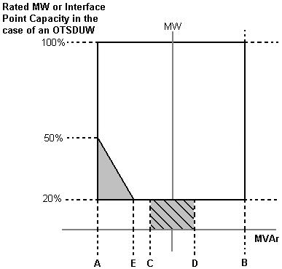

Figure 1

|  |  |
| --- | --- |
| Point A is equivalent (in MVAr) to | 0.95 leading Power Factor at Rated MW output or **Interface Point Capacity** in the case of **OTSDUW Plant and Apparatus** |
| Point B is equivalent (in MVAr) to: | 0.95 lagging Power Factor at Rated MW output or **Interface Point Capacity** in the case of **OTSDUW Plant and Apparatus** |
| Point C is equivalent (in MVAr) to: | -5% of Rated MW output or **Interface Point Capacity** in the case of **OTSDUW Plant and Apparatus** |
| Point D is equivalent (in MVAr) to: | +5% of Rated MW output or **Interface Point Capacity** in the case of **OTSDUW Plant and Apparatus** |
| Point E is equivalent (in MVAr) to: | -12% of Rated MW output or **Interface Point Capacity** in the case of **OTSDUW Plant and Apparatus** |

(d) All **Onshore Non-Synchronous Generating Units** and **Onshore Power Park Modules** in Scotland with a **Completion Date** after 1 April 2005 and before 1 January 2006 must be capable of supplying **Rated MW** at the range of power factors either:

(i) from 0.95 lead to 0.95 lag as illustrated in Figure 1 at the **User System Entry Point** for **Embedded GB Generators** or at the HV side of the 33/132kV or 33/275kV or 33/400kV transformer for **GB** **Generators** directly connected to the  **Onshore Transmission System**.With all **Plant** in service, the **Reactive Power** limits defined at **Rated** **MW** will apply at all **Active Power** output levels above 20% of the **Rated** **MW** output as defined in Figure 1. These **Reactive Power** limits will be reduced pro rata to the amount of **Plant** in service, or

(ii) from 0.95 lead to 0.90 lag at the **Onshore Non-Synchronous Generating Unit** (including **Power Park Unit**) terminals. For the avoidance of doubt **GB** **Generators** complying with this option (ii) are not required to comply with CC.6.3.2(b).

(e) The short circuit ratio of **Offshore Synchronous Generating Units** at a **Large Power Station** shall be not less than 0.5. At a **Large Power Station** all **Offshore Synchronous Generating Units**, **Offshore Non-Synchronous Generating Units**, **Offshore DC Converters** and **Offshore Power Park Modules** must be capable of maintaining:

(i) zero transfer of **Reactive Power** at the **Offshore Grid Entry Point** for all **GB Generators** with an **Offshore Grid Entry Point** at the **LV Side of the Offshore Platform** at all **Active Power** output levels under steady state voltage conditions. The steady state tolerance on **Reactive Power** transfer to and from an **Offshore Transmission System** expressed in MVAr shall be no greater than 5% of the **Rated MW**,or

(ii) a transfer of **Reactive Power** at the **Offshore Grid Entry Point** at a value specified in the **Bilateral Agreement** that will be equivalent to zero at the **LV Side of the Offshore Platform**.In addition,the steady state tolerance on **Reactive Power** transfer to and from an **Offshore Transmission System** expressed in MVAr at the **LV Side of the Offshore Platform** shall be no greater than 5% of the **Rated MW**, or

(iii) the **Reactive Power** capability (within associated steady state tolerance) specified in the **Bilateral Agreement** if any alternative has been agreed with the **GB** **Generator**, **Offshore Transmission Licensee** and **The Company**.

(f) In addition, a **Genset** shall meet the operational requirements as specified in BC2.A.2.6.

CC.6.3.3 Each **Generating Unit**, **DC Converter**(including an **OTSDUW DC Converter**), **Power Park Module** and/or **CCGT Module** must be capable of:

(a) continuously maintaining constant **Active Power** output for **System Frequency** changes within the range 50.5 to 49.5 Hz; and

(b) (subject to the provisions of CC.6.1.3) maintaining its **Active Power** output at a level not lower than the figure determined by the linear relationship shown in Figure 2 for **System Frequency** changes within the range 49.5 to 47 Hz, such that if the **System Frequency** drops to 47 Hz the **Active Power** output does not decrease by more than 5%. In the case of a **CCGT Module**, the above requirement shall be retained down to the **Low Frequency Relay** trip setting of 48.8 Hz, which reflects the first stage of the Automatic Low **Frequency Demand Disconnection** scheme notified to **Network Operators** under OC6.6.2. For **System Frequency** below that setting, the existing requirement shall be retained for a minimum period of 5 minutes while **System Frequency** remains below that setting, and special measure(s) that may be required to meet this requirement shall be kept in service during this period. After that 5 minutes period, if **System Frequency** remains below that setting, the special measure(s) must be discontinued if there is a materially increased risk of the **Gas Turbine** tripping. The need for special measure(s) is linked to the inherent **Gas Turbine Active Power** output reduction caused by reduced shaft speed due to falling **System Frequency**.

Figure 2

(c) For the avoidance of doubt in the case of a **Generating Unit** or **Power Park Module** (or **OTSDUW DC Converters** at the **Interface Point**)using an **Intermittent Power Source** where the mechanical power input will not be constant over time, the requirement is that the **Active Power** output shall be independent of **System Frequency** under (a) above and should not drop with **System Frequency** by greater than the amount specified in (b) above.

(d) A **DC Converter Station** must be capable of maintaining its **Active Power** input (i.e. when operating in a mode analogous to **Demand**) from the **National Electricity Transmission System** (or **User System** in the case of an **Embedded DC Converter Station**) at a level not greater than the figure determined by the linear relationship shown in Figure 3 for **System Frequency** changes within the range 49.5 to 47 Hz, such that if the **System Frequency** drops to 47.8 Hz the **Active Power** input decreases by more than 60%.



Figure 3

(e) At a **Large Power Station**, in the case of an **Offshore Generating Unit**, **Offshore Power Park Module**, **Offshore DC Converter** and **OTSDUW DC Converter**, the **GB** **Generator** shall comply with the requirements of CC.6.3.3. **GB** **Generators** should be aware that Section K of the **STC** places requirements on **Offshore Transmission Licensees** which utilise a **Transmission DC Converter** as part of their **Offshore Transmission System** to make appropriate provisions to enable **GB** **Generators** to fulfil their obligations.

(f) In the case of an **OTSDUW DC Converter** the **OTSDUW Plant and Apparatus** shall provide a continuous signal indicating the real time frequency measured at the **Interface Point** to the **Offshore Grid Entry Point**.

CC.6.3.4 At the **Grid Entry Point**, the **Active Power** output under steady state conditions of any **Generating Unit**, **DC Converter** or **Power Park Module** directly connected to the **National Electricity Transmission System** or in the case of **OTSDUW**, the **Active Power** transfer at the **Interface Point**, under steady state conditions of any **OTSDUW Plant and Apparatus** should not be affected by voltage changes in the normal operating range specified in paragraph CC.6.1.4 by more than the change in **Active Power** losses at reduced or increased voltage. In addition:

(a) For any **Onshore Generating Unit**, **Onshore DC Converter** and **Onshore Power Park Module** or **OTSDUW** the **Reactive Power** output under steady state conditions should be fully available within the voltage range ±5% at 400kV, 275kV and 132kV and lower voltages, except for an **Onshore** **Power Park Module** or **Onshore** **Non-Synchronous Generating Unit** if **Embedded** at 33kV and below (or directly connected to the **Onshore Transmission System** at 33kV and below) where the requirement shown in Figure 4 applies.

(b) At a **Large Power Station**, **in** the case of an **Offshore Generating Unit**, **Offshore DC Converter** and **Offshore Power Park Module** where an alternative reactive capability has been agreed with the **GB** **Generator**, as specified in CC.6.3.2(e) (iii), the voltage / **Reactive Power** requirement shall be specified in the **Bilateral Agreement**. The **Reactive Power** output under steady state conditions shall be fully available within the voltage range ±5% at 400kV, 275kV and 132kV and lower voltages.



Figure 4

CC.6.3.5 It is an essential requirement that the **National Electricity Transmission System** must incorporate a **Black Start Capability**. This will be achieved by agreeing a **Black Start** **Capability** at a number of strategically located **Power Stations**. For each **Power Station** **The Company** will state in the **Bilateral Agreement** whether or not a **Black Start** **Capability** is required.

Control Arrangements

CC.6.3.6 (a) Each:

(i) **Offshore Generating Unit** in a **Large Power Station** or **Onshore Generating Unit**; or,

(ii) **Onshore DC Converter** with a **Completion Date** on or after 1 April 2005 or **Offshore DC Converter** at a **Large Power Station**; or,

(iii) **Onshore Power Park Module** in England and Wales with a **Completion Date** on or after 1 January 2006; or,

(iv) **Onshore Power Park Module** in operation in Scotland on or after 1 January 2006 (with a **Completion Date** after 1 July 2004 and in a **Power Station** with a **Registered Capacity** of 50MW or more); or,

(v) **Offshore Power Park Module** in a **Large Power Station** with a **Registered Capacity** of 50MW or more;

must be capable of contributing to **Frequency** control by continuous modulation of **Active Power** supplied to the **National Electricity Transmission System** or the **User System** in which it is **Embedded**. For the avoidance of doubt each **OTSDUW DC Converter** shall provide each **GB Code** **User** in respect of its **Offshore** **Power** **Stations** connected to and/or using an **Offshore Transmission System** a continuous signal indicating the real time **Frequency** measured at the **Transmission** **Interface Point**.

(b) Each:

(i) **Onshore Generating Unit**; or,

(ii) **Onshore DC Converter** (with a **Completion Date** on or after 1 April 2005 excluding current source technologies); or

(iii) **Onshore Power Park Module** in England and Wales with a **Completion Date** on or after 1 January 2006; or,

(iv) **Onshore Power Park Module** in Scotland irrespective of **Completion Date**; or,

(v) **Offshore Generating Unit** at a **Large Power Station**, **Offshore DC Converter** at a **Large Power Station** or **Offshore Power Park Module** at a **Large Power Station** which provides a reactive range beyond the minimum requirements specified in CC.6.3.2(e) (iii); or,

(vi) **OTSDUW Plant and Apparatus** at a **Transmission Interface Point**

must be capable of contributing to voltage control by continuous changes to the **Reactive Power** supplied to the **National Electricity Transmission System** or the **User System** in which it is **Embedded**.

CC.6.3.7 (a) Each **Generating Unit**, **DC Converter** or **Power Park Module** (excluding **Onshore Power Park Modules** in Scotland with a **Completion Date** before 1 July 2004 or **Onshore Power Park Modules** in a **Power Station** in Scotland with a **Registered Capacity** less than 50MW or **Offshore Power Park Modules** in a **Large Power Station** located **Offshore** with a **Registered Capacity** less than 50MW) must be fitted with a fast acting proportional **Frequency** control device (or turbine speed governor) and unit load controller or equivalent control device to provide **Frequency** response under normal operational conditions in accordance with **Balancing Code 3** (**BC3**). In the case of a **Power Park Module** the **Frequency** or speed control device(s) may be on the **Power Park Module** or on each individual **Power Park Unit** or be a combination of both. The **Frequency** control device(s) (or speed governor(s)) must be designed and operated to the appropriate:

(i) **European Specification**; or

(ii) in the absence of a relevant **European Specification**, such other standard which is in common use within the European Community (which may include a manufacturer specification);

as at the time when the installation of which it forms part was designed or (in the case of modification or alteration to the **Frequency** control device (or turbine speed governor)) when the modification or alteration was designed.

The **European Specification** or other standard utilised in accordance with sub-paragraph CC.6.3.7 (a) (ii) will be notified to **The Company** by the **GB** **Generator** or **DC Converter Station** owner or, in the case of an **Embedded Medium Power Station** not subject to a **Bilateral Agreement** or **Embedded DC Converter Station** not subject to a **Bilateral Agreement**, the relevant **Network Operator**:

(i) as part of the application for a **Bilateral Agreement**;or

(ii)aspart of the application for a varied **Bilateral Agreement**; or

(iii) in the case of an **Embedded Development**, within 28 days of entry into the **Embedded Development Agreement** (or such later time as agreed with **The Company**); or

(iv)assoon as possible prior to any modification or alteration to the **Frequency** control device (or governor); and

(b) The **Frequency** control device (or speed governor) in co-ordination with other control devices must control the **Generating Unit**, **DC Converter** or **Power Park Module Active Power Output** with stability over the entire operating range of the **Generating Unit**, **DC Converter** or **Power Park Module**; and

(c) The **Frequency** control device (or speed governor) must meet the following minimum requirements:

(i) Where a **Generating Unit**, **DC Converter** or **Power Park Module** becomes isolated from the rest of the **Total System** but is still supplying **Customers**, the **Frequency** control device (or speed governor) must also be able to control **System** **Frequency** below 52Hz unless this causes the **Generating Unit**, **DC Converter** or **Power Park Module** to operate below its **Designed Minimum Operating Level** when it is possible that it may, as detailed in BC 3.7.3, trip after a time. For the avoidance of doubt the **Generating Unit**, **DC Converter** or **Power Park Module** is only required to operate within the **System Frequency** range 47 - 52 Hz as defined in CC.6.1.3;

(ii) the **Frequency** control device (or speed governor) must be capable of being set so that it operates with an overall speed **Droop** of between 3% and 5%. For the avoidance of doubt, in the case of a **Power Park Module** the speed **Droop** should be equivalent of a fixed setting between 3% and 5% applied to each **Power Park Unit** in service;

(iii) in the case of all **Generating Units**, **DC Converter** or **Power Park Module** other than the **Steam Unit** within a **CCGT Module** the **Frequency** control device (or speed governor) deadband should be no greater than 0.03Hz (for the avoidance of doubt, ±0.015Hz). In the case of the **Steam Unit** within a **CCGT Module**, the speed **Governor Deadband** should be set to an appropriate value consistent with the requirements of CC.6.3.7(c)(i) and the requirements of BC3.7.2 for the provision of **Limited High Frequency Response**;

For the avoidance of doubt, the minimum requirements in (ii) and (iii) for the provision of **System Ancillary Services** do not restrict the negotiation of **Commercial Ancillary Services** between **The Company** and the **GB Code** **User** using other parameters; and

(d) A facility to modify, so as to fulfil the requirements of the **Balancing** **Codes**, the **Target Frequency** setting either continuously or in a maximum of 0.05 Hz steps over at least the range 50 ±0.1 Hz should be provided in the unit load controller or equivalent device.

(e) (i) Each **Onshore** **Generating Unit** and/or **CCGT Module** which has a **Completion Date** after 1 January 2001 in England and Wales, and after 1 April 2005 in Scotland,must be capable of meeting the minimum **Frequency** response requirement profile subject to and in accordance with the provisions of Appendix 3.

(ii) Each **DC Converter** at a **DC Converter Station** which has a **Completion Date** on or after 1 April 2005 and each **Offshore DC Converter** at a **Large Power Station** must be capable of meeting the minimum **Frequency** response requirement profile subject to and in accordance with the provisions of Appendix 3.

(iii) Each **Onshore Power Park Module** in operation in England and Wales with a **Completion Date** on orafter 1 January 2006 must be capable of meeting the minimum **Frequency** response requirement profile subject to and in accordance with the provisions of Appendix 3.

(iv) Each **Onshore Power Park Module** in operation on orafter 1 January 2006 in Scotland (with a **Completion Date** on or after 1 April 2005 and a **Registered Capacity** of 50MW or more) must be capable of meeting the minimum **Frequency** response requirement profile subject to and in accordance with the provisions of Appendix 3.

(v) Each **Offshore Generating Unit** in a **Large Power Station** must be capable of meeting the minimum **Frequency** response requirement profile subject to and in accordance with the provisions of Appendix 3.

(vi) Each **Offshore Power Park Module** in a **Large Power Station** with a **Registered Capacity** of 50 MW or greater, must be capable of meeting the minimum **Frequency** response requirement profile subject to and in accordance with the provisions of Appendix 3.

(vii) Subject to the requirements of CC.6.3.7(e), **Offshore Generating Units** at a **Large Power Station**, **Offshore Power Park Modules** at a **Large Power Station** and **Offshore DC Converters** in a **Large Power Station** shall comply with the requirements of CC.6.3.7. **GB** **Generators** should be aware that Section K of the **STC** places requirements on **Offshore Transmission Licensees** which utilise a **Transmission DC Converter** as part of their **Offshore Transmission System** to make appropriate provisions to enable **GB** **Generators** to fulfil their obligations.

(viii) Each **OTSDUW DC Converter** must be capable of providing a continuous signal indicating the real time frequency measured at the **Interface Point** to the **Offshore Grid Entry Point**.

(f) For the avoidance of doubt, the requirements of Appendix 3 do not apply to:

(i) **Generating Units** and/or **CCGT Modules** which have a **Completion Date** before 1 January 2001 in England and Wales, and before 1 April 2005 in Scotland, for whom the remaining requirements of this clause CC.6.3.7 shall continue to apply unchanged: or

(ii) **DC Converters** at a **DC Converter Station** which have a **Completion Date** before 1 April 2005; or

(iii) **Onshore Power Park Modules** in England and Wales with a **Completion Date** before 1 January 2006 for whom only the requirements of **Limited Frequency Sensitive Mode** (BC3.5.2) operation shall apply; or

(iv) **Onshore Power Park Modules** in operation in Scotland before 1 January 2006 for whom only the requirements of **Limited Frequency Sensitive Mode** (BC3.5.2) operation shall apply; or

(v) **Onshore Power Park Modules** in operation after 1 January 2006 in Scotland which have a **Completion Date** before 1 April 2005 for whom the remaining requirements of this clause CC.6.3.7 shall continue to apply unchanged; or

(vi) **Offshore Power Park Modules** which are in a **Large Power Station** with a **Registered Capacity** less than 50MW for whom only the requirements of **Limited Frequency Sensitive Mode** (BC3.5.2) operation shall apply; or

Excitation and Voltage Control Performance Requirements

CC.6.3.8 (a) Excitation and voltage control performance requirements applicable to **Onshore Generating Units**, **Onshore Power Park Modules**, **Onshore DC Converters** and **OTSDUW Plant and Apparatus**.

(i) A continuously-acting automatic excitation control system is required to provide constant terminal voltage control of the **Onshore** **Synchronous Generating Unit** without instability over the entire operating range of the **Onshore** **Generating Unit**.

(ii) In respect of **Onshore** **Synchronous Generating Units** with a **Completion Date** before 1 January 2009, the requirements for excitation control facilities, including **Power System Stabilisers**, where in **The Company's** view these are necessary for system reasons, will be specified in the **Bilateral Agreement**. If any **Modification** to the excitation control facilities of such **Onshore** **Synchronous Generating Units** is made on or after 1 January 2009 the requirements that shall apply may be specified in the **Bilateral Agreement** as varied. To the extent that the **Bilateral Agreement** does not specify, the requirements given or referred to in CC.A.6 shall apply. The performance requirements for a continuously acting automatic excitation control system that shall be complied with by the **GB Code** **User** in respect of such **Onshore** **Synchronous Generating Units** with a **Completion Date** on or after 1 January 2009 are given or referred to in CC.A.6. Reference is made to on-load commissioning witnessed by **The Company** in BC2.11.2.

(iii) In the case of an **Onshore** **Non-Synchronous** **Generating Unit**, **Onshore DC Converter**, **Onshore Power Park Module** or **OTSDUW Plant and Apparatus** at the **Interface Point** a continuously-acting automatic control system is required to provide control of the voltage (or zero transfer of **Reactive Power** as applicable to CC.6.3.2) at the **Onshore** **Grid Entry Point** or **User System Entry Point** or in the case of **OTSDUW Plant and Apparatus at the Interface Point** without instability over the entire operating range of the **Onshore** **Non-Synchronous** **Generating Unit**, **Onshore DC Converter**, **Onshore Power Park Module** or **OTSDUW Plant and Apparatus**. Any **Plant** or **Apparatus** used in the provisions of such voltage control within an **Onshore** **Power Park Module** may be located at the **Power Park Unit** terminals, an appropriate intermediate busbar or the **Connection Point**. **OTSDUW Plant and Apparatus** used in the provision of such voltage control may be located at the **Offshore Grid Entry Point**, an appropriate intermediate busbar or at the **Interface Point**. In the case of an **Onshore** **Power Park Module** in Scotland with a **Completion Date** before 1 January 2009, voltage control may be at the **Power Park Unit** terminals, an appropriate intermediate busbar or the **Connection Point** as specified in the **Bilateral Agreement**. When operating below **20% Rated MW** the automatic control system may continue to provide voltage control utilising any available reactive capability. If voltage control is not being provided the automatic control system shall be designed to ensure a smooth transition between the shaded area bound by CD and the non shaded area bound by AB in Figure 1 of CC.6.3.2 (c).

(iv) The performance requirements for a continuously acting automatic voltage control system in respect of **Onshore** **Power Park Modules**, **Onshore** **Non-Synchronous Generating Units** and **Onshore** **DC Converters** with a **Completion Date** before 1 January 2009 will be specified in the **Bilateral Agreement**. If any **Modification** to the continuously acting automatic voltage control system of such **Onshore** **Power Park Modules**, **Onshore** **Non-Synchronous Generating Units** and **Onshore** **DC Converters** is made on or after 1 January 2009 the requirements that shall apply may be specified in the **Bilateral Agreement** as varied. To the extent that the **Bilateral Agreement** does not specify, the requirements given or referred to in CC.A.7 shall apply. The performance requirements for a continuously acting automatic voltage control system that shall be complied with by the **GB Code** **User** in respect of **Onshore** **Power Park Modules**, **Onshore** **Non-Synchronous Generating Units** and **Onshore** **DC Converters** or **OTSDUW Plant and Apparatus** at the **Interface Point** with a **Completion Date** on or after 1 January 2009 are given or referred to in CC.A.7.

(v) Unless otherwise required for testing in accordance with OC5.A.2, the automatic excitation control system of an **Onshore Synchronous Generating Unit** shall always be operated such that it controls the **Onshore Synchronous Generating Unit** terminal voltage to a value that is

* + - equal to its rated value; or
    - only where provisions have been made in the **Bilateral Agreement**, greater than its rated value.

(vi) In particular, other control facilities, including constant **Reactive Power** output control modes and constant **Power Factor** control modes (but excluding VAR limiters) are not required. However, if present in the excitation or voltage control system they will be disabled unless the **Bilateral Agreement** records otherwise. Operation of such control facilities will be in accordance with the provisions contained in **BC2**.

(b) Excitation and voltage control performance requirements applicable to **Offshore Generating Units** at a **Large Power Station**, **Offshore Power Park Modules** at a **Large Power Station** and **Offshore DC Converters** at a **Large Power Station**.

A continuously acting automatic control system is required to provide either:

(i) control of **Reactive Power** (as specified in CC.6.3.2(e) (i) (ii)) at the **Offshore Grid Entry Point** without instability over the entire operating range of the **Offshore Generating Unit**, **Offshore** **DC Converter** or **Offshore Power Park Module**. The performance requirements for this automatic control system will be specified in the **Bilateral Agreement** or;

(ii) where an alternative reactive capability has been specified in the **Bilateral Agreement**, in accordance with CC.6.3.2 (e) (iii), the **Offshore Generating Unit**, **Offshore Power Park Module** or **Offshore DC Converter** will be required to control voltage and / or **Reactive Power** without instability over the entire operating range of the **Offshore Generating Unit**, **Offshore Power Park Module** or **Offshore DC Converter**. The performance requirements of the control system will be specified in the **Bilateral Agreement**.

In addition to CC.6.3.8(b) (i) and (ii) the requirements for excitation control facilities, including **Power System Stabilisers**, where in **The Company’s** view these are necessary for system reasons, will be specified in the **Bilateral Agreement**. Reference is made to on-load commissioning witnessed by **The Company** in BC2.11.2.

Steady state Load Inaccuracies

CC.6.3.9 The standard deviation of **Load** error at steady state **Load** over a 30 minute period must not exceed 2.5 per cent of a **Genset’s Registered Capacity**.Where a **Genset** is instructed to **Frequency** sensitive operation, allowance will be made in determining whether there has been an error according to the governor droop characteristic registered under the **PC**.

For the avoidance of doubt in the case of a **Power Park Module** allowance will be made for the full variation of mechanical power output.

Negative Phase Sequence Loadings

CC.6.3.10 In addition to meeting the conditions specified in CC.6.1.5(b), each **Synchronous** **Generating Unit** will be required to withstand, without tripping, the negative phase sequence loading incurred by clearance of a close-up phase-to-phase fault, by **System** **Back-Up** **Protection** on the **National Electricity Transmission System** or **User** **System** located **Onshore** in which it is **Embedded**.

Neutral Earthing

CC.6.3.11 At nominal **System** voltages of 132kV and above the higher voltage windings of a transformer of a **Generating Unit**, **DC Converter**, **Power Park Module** or transformer resulting from **OTSDUW** must be star connected with the star point suitable for connection to earth. The earthing and lower voltage winding arrangement shall be such as to ensure that the **Earth Fault Factor** requirement of paragraph CC.6.2.1.1 (b) will be met on the **National Electricity Transmission System** at nominal **System** voltages of 132kV and above.

Frequency Sensitive Relays

CC.6.3.12 As stated in CC.6.1.3, the **System** **Frequency** could rise to 52Hz or fall to 47Hz. Each **Generating Unit**, **DC Converter**, **OTSDUW Plant and Apparatus**, **Power Park Module** or any constituent element must continue to operate within this **Frequency** range for at least the periods of time given in CC.6.1.3 unless **The Company** has agreed to any **Frequency**-level relays and/or rate-of-change-of-**Frequency** relays which will trip such **Generating Unit**, **DC Converter**, **OTSDUW Plant and Apparatus**, **Power Park Module** and any constituent element within this **Frequency** range, under the **Bilateral Agreement**.

CC.6.3.13 **GB** **Generators** (including in respect of **OTSDUW Plant and Apparatus**) and **DC Converter Station** owners will be responsible for protecting all their **Generating Units**(and **OTSDUW Plant and Apparatus**), **DC Converters** or **Power Park Modules** against damage should **Frequency** excursions outside the range 52Hz to 47Hz ever occur. Should such excursions occur, it is up to the **GB** **Generator** or **DC Converter Station** owner to decide whether to disconnect his **Apparatus** for reasons of safety of **Apparatus**, **Plant** and/or personnel.

CC.6.3.14 It may be agreed in the **Bilateral Agreement** that a **Genset** shall have a **Fast-Start Capability**. Such **Gensets** may be used for **Operating Reserve** and their **Start-Up** may be initiated by **Frequency**-level relays with settings in the range 49Hz to 50Hz as specified pursuant to **OC2**.

CC.6.3.15 Fault Ride Through

This section sets out the fault ride through requirements on **Generating Units**, **Power Park Modules**, **DC Converters** and **OTSDUW Plant and Apparatus**. **Onshore Generating Units**, **Onshore Power Park Modules**, **Onshore DC Converters** (including **Embedded Medium Power Stations** and **Embedded DC Converter Stations** not subject to a **Bilateral Agreement** and with an **Onshore User System Entry Point** (irrespective of whether they are located **Onshore** or **Offshore**))and **OTSDUW Plant and Apparatus** are required to operate through **System** faults and disturbances as defined in CC.6.3.15.1 (a), CC.6.3.15.1 (b) and CC.6.3.15.3. **Offshore GB Generators** in respect of **Offshore Generating Units** at a **Large Power Station**, **Offshore Power Park Modules** at a **Large Power Station** and **DC Converter Station** owners in respect of **Offshore DC Converters** at a **Large Power Station** shall have the option of meeting either:

(i) CC.6.3.15.1 (a), CC.6.3.15.1 (b) and CC.6.3.15.3, or:

(ii) CC.6.3.15.2 (a), CC.6.3.15.2 (b) and CC.6.3.15.3

**Offshore GB Generators** and **Offshore DC Converter** owners, should notify **The Company** which option they wish to select within 28 days (or such longer period as **The Company** may agree, in any event this being no later than 3 months before the **Completion Date** of the offer for a final **CUSC Contract** which would be made following the appointment of the **Offshore Transmission Licensee**).

CC.6.3.15.1 Fault Ride through applicable to **Generating Units**, **Power Park Modules** and **DC Converters** and **OTSDUW Plant and Apparatus**

(a) Short circuit faults on the **Onshore Transmission System** (which may include an **Interface Point**) at **Supergrid Voltage** up to 140ms in duration.

(i) Each **Generating Unit**, **DC Converter**, or **Power Park Module** and any constituent **Power Park Unit** thereof and **OTSDUW Plant and Apparatus** shall remain transiently stable and connected to the **System** without tripping of any **Generating Unit**, **DC Converter** or **Power Park Module** and / or any constituent **Power Park Unit,** **OTSDUW Plant and Apparatus**, and for **Plant and Apparatus** installed on or after 1 December 2017, reactive compensation equipment, for a close-up solid three-phase short circuit fault or any unbalanced short circuit fault on the **Onshore Transmission System**(including in respect of **OTSDUW Plant and Apparatus**, the **Interface Point**)operating at **Supergrid Voltages** for a total fault clearance time of up to 140 ms. A solid three-phase or unbalanced earthed fault results in zero voltage on the faulted phase(s) at the point of fault. The duration of zero voltage is dependent on local **Protection** and circuit breaker operating times. This duration and the fault clearance times will be specified in the **Bilateral Agreement**. Following fault clearance, recovery of the **Supergrid Voltage** on the **Onshore Transmission System** to 90% may take longer than 140ms as illustrated in Appendix 4A Figures CC.A.4A.1 (a) and (b). It should be noted that in the case of an **Offshore Generating Unit**, **Offshore DC Converter** or **Offshore Power Park Module** (including any **Offshore Power Park Unit** thereof) which is connected to an **Offshore Transmission System** which includes a **Transmission DC Converter** as part of that **Offshore Transmission System**, the **Offshore Grid Entry Point** voltage may not indicate the presence of a fault on the **Onshore Transmission System**. The fault will affect the level of **Active Power** that can be transferred to the **Onshore Transmission System** and therefore subject the **Offshore Generating Unit**, **Offshore DC Converter** or **Offshore Power Park Module** (including any **Offshore Power Park Unit** thereof) to a load rejection.

(ii) Each **Generating Unit**, **Power Park Module** and **OTSDUW Plant and Apparatus**, shall be designed such that upon both clearance of the fault on the **Onshore Transmission System** as detailed in CC.6.3.15.1 (a) (i) and within 0.5 seconds of the restoration of the voltage at the **Onshore Grid Entry Point** (for **Onshore Generating Units** or **Onshore Power Park Modules**)or **Interface Point** (for **Offshore Generating Units**, **Offshore Power Park Modules** or **OTSDUW Plant and Apparatus**) to the minimum levels specified in CC.6.1.4 (or within 0.5 seconds of restoration of the voltage at the **User System Entry** **Point** to 90% of nominal or greater if **Embedded**), **Active Power** output or in the case of **OTSDUW Plant and Apparatus**, **Active Power** transfer capability, shall be restored to at least 90% of the level available immediately before the fault. Once the **Active Power** output, or in the case of **OTSDUW Plant and Apparatus**, **Active Power** transfer capability, has been restored to the required level, **Active Power** oscillations shall be acceptable provided that:

- the total **Active Energy** delivered during the period of the oscillations is at least that which would have been delivered if the **Active Power** was constant

- the oscillations are adequately damped

During the period of the fault as detailed in CC.6.3.15.1 (a) (i) for which the voltage at the **Grid Entry Point** (or **Interface Point** in the case of **OTSDUW Plant and Apparatus**) is outside the limits specified in CC.6.1.4, each **Generating Unit** or **Power Park Module**or **OTSDUW Plant and Apparatus** shall generate maximum reactive current without exceeding the transient rating limit of the **Generating Unit**, **OTSDUW Plant and Apparatus** or **Power Park Module** and / or any constituent **Power Park Unit** orreactive compensation equipment. For **Plant and Apparatus** installed on or after 1 December 2017, switched reactive compensation equipment(such as mechanically switched capacitors and reactors)shall be controlled such that it is not switched in or out of serviceduring the fault but may act to assist in post fault voltage recovery.

(iii) Each **DC Converter** shall be designed to meet the **Active Power** recovery characteristics (and **OTSDUW DC Converter** shall be designed to meet the **Active Power** transfer capability at the **Interface Point**) as specified in the **Bilateral Agreement** upon clearance of the fault on the **Onshore Transmission System** as detailed in CC.6.3.15.1 (a) (i).

(b) **Supergrid Voltage** dips on the **Onshore Transmission System** greater than 140ms in duration

(1b) Requirements applicable to **Synchronous Generating Units** subject to **Supergrid Voltage** dips on the **Onshore Transmission System** greater than 140ms in duration.

In addition to the requirements of CC.6.3.15.1 (a) each **Synchronous** **Generating Unit**, each with a **Completion Date** on or after **1 April 2005** shall:

(i) remain transiently stable and connected to the **System** without tripping of any **Synchronous** **Generating Unit** forbalanced **Supergrid Voltage** dips and associated durations on the **Onshore Transmission System** (which could be at the **Interface Point**) anywhere on or above the heavy black line shown in Figure 5a. Appendix 4A and Figures CC.A.4A.3.2 (a), (b) and (c) provide an explanation and illustrations of Figure 5a; and,

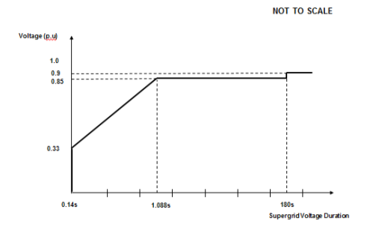

Figure 5a

(ii) provide **Active Power** output at the **Grid Entry Point**, during **Supergrid Voltage** dips on the **Onshore Transmission System** as described in Figure 5a, at least in proportion to the retained balanced voltage at the **Onshore Grid Entry Point** (for **Onshore Synchronous Generating Units)** or **Interface Point** (for **Offshore Synchronous Generating Units)** (or theretained balanced voltage at the **User System Entry Point** if **Embedded**) and shall generate maximum reactive current (where the voltage at the **Grid Entry Point** is outside the limits specified in CC.6.1.4) without exceeding the transient rating limits of the **Synchronous** **Generating Unit** and,

(iii) restore **Active Power** output following **Supergrid Voltage** dips on the **Onshore Transmission System** as described in Figure 5a, within 1 second of restoration ofthevoltage to 1.0p.u of the nominal voltage at the:

**Onshore** **Grid Entry Point** for directly connected **Onshore** **Synchronous** **Generating** **Units** or,

**Interface Point** for **Offshore Synchronous Generating Units or**,

**User** **System** **Entry Point** for **Embedded Onshore Synchronous Generating Units** or,

**User** **System** **Entry Point** for **Embedded Medium Power Stations** not subject to a **Bilateral Agreement** which comprise **Synchronous Generating Units** andwith an **Onshore User System Entry Point** (irrespective of whether they are located **Onshore** or **Offshore**)

to at least 90% of the level available immediately before the occurrence of the dip. Once the **Active Power** output has been restored to the required level, **Active Power** oscillations shall be acceptable provided that:

- the total **Active Energy** delivered during the period of the oscillations is at least that which would have been delivered if the **Active Power** was constant

- the oscillations are adequately damped.

For the avoidance of doubt a balanced **Onshore Transmission System Supergrid Voltage** meets the requirements of CC.6.1.5 (b) and CC.6.1.6.

(2b) Requirements applicable to **OTSDUW Plant and Apparatus** and **Power Park Modules** subject to **Supergrid Voltage** dips on the **Onshore Transmission System** greater than 140ms in duration

In addition to the requirements of CC.6.3.15.1 (a) each **OTSDUW Plant and Apparatus** or each **Power Park Module** and / or any constituent **Power Park Unit**, each with a **Completion Date** on or after the 1 April 2005 shall:

(i) remain transiently stable and connected to the **System** without tripping of any  **OTSDUW Plant and Apparatus**, or **Power Park Module** and / or any constituent **Power Park Unit**, for balanced **Supergrid Voltage** dips and associated durations on the **Onshore Transmission System** (which could be at the **Interface Point**) anywhere on or above the heavy black line shown in Figure 5b. Appendix 4A and Figures CC.A.4A.3.4 (a), (b) and (c) provide an explanation and illustrations of Figure 5b; and,



Figure 5b

(ii) provide **Active Power** output at the **Grid Entry Point** or in the case of an **OTSDUW**, **Active Power** transfer capability at the **Transmission Interface Point**, during **Supergrid Voltage** dips on the **Onshore Transmission System** as described in Figure 5b, at least in proportion to the retained balanced voltage at the **Onshore Grid Entry Point** (for **Onshore Power Park Modules**) or **Interface Point** (for**OTSDUW Plant and Apparatus** and **Offshore Power Park Modules**) (or theretained balanced voltage at the **User System Entry Point** if **Embedded**)except in the case of a **Non-Synchronous Generating Unit** or**OTSDUW Plant and Apparatus** or **Power Park Module** where there has been a reduction in the **Intermittent Power Source** or in the case of **OTSDUW Active Power** transfer capability in the time range in Figure 5b that restricts the **Active Power** output or in the case of an **OTSDUW Active Power** transfer capability below this level and shall generate maximum reactive current (where the voltage at the **Grid Entry Point**, or in the case of an **OTSDUW Plant and Apparatus**, the **Interface Point** voltage,is outside the limits specified in CC.6.1.4) without exceeding the transient rating limits of the **OTSDUW Plant and Apparatus** or **Power Park Module** and any constituent **Power Park Unit**; and,

(iii) restore **Active Power** output (or, in the case of **OTSDUW**, **Active Power** transfer capability), following **Supergrid Voltage** dips on the **Onshore Transmission System** as described in Figure 5b, within 1 second of restoration ofthevoltage at the:

**Onshore** **Grid Entry Point** for directly connected **Onshore** **Power Park Modules** or,

**Interface Point** for **OTSDUW Plant and Apparatus** and **Offshore Power Park Modules** or,

**User** **System** **Entry Point** for **Embedded Onshore Power Park Modules** or,

**User** **System** **Entry Point** for **Embedded Medium Power Stations** which comprise **Power Park Modules** not subject to a **Bilateral Agreement** and with an **Onshore** **User** **System Entry Point** (irrespective of whether they are located **Onshore** or **Offshore**)

to the minimum levels specified in CC.6.1.4 to at least 90% of the level available immediately before the occurrence of the dip except in the case of a **Non-Synchronous Generating Unit**, **OTSDUW Plant and Apparatus** or **Power Park Module** where there has been a reduction in the **Intermittent Power Source** in the time range in Figure 5b that restricts the **Active Power** output or, in the case of **OTSDUW**, **Active Power** transfer capability below this level. Once the **Active Power** output or, in the case of **OTSDUW**, **Active Power** transfer capability has been restored to the required level, **Active Power** oscillations shall be acceptable provided that:

- the total **Active Energy** delivered during the period of the oscillations is at least that which would have been delivered if the **Active Power** was constant

- the oscillations are adequately damped.

For the avoidance of doubt a balanced **Onshore Transmission System Supergrid Voltage** meets the requirements of CC.6.1.5 (b) and CC.6.1.6.

CC.6.3.15.2 Fault Ride Through applicable to **Offshore Generating Units** at a **Large Power Station**, **Offshore Power Park Modules** at a **Large Power Station** and **Offshore DC Converters** at a **Large Power Station** who choose to meet the fault ride through requirements at the **LV** **side of the Offshore Platform**

(a) Requirements on **Offshore Generating Units**, **Offshore Power Park Modules** and **Offshore DC Converters** to withstand voltage dips on the **LV Side of the Offshore Platform** for up to 140ms in duration as a result of faults and / or voltage dips on the **Onshore Transmission System** operating at **Supergrid** **Voltage**

(i) Each **Offshore Generating Unit**, **Offshore DC Converter**, or **Offshore Power Park Module** and any constituent **Power Park Unit** thereof shall remain transiently stable and connected to the **System** without tripping of any **Offshore Generating Unit**, or **Offshore DC Converter** or **Offshore Power Park Module** and / or any constituent **Power Park Unit** or, in the case of **Plant and Apparatus** installed on or after 1 December 2017, reactive compensation equipment, for any balanced or unbalanced voltage dips on the **LV Side of the Offshore Platform** whose profile is anywhere on or above the heavy black line shown in Figure 6. For the avoidance of doubt, the profile beyond 140ms in Figure 6 shows the minimum recovery in voltage that will be seen by the generator following clearance of the fault at 140ms. Appendix 4B and Figures CC.A.4B.2 (a) and (b) provide further illustration of the voltage recovery profile that may be seen. It should be noted that in the case of an **Offshore Generating Unit**, **Offshore DC Converter** or **Offshore Power Park Module** (including any **Offshore Power Park Unit** thereof) which is connected to an **Offshore Transmission System** which includes a **Transmission DC Converter** as part of that **Offshore Transmission System**, the **Offshore Grid Entry Point** voltage may not indicate the presence of a fault on the **Onshore Transmission System**. The voltage dip will affect the level of **Active Power** that can be transferred to the **Onshore Transmission System** and therefore subject the **Offshore Generating Unit**, **Offshore DC Converter** or **Offshore Power Park Module** (including any **Offshore Power Park Unit** thereof) to a load rejection.

V/VN(%)

100%

94%

60%

15%

0

140ms

500ms

Time

Figure 6

V/VN is the ratio of the actual voltage on one or more phases at the **LV Side of the** **Offshore Platform** to the nominal voltage of the **LV Side of the** **Offshore Platform**.

(ii) Each **Offshore Generating Unit**, or **Offshore Power Park Module** and any constituent **Power Park Unit** thereof shall provide **Active Power** output, during voltage dips on the **LV Side of the** **Offshore Platform** as described in Figure 6, at least in proportion to the retained voltage at the **LV Side of the Offshore Platform** except in the case of an **Offshore** **Non-Synchronous Generating Unit** or **Offshore Power Park Module**  where there has been a reduction in the **Intermittent Power Source** in the time range in Figure 6 that restricts the **Active Power** output below this level and shall generate maximum reactive current without exceeding the transient rating limits of the **Offshore Generating Unit** or **Offshore Power Park Module** and any constituent **Power Park Unit** or, in the case of **Plant and Apparatus** installed on or after 1 December 2017, reactive compensation equipment. Once the **Active Power** output has been restored to the required level, **Active Power** oscillations shall be acceptable provided that:

- the total **Active Energy** delivered during the period of the oscillations is at least that which would have been delivered if the **Active Power** was constant

- the oscillations are adequately damped

and;

(iii) Each **Offshore** **DC Converter** shall be designed to meet the **Active Power** recovery characteristics as specified in the **Bilateral Agreement** upon restoration of the voltage at the **LV Side of the** **Offshore Platform**.

(b) Requirements of **Offshore Generating Units**, **Offshore Power Park Modules**, to withstand voltage dips on the **LV Side of the Offshore Platform** greater than 140ms in duration.

(1b) Requirements applicable to **Offshore Synchronous Generating Units** to withstand voltage dips on the **LV Side of the** **Offshore Platform** greater than 140ms in duration.

In addition to the requirements of CC.6.3.15.2. (a) each **Offshore Synchronous Generating Unit** shall:

(i) remain transiently stable and connected to the **System** without tripping of any **Offshore Synchronous Generating Unit** for any balanced voltage dips on the **LV side of the** **Offshore Platform** and associated durations anywhere on or above the heavy black line shown in Figure 7a. Appendix 4B and Figures CC.A.4B.3.2 (a), (b) and (c) provide an explanation and illustrations of Figure 7a. It should be noted that in the case of an **Offshore Synchronous Generating Unit** which is connected to an **Offshore Transmission System** which includes a **Transmission** **DC Converter** as part of that **Offshore Transmission System**, the **Offshore Grid Entry Point** voltage may not indicate the presence of a voltage dip on the **Onshore Transmission System**. The voltage dip will affect the level of **Active Power** that can be transferred to the **Onshore Transmission System** and therefore subject the **Offshore Generating Unit**, to a load rejection.

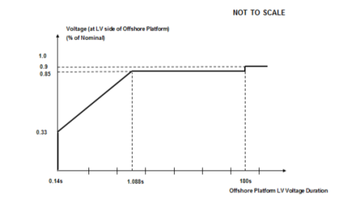

(ii) provide **Active Power** output, during voltage dips on the **LV Side of the Offshore Platform** as described in Figure 7a, at least in proportion to the retained balanced or unbalanced voltage at the **LV Side of the Offshore Platform** and shall generate maximum reactive current (where the voltage at the **Offshore Grid Entry Point** is outside the limits specified in CC.6.1.4) without exceeding the transient rating limits of the **Offshore Synchronous Generating Unit** and,

(iii) within 1 second of restoration of the voltage to 1.0p.u of the nominal voltage at the **LV Side of the** **Offshore Platform**, restore **Active Power** to at least 90% of the **Offshore Synchronous Generating Unit's** immediate pre-disturbed value, unless there has been a reduction in the **Intermittent Power Source** in the time range in Figure 7a that restricts the **Active Power** output below this level. Once the **Active Power** output has been restored to the required level, **Active Power** oscillations shall be acceptable provided that:

- the total **Active Energy** delivered during the period of the oscillations is at least that which would have been delivered if the **Active Power** was constant

- the oscillations are adequately damped

(2b) Requirements applicable to **Offshore Power Park Modules** to withstand voltage dips on the **LV Side of the** **Offshore Platform** greater than 140ms in duration.

In addition to the requirements of CC.6.3.15.2. (a) each **Offshore Power Park Module** and / or any constituent **Power Park Unit**, shall:

(i) remain transiently stable and connected to the **System** without tripping of any **Offshore Power Park Module** and / or any constituent **Power Park Unit**, for any balanced voltage dips on the **LV side of the** **Offshore Platform** and associated durations anywhere on or above the heavy black line shown in Figure 7b. Appendix 4B and Figures CC.A.4B.5. (a), (b) and (c) provide an explanation and illustrations of Figure 7b. It should be noted that in the case of an **Offshore Power Park Module** (including any **Offshore Power Park Unit** thereof) which is connected to an **Offshore Transmission System** which includes a **Transmission** **DC Converter** as part of that **Offshore Transmission System**, the **Offshore Grid Entry Point** voltage may not indicate the presence of a voltage dip on the **Onshore Transmission System**. The voltage dip will affect the level of **Active Power** that can be transferred to the **Onshore Transmission System** and therefore subject the **Offshore Power Park Module** (including any **Offshore Power Park Unit** thereof) to a load rejection.



Figure 7b

(ii) provide **Active Power** output, during voltage dips on the **LV Side of the Offshore Platform** as described in Figure 7b, at least in proportion to the retained balanced or unbalanced voltage at the **LV Side of the Offshore Platform** except in the case of an **Offshore** **Non-Synchronous Generating Unit** or **Offshore Power Park Module** where there has been a reduction in the **Intermittent Power Source** in the time range in Figure 7b that restricts the **Active Power** output below this level and shall generate maximum reactive current (where the voltage at the **Offshore Grid Entry Point** is outside the limits specified in CC.6.1.4) without exceeding the transient rating limits of the **Offshore Power Park Module** and any constituent **Power Park Unit** orreactive compensation equipment. For **Plant and Apparatus** installed on or after 1 December 2017, switched reactive compensation equipment(such as mechanically switched capacitors and reactors)shall be controlled such that it is not switched in or out of serviceduring the fault but may act to assist in post fault voltage recovery; and,

(iii) within 1 second of the restoration of the voltage at the **LV Side of the** **Offshore Platform** (to the minimum levels specified in CC.6.1.4) restore **Active Power** to at least 90% of the **Offshore Power Park Module's** immediate pre-disturbed value, unless there has been a reduction in the **Intermittent Power Source** in the time range in Figure 7b that restricts the **Active Power** output below this level. Once the **Active Power** output has been restored to the required level, **Active Power** oscillations shall be acceptable provided that:

- the total **Active Energy** delivered during the period of the oscillations is at least that which would have been delivered if the **Active Power** was constant

- the oscillations are adequately damped

CC.6.3.15.3 Other Requirements

(i) In the case of a **Power Park Module** (comprising of wind-turbine generator units), the requirements in CC.6.3.15.1 and CC.6.3.15.2 do not apply when the **Power Park Module** is operating at less than 5% of its **Rated MW** or during very high wind speed conditions when more than 50% of the wind turbine generator units in a **Power Park Module** have been shut down or disconnected under an emergency shutdown sequence to protect **GB Code**  **User’s Plant** and **Apparatus**.

(ii) In addition to meeting the conditions specified in CC.6.1.5(b) and CC.6.1.6, each **Non-Synchronous** **Generating Unit**, **OTSDUW Plant and Apparatus** or **Power Park Module** with a **Completion Date** after 1 April 2005and any constituent **Power Park Unit** thereof will be required to withstand, without tripping, the negative phase sequence loading incurred by clearance of a close-up phase-to-phase fault, by **System** **Back-Up** **Protection** on the **Onshore Transmission System** operating at **Supergrid Voltage**.

(iii) In the case of an **Onshore** **Power Park Module** in Scotland with a **Completion Date** before 1 January 2004 and a **Registered Capacity** less than 30MW the requirements in CC.6.3.15.1 (a) do not apply. In the case of an **Onshore** **Power Park Module** in Scotland with a **Completion Date** on or after 1 January 2004 and before 1 July 2005 and a **Registered Capacity** less than 30MW the requirements in CC.6.3.15.1 (a) are relaxed from the minimum **Onshore Transmission System Supergrid Voltage** of zero to a minimum **Onshore Transmission System Supergrid Voltage** of 15% of nominal. In the case of an **Onshore** **Power Park Module** in Scotland with a **Completion Date** before 1 January 2004 and a **Registered Capacity** of 30MW and above the requirements in CC.6.3.15.1 (a) are relaxed from the minimum **Onshore Transmission System Supergrid Voltage** of zero to a minimum **Onshore Transmission System Supergrid Voltage** of 15% of nominal.

(iv) To avoid unwanted island operation, **Non-Synchronous Generating Units** inScotland (and those directly connected to a **Scottish Offshore Transmission System**), **Power Park Modules** in Scotland (and those directly connected to a **Scottish Offshore Transmission System**), or **OTSDUW Plant and Apparatus** with an **Interface Point** in Scotlandshall be tripped for the following conditions:

(1) **Frequency** above 52Hz for more than 2 seconds

(2) **Frequency** below 47Hz for more than 2 seconds

(3) Voltage as measured at the **Onshore** **Connection Point** or **Onshore** **User System Entry Point** or **Offshore Grid Entry Point** or **Interface Point** in the case of **OTSDUW Plant and Apparatus** is below 80% for more than 2.5 seconds

(4) Voltage as measured at the **Onshore** **Connection Point** or **Onshore** **User System Entry Point** or **Offshore Grid Entry Point** or **Interface Point** in the case of **OTSDUW Plant and Apparatus** is above 120% (115% for 275kV) for more than 1 second.

The times in sections (1) and (2) are maximum trip times. Shorter times may be used to protect the **Non-Synchronous Generating Units**,or **OTSDUW Plant and Apparatus** or **Power Park Modules**.

Additional Damping Control Facilities for DC Converters

CC.6.3.16 (a) **DC Converter** owners, or **GB** **Generators** in respect of **OTSDUW DC Converters** or **Network Operators** in the case of an **Embedded DC Converter Station** not subject to a **Bilateral Agreement** must ensure that any of their **Onshore DC Converters** or **OTSDUW DC Converters** will not cause a sub-synchronous resonance problem on the **Total** **System**. Each **DC Converter** or **OTSDUW DC Converter** is required to be provided with sub-synchronous resonance damping control facilities.

(b) Where specified in the **Bilateral Agreement**, each **DC Converter**or **OTSDUW DC Converter** is required to be provided with power oscillation damping or any other identified additional control facilities.

System to Generator Operational Intertripping Scheme

CC.6.3.17 **The Company** may require that a **System to Generator Operational Intertripping Scheme** be installed as part of a condition of the connection of the **GB** **Generator**. Scheme specific details shall be included in the relevant **Bilateral Agreement** and shall, in respect of **Bilateral Agreements** entered into on or after 16th March 2009 include the following information:

(1) the relevant category(ies) of the scheme (referred to as Category 1 Intertripping Scheme, Category 2 Intertripping Scheme, Category 3 Intertripping Scheme and Category 4 Intertripping Scheme);

(2) the **Generating Unit(s)** or **CCGT Module(**s) or **Power Park Module(s)** to be either permanently armed or that can be instructed to be armed in accordance with BC2.8;

(3) the time within which the **Generating Unit(s)** or **CCGT Module(s)** or **Power Park Module(s)** circuit breaker(s) are to be automatically tripped;

(4) the location to which the trip signal will be provided by **The Company**. Such location will be provided by **The Company** prior to the commissioning of the **Generating Unit(s)** or **CCGT Module(s)** or **Power Park Module(s)**.

Where applicable, the **Bilateral Agreement** shall include the conditions on the **National Electricity Transmission System** during which **The Company** may instruct the **System to Generator Operational Intertripping Scheme** to be armed and the conditions that would initiate a trip signal.

CC.6.3.18 The time within which the **Generating Unit(s)** or **CCGT Module** or **Power Park Module** circuit breaker(s) need to be automatically tripped is determined by the specific conditions local to the **GB** **Generator**. This ‘time to trip’ (defined as time from provision of the trip signal by **The Company** to the specified location, to circuit breaker main contact opening) can typically range from 100ms to 10sec. A longer time to trip may allow the initiation of an automatic reduction in the **Generating Unit(s)** or **CCGT Module(s)** or **Power Park Module(s)** output prior to the automatic tripping of the **Generating Unit(s)** or **CCGT Module(s)** or **Power Park Module(s)** circuit breaker. Where applicable **The Company** may provide separate trip signals to allow for either a longer or shorter ‘time to trip’ to be initiated.

CC.6.4 General Network Operator And Non-Embedded Customer Requirements

CC.6.4.1 This part of the **Grid Code** describes the technical and design criteria and performance requirements for **Network Operators** and **Non-Embedded Customers**.

Neutral Earthing

CC.6.4.2 At nominal **System** voltages of 132kV and above the higher voltage windings of three phase transformers and transformer banks connected to the **National Electricity Transmission System** must be star connected with the star point suitable for connection to earth. The earthing and lower voltage winding arrangement shall be such as to ensure that the **Earth Fault Factor** requirement of paragraph CC.6.2.1.1 (b) will be met on the **National Electricity Transmission System** at nominal **System** voltages of 132kV and above.

Frequency Sensitive Relays

CC.6.4.3 As explained under **OC6**, each **Network Operator**, will make arrangements that will facilitate automatic low **Frequency** **Disconnection** of **Demand** (based on **Annual ACS Conditions**). CC.A.5.5. of Appendix 5 includes specifications of the local percentage **Demand** that shall be disconnected at specific frequencies. The manner in which **Demand** subject to low **Frequency** disconnection will be split into discrete MW blocks is specified in OC6.6. Technical requirements relating to **Low Frequency Relays** are also listed in Appendix 5.

Operational Metering

CC.6.4.4 Where **The Company** can reasonably demonstrate that an **Embedded Medium Power Station** or **Embedded DC Converter Station** has a significant effect on the **National Electricity Transmission System**, it may require the **Network Operator** within whose **System** the **Embedded Medium Power Station or** **Embedded DC Converter Station** is situated to ensure that the operational metering equipment described in CC.6.5.6 is installed such that **The Company** can receive the data referred to in CC.6.5.6. In the case of an **Embedded Medium Power** **Station** subject to, or proposed to be subject to a **Bilateral Agreement The Company** shall notify such **Network Operator** of the details of such installation in writing within 3 months of being notified of the application to connect under **CUSC** and in the case of an **Embedded Medium Power Station** not subject to, or not proposed to be subject to a **Bilateral Agreement** in writing as a **Site Specific Requirement** in accordance with the timescales in CUSC6.5.5. In either case the **Network Operator** shall ensure that the data referred to in CC.6.5.6 is provided to **The Company**.

CC.6.5 Communications Plant

CC.6.5.1 In order to ensure control of the **National Electricity Transmission System**, telecommunications between **GB Code** **Users** and **The Company** must (including in respect of any **OTSDUW Plant and Apparatus** at the **OTSUA Transfer Time**), if required by **The Company**, be established in accordance with the requirements set down below.

CC.6.5.2 Control Telephony and System Telephony

CC.6.5.2.1 **Control Telephony** is the principle method by which a **User's Responsible Engineer/Operator** and **The Company’s Control Engineers** speak to one another for the purposes of control of the **Total System** in both normal and emergency operating conditions. **Control Telephony** provides secure point to point telephony for routine **Control Calls**, priority **Control Calls** and emergency **Control Calls**.

CC.6.5.2.2 **System Telephony** is an alternate method by which a **User's Responsible Engineer/Operator** and **The Company’s Control Engineers** speak to one another for the purposes of control of the **Total System** in both normal operating conditions and where practicable, emergency operating conditions. **System Telephony** uses the Public Switched Telephony Network to provide telephony for **Control Calls**, inclusive of emergency **Control Calls**.

CC.6.5.2.3 Calls made and received over **Control Telephony** and **System Telephony** may be recorded and subsequently replayed for commercial and operational reasons.

CC.6.5.3 Supervisory Tones

CC.6.5.3.1 **Control Telephony** supervisory tones indicate to the calling and receiving parties dial, engaged, ringing, secondary engaged (signifying that priority may be exercised) and priority disconnect tones.

CC.6.5.3.2 **System Telephony** supervisory tones indicate to the calling and receiving parties dial, engaged and ringing tones.

CC.6.5.4 Obligations in respect of Control Telephony and System Telephony

CC.6.5.4.1 Where **The Company** requires **Control Telephony**, **Users** are required to use the **Control Telephony** with **The Company** in respect of all **Connection Points** with the **National Electricity Transmission System** and in respect of all **Embedded** **Large Power Stations** and **Embedded DC Converter Stations**. **The Company** will have **Control Telephony** installed at the **GB Code** **User’s Control Point** where the **GB Code** **User’s** telephony equipment is not capable of providing the required facilities or is otherwise incompatible with the **Transmission** **Control Telephony**. Details of and relating to the **Control Telephony** required are contained in the **Bilateral Agreement**.

CC.6.5.4.2 Where in **The Company’s** sole opinion the installation of **Control Telephony** is not practicable at a **GB Code** **User’s Control Point(s)**, **The Company** shall specify in the **Bilateral Agreement** whether **System Telephony** is required. Where **System Telephony** is required by **The Company**, the **GB Code** **User** shall ensure that **System Telephony** is installed.

CC.6.5.4.3 Where **System Telephony** is installed, **GB Code** **Users** are required to use the **System Telephony** with **The Company** in respect of those **Control Point(s)** for which it has been installed. Details of and relating to the **System Telephony** required are contained in the **Bilateral Agreement**.

CC.6.5.4.4 Where **Control Telephony** or **System Telephony** is installed, routine testing of such facilities may be required by **The Company** (not normally more than once in any calendar month). The **GB Code** **User** and **The Company** shall use reasonable endeavours to agree a test programme and where **The Company** requests the assistance of the **GB Code** **User** in performing the agreed test programme the **User** shall provide such assistance.

CC.6.5.4.5 **Control Telephony** and **System Telephony** shall only be used for the purposes of operational voice communication between **The Company** and the relevant **User**.

CC.6.5.4.6 **Control Telephony** contains emergency calling functionality to be used for urgent operational communication only. Such functionality enables **The Company** and **Users** to utilise a priority call in the event of an emergency. **The Company** and **GB Code** **Users** shall only use such priority call functionality for urgent operational communications.

CC.6.5.5 Technical Requirements for Control Telephony and System Telephony

CC.6.5.5.1 Detailed information on the technicalinterfaces and support requirements for **Control Telephony** is provided in the **Control Telephony Electrical Standard** identified in the Annex to the **General Conditions**. Where additional information, or information in relation to **Control Telephony** applicable in Scotland, is requested by **GB Code** **Users**, this will be provided, where possible, by **The Company**.

CC.6.5.5.2 **System Telephony** shall consist of a dedicated Public Switched Telephone Network telephone line that shall be installed and configured by the relevant **GB Code** **User**. **The Company** shall provide a dedicated free phone number (UK only), for the purposes of receiving incoming calls to **The Company**, which **GB Code** **Users** shall utilise for **System Telephony**.  **System Telephony** shall only be utilised by **The Company Control** **Engineer** and the **GB Code** **User’s Responsible Engineer/Operator** for the purposes of operational communications.

Operational Metering

CC.6.5.6 (a) **NGET** shall provide system control and data acquisition (SCADA) outstation interface equipment. The **GB Code** **User** shall provide such voltage, current, **Frequency**, **Active Power** and **Reactive Power** measurement outputs and plant status indications and alarms to the **Transmission** SCADA outstation interface equipment as required by **The Company** in accordance with the terms of the **Bilateral Agreement**. In the case of **OTSDUW**, the **GB Code** **User** shall provide such SCADA outstation interface equipment and voltage, current, **Frequency**, **Active Power** and **Reactive Power** measurement outputs and plant status indications and alarms to the SCADA outstation interface equipment as required by **The Company** in accordance with the terms of the **Bilateral Agreement**.

(b) For the avoidance of doubt, for **Active Power** and **Reactive Power** measurements, circuit breaker and disconnector status indications from:

(i) **CCGT Modules** at **Large Power Stations**, the outputs and status indications must each be provided to **The Company** on an individual **CCGT Unit** basis. In addition, where identified in the **Bilateral Agreement**, **Active Power** and **Reactive Power** measurements from **Unit Transformers** and/or **Station Transformers** must be provided.

(ii) **DC Converters** at **DC Converter Stations** and **OTSDUW DC Converters**, the outputs and status indications must each be provided to **The Company** on an individual **DC Converter** basis. In addition, where identified in the **Bilateral Agreement**, **Active Power** and **Reactive Power** measurements from converter and/or station transformers must be provided.

(iii) **Power Park Modules** at **Embedded Large Power Stations** and at directly connected **Power Stations**, the outputs and status indications must each be provided to **The Company** on an individual **Power Park Module** basis. In addition, where identified in the **Bilateral Agreement**, **Active Power** and **Reactive Power** measurements from station transformers must be provided.

(iv) In respect of **OTSDUW Plant and Apparatus**, the outputs and status indications must be provided to **The Company** for each piece of electrical equipment. In addition, where identified in the **Bilateral Agreement**, **Active Power** and **Reactive Power** measurements at the **Interface Point** must be provided.

(c) For the avoidance of doubt, the requirements of CC.6.5.6(a) in the case of a **Cascade Hydro Scheme** will be provided for each **Generating Unit** forming part of that **Cascade Hydro Scheme**. In the case of **Embedded Generating Units** forming part of a **Cascade Hydro Scheme** the data may be provided by means other than **NGET** SCADA outstation located at the **Power Station**, such as, with the agreement of the **Network Operator** in whose system such **Embedded Generating Unit** is located, from the **Network Operator’s** SCADA system to **NGET**. Details of such arrangements will be contained in the relevant **Bilateral Agreements** between **The Company** and the **GB** **Generator** and the **Network Operator**.

(d) In the case of a **Power Park Module,** additional energy input signals (e.g. wind speed, and wind direction) may be specified in the **Bilateral Agreement**. For **Power Park Modules** with a **Completion Date** on or after 1st April 2016 a **Power Available** signal will also be specified in the **Bilateral Agreement**. The signals would be used to establish the potential level of energy input from the **Intermittent Power Source** for monitoring pursuant to CC.6.6.1 and **Ancillary Services** and will, in the case of a wind farm, be used to provide **The Company** with advanced warning of excess wind speed shutdown and to determine the level of **Headroom** available from **Power Park Modules** for the purposes of calculating response and reserve. For the avoidance of doubt, the **Power Available** signal would be automatically provided to **The Company** and represent the sum of the potential output of all available and operational **Power Park Units** within the **Power Park Module**. The refresh rate of the **Power Available** signal shall be specified in the **Bilateral Agreement**.

Instructor Facilities

CC.6.5.7 The **User** shall accommodate **Instructor Facilities** provided by **The Company** for the receipt of operational messages relating to **System** conditions.

Electronic Data Communication Facilities

CC.6.5.8 (a) All **BM Participants** must ensure that appropriate electronic data communication facilities are in place to permit the submission of data, as required by the **Grid Code**, to **The Company**.

(b) In addition,

(1) any **GB Code** **User** that wishes to participate in the **Balancing Mechanism**;

or

(2) any **BM Participant** in respect of its **BM Units** at a **Power Station** where the **Construction Agreement** and/or a **Bilateral Agreement** has a **Completion Date** on or after 1 January 2013 and the **BM Participant** is required to provide all **Part 1 System Ancillary** **Services** in accordance with CC.8.1 (unless **The Company** has otherwise agreed)

must ensure that appropriate automatic logging devices are installed at the **Control Points** of its **BM Units** to submit data to and to receive instructions from **The Company**, as required by the **Grid Code**. For the avoidance of doubt, in the case of an **Interconnector User** the **Control Point** will be at the **Control Centre** of the appropriate **Externally Interconnected System Operator**.

(c) Detailed specifications of these required electronic facilities will be provided by **The Company** on request and they are listed as **Electrical Standards** in the Annex to the **General Conditions**.

Facsimile Machines

CC.6.5.9 Each **GB Code** **User** and **The Company** shall provide a facsimile machine or machines:

(a) in the case of **GB** **Generators**, at the **Control Point** of each **Power Station** and at its **Trading Point**;

(b) in the case of **The Company** and **Network Operators**, at the **Control Centre(s)**;and

(c)in the case of **Non-Embedded Customers** and **DC Converter Station** owners at the **Control Point**.

Each **GB Code** **User** shall notify, prior to connection to the **System** of the **GB Code** **User's Plant and Apparatus**, **The Company** of its or their telephone number or numbers, and will notify **The Company** of any changes. Prior to connection to the **System** of the **GB Code** **User's Plant** and **Apparatus** **The Company** shall notify each **GB Code** **User** of the telephone number or numbers of its facsimile machine or machines and will notify any changes.

CC.6.5.10 Busbar Voltage

The **Relevant Transmission Licensee** shall, subject as provided below, provide each **GB** **Generator** or **DC Converter Station** owner at each **Grid Entry Point** where one of its **Power Stations** or **DC Converter Stations** is connected with appropriate voltage signals to enable the **GB** **Generator** or **DC Converter Station** owner to obtain the necessary information to permit its **Gensets** or **DC Converters** to be **Synchronised** to the **National Electricity Transmission System**. The term "**voltage signal**" shall mean in this context, a point of connection on (or wire or wires from) a relevant part of **Transmission Plant** and/or **Apparatus** at the **Grid Entry Point**, to which the **GB** **Generator** or **DC Converter Station** owner, with **The Company's** agreement (not to be unreasonably withheld) in relation to the **Plant** and/or **Apparatus** to be attached, will be able to attach its **Plant** and/or **Apparatus** (normally a wire or wires) in order to obtain measurement outputs in relation to the busbar.

CC.6.5.11 Bilingual Message Facilities

(a) A Bilingual Message Facility is the method by which the **User’s Responsible Engineer/Operator**,the **Externally Interconnected System Operator** and **The Company’s Control Engineers** communicate clear and unambiguous information in two languages for the purposes of control of the **Total System** in both normal and emergency operating conditions.

(b) A Bilingual Message Facility, where required, will provide up to two hundred pre-defined messages with up to five hundred and sixty characters each. A maximum of one minute is allowed for the transmission to, and display of, the selected message at any destination. The standard messages must be capable of being displayed at any combination of locations and can originate from any of these locations. Messages displayed in the UK will be displayed in the English language.

(c) Detailed information on a Bilingual Message Facility and suitable equipment required for individual **GB Code** **User** applications will be provided by **The Company** upon request.

CC.6.6 System Monitoring

CC.6.6.1 Monitoring equipment is provided on the **National Electricity Transmission System** to enable **The Company** to monitor its power system dynamic performance conditions. Where this monitoring equipment requires voltage and current signals on the **Generating Unit** (other than **Power Park Unit**), **DC Converter** or **Power Park Module** circuit from the **GB Code** **User** orfrom **OTSDUW Plant and Apparatus**, **The Company** will inform the **GB Code** **User** and they will be provided by the **GB Code** **User** with both the timing of the installation of the equipment for receiving such signals and its exact position being agreed (the **GB Code** **User's** agreement not to be unreasonably withheld) and the costs being dealt with, pursuant to the terms of the **Bilateral Agreement**.

CC.6.6.2 For all on site monitoring by **The Company** of witnessed tests pursuant to the **CP** or **OC5** the **GB Code** **User** shall provide suitable test signals as outlined in OC5.A.1.

CC.6.6.2.1 The signals which shall be provided by the **GB Code** **User** to **The Company** for onsite monitoring shall be of the following resolution, unless otherwise agreed by **The Company**:

(i) 1 Hz for reactive range tests

(ii) 10 Hz for frequency control tests

(iii) 100 Hz for voltage control tests

CC.6.6.2.2 The **GB Code** **User** will provide all relevant signals for this purpose in the form of d.c. voltages within the range -10V to +10V. In exceptional circumstances some signals may be accepted as d.c. voltages within the range -60V to +60V with prior agreement between the **GB Code** **User** and **The Company**. All signals shall:

(i) in the case of an **Onshore Power Park Module**, **DC Convertor Station** or **Synchronous Generating Unit**, be suitably terminated in a single accessible location at the **GB** **Generator** or **DC Converter Station** owner’s site.

(ii) in the case of an **Offshore Power Park Module** and **OTSDUW Plant and Apparatus**, be transmitted onshore without attenuation, delay or filtering which would result in the inability to fully demonstrate the objectives of the test, or identify any potential safety or plant instability issues, and be suitably terminated in a single robust location normally located at or near the onshore **Interface Point** of the **Offshore Transmission System** to which it is connected.

CC.6.6.2.3 All signals shall be suitably scaled across the range. The following scaling would (unless **The Company** notify the **GB Code** **User** otherwise) be acceptable to **The Company**:

(a) 0MW to **Registered Capacity** or **Interface Point Capacity** 0-8V dc

(b) Maximum leading **Reactive Power** to maximum lagging **Reactive Power** -8 to 8V dc

(c) 48 – 52Hz as -8 to 8V dc

(d) Nominal terminal or connection point voltage -10% to +10% as -8 to 8V dc

CC.6.6.2.4 The **GB Code** **User** shall provide to **The Company** a 230V power supply adjacent to the signal terminal location.

CC.7 SITE RELATED CONDITIONS

CC.7.1 Not used.

CC.7.2 Responsibilities For Safety

CC.7.2.1 Any **User** entering and working on its **Plant** and/or **Apparatus** (including, until the **OTSUA Transfer Time**, any **OTSUA**) on a **Transmission Site** will work to the **Safety Rules** of the **Relevant Transmission** **Licensee**, as advised by **The Company**.

CC.7.2.2 For **User Sites**, **The Company** shall procure that the **Relevant Transmission Licensee** entering and working on **Transmission** **Plant** and/or **Apparatus** on a **User Site** will work to the **User’s Safety Rules**.

CC.7.2.3 A **User** may, with a minimum of six weeks notice, apply to **The Company** for permission to work according to that **Users** own **Safety Rules** when working on its **Plant** and/or **Apparatus** on a **Transmission Site** rather than those set out in CC.7.2.1. If **The Company** is of the opinion that the **User's** **Safety Rules** provide for a level of safety commensurate with those set out in CC.7.2.1, **The Company** will notify the **User**, in writing, that, with effect from the date requested by the **User**, the **User** may use its own **Safety Rules** when working on its **Plant** and/or **Apparatus** on the **Transmission Site.** In forming its opinion, **The Company** will seek the opinion of the **Relevant Transmission Licensee**. Until receipt of such written approval from **The Company**, the **GB Code** **User** will continue to use the **Safety Rules** as set out in CC.7.2.1.

CC.7.2.4  In the case of a **User Site**, **The Company** may, with a minimum of six weeks notice, apply to a **User** for permission for the **Relevant Transmission** **Licensee** to work according to the **Relevant Transmission Licensee’s Safety Rules** when working on **Transmission Plant** and/or **Apparatus** on that **User Site**, rather than the **User’s Safety Rules**. If the **User** is of the opinion that the **Relevant** **Transmission Licensee’s** **Safety Rules**, provide for a level of safety commensurate with that of that **User’s Safety Rules**, it will notify **The Company**, in writing, that, with effect from the date requested by **The Company**, that the **Relevant Transmission** **Licensee** may use its own **Safety Rules** when working on its **Transmission Plant** and/or **Apparatus** on that **User’s Site**. Until receipt of such written approval from the **User**, **The Company** shall procure that the **Relevant Transmission Licensee** shall continue to use the **User’s Safety Rules**.

CC.7.2.5  For a **Transmission Site**, if **The Company** gives its approval for the **User’s** **Safety Rules** to apply to the **User** when working on its **Plant** and/or **Apparatus**, that does not imply that the **User’s Safety Rules** will apply to entering the **Transmission Site** and access to the **User’s Plant** and/or **Apparatus** on that **Transmission Site**. Bearing in mind the **Relevant Transmission Licensee’s** responsibility for the whole **Transmission Site**, entry and access will always be in accordance with the **Relevant Transmission Licensee’s** site access procedures. For a **User Site**, if the **User** gives its approval for **Relevant** **Transmission Licensee Safety Rules** to apply to the **Relevant Transmission** **Licensee** when working on its **Plant** and **Apparatus**, that does not imply that the **Relevant Transmission Licensee’s Safety Rules** will apply to entering the **User Site**, and access to the **Transmission Plant** and **Apparatus** on that **User Site**. Bearing in mind the **User’s** responsibility for the whole **User Site**, entry and access will always be in accordance with the **User’s** site access procedures.

CC.7.2.6  For **User Sites**, **Users** shall notify **The Company** of any **Safety Rules** that apply to the **Relevant Transmission Licensee’s** staff working on **User Sites**. **The Company** shall procure that the **Relevant Transmission** **Licensee** shall notify **Users** of any **Safety Rules** that apply to the **User’s** staff working on the **Transmission Site**.

CC.7.2.7 Each **Site Responsibility Schedule** must have recorded on it the **Safety Rules** which apply to each item of **Plant** and/or **Apparatus**.

CC.7.2.8 In the case of **OTSUA** a **User Site** or **Transmission Site** shall, for the purposes of this CC.7.2, include a site at which there is an **Interface Point** until the **OTSUA Transfer Time** when it becomes part of the **National Electricity Transmission System**.

CC.7.3 Site Responsibility Schedules

CC.7.3.1 In order to inform site operational staff and **The Company’s Control Engineers** of agreed responsibilities for **Plant** and/or **Apparatus** at the operational interface, a **Site Responsibility Schedule** shall be produced for **Connection Sites** (and in the case of **OTSUA**, until the **OTSUA Transfer Time**, **Interface Sites**) for **The Company**,the **Relevant Transmission Licensee** and **Users** with whom they interface.

CC.7.3.2 The format, principles and basic procedure to be used in the preparation of **Site Responsibility Schedules** are set down in Appendix 1.

CC.7.4 Operation And Gas Zone Diagrams

Operation Diagrams

CC.7.4.1 An **Operation Diagram** shall be prepared for each **Connection Site** at which a **Connection Point** exists (and in the case of **OTSDUW Plant and Apparatus**, by **User’s** for each **Interface Point**) using, where appropriate, the graphical symbols shown in Part 1A of Appendix 2. **Users** should also note that the provisions of **OC11** apply in certain circumstances.

CC.7.4.2 The **Operation Diagram** shall include all **HV Apparatus** and the connections to all external circuits and incorporate numbering, nomenclature and labelling, as set out in **OC11**. At those **Connection Sites** (or in the case of **OTSDUW Plant and Apparatus**, **Interface Points**) where gas-insulated metal enclosed switchgear and/or other gas-insulated **HV** **Apparatus** is installed, those items must be depicted within an area delineated by a chain dotted line which intersects gas-zone boundaries. The nomenclature used shall conform with that used on the relevant **Connection Site** and circuit (and in the case of **OTSDUW Plant and Apparatus**, **Interface Point** and circuit). The **Operation Diagram** (and the list of technical details) is intended to provide an accurate record of the layout and circuit interconnections, ratings and numbering and nomenclature of **HV Apparatus** and related **Plant**.

CC.7.4.3 A non-exhaustive guide to the types of **HV Apparatus** to be shown in the **Operation Diagram** is shown in Part 2 of Appendix 2, together with certain basic principles to be followed unless equivalent principles are approved by **The Company**.

Gas Zone Diagrams

CC.7.4.4 A **Gas Zone Diagram** shall be prepared for each **Connection Site** at which a **Connection Point** (and in the case of **OTSDUW Plant and Apparatus**, by **User’s** for an **Interface Point**) exists where gas-insulated switchgear and/or other gas-insulated **HV Apparatus** is utilised. They shall use, where appropriate, the graphical symbols shown in Part 1B of Appendix 2.

CC.7.4.5 The nomenclature used shall conform with that used in the relevant **Connection Site** and circuit (and in the case of **OTSDUW Plant and Apparatus**, relevant **Interface Point** and circuit).

CC.7.4.6 The basic principles set out in Part 2 of Appendix 2 shall be followed in the preparation of **Gas Zone Diagrams** unless equivalent principles are approved by **The Company**.

Preparation of Operation and Gas Zone Diagrams for Users' Sites and Transmission Interface Sites

CC.7.4.7 In the case of a **User Site**, the **User** shall prepare and submit to **The Company**, an **Operation Diagram** for all **HV Apparatus** on the **User** side of the **Connection Point** (and in the case of **OTSDUW Plant and Apparatus**, on what will be the **Offshore** **Transmission** side of the **Connection Point** and the **Interface Point**) and **The Company** shall provide the **User** with an **Operation Diagram** for all **HV Apparatus** on the **Transmission** side of the **Connection Point** (and in the case of **OTSDUW Plant and Apparatus** on what will be the **Onshore Transmission** side of the **Interface Point**, in accordance with the timing requirements of the **Bilateral Agreement** and/or **Construction Agreement** prior to the **Completion Date** under the **Bilateral Agreement** and/or **Construction Agreement**.

CC.7.4.8 The **User** will then prepare, produce and distribute, using the information submitted on the **User's Operation Diagram** and **The Company Operation Diagram**, a composite **Operation Diagram** for the complete **Connection Site**(and in the case of **OTSDUW Plant and Apparatus**, **Interface Point**), also in accordance with the timing requirements of the **Bilateral Agreement** and/or **Construction Agreement** .

CC.7.4.9 The provisions of CC.7.4.7 and CC.7.4.8 shall apply in relation to **Gas Zone Diagrams** where gas-insulated switchgear and/or other gas-insulated **HV Apparatus** is utilised.

Preparation of Operation and Gas Zone Diagrams for Transmission Sites

CC.7.4.10 In the case of an **Transmission Site**, the **User** shall prepare and submit to **The Company** an **Operation Diagram** for all **HV Apparatus** on the **User** side of the **Connection Point**, in accordance with the timing requirements of the **Bilateral Agreement** and/or **Construction Agreement**.

CC.7.4.11 **The Company** will then prepare, produce and distribute, using the information submitted on the **User's Operation Diagram**, a composite **Operation Diagram** for the complete **Connection Site**, also in accordance with the timing requirements of the **Bilateral Agreement** and/or **Construction Agreement** .

CC.7.4.12 The provisions of CC.7.4.10 and CC.7.4.11 shall apply in relation to **Gas Zone Diagrams** where gas-insulated switchgear and/or other gas-insulated **HV Apparatus** is utilised.

CC.7.4.13 Changes to Operation and Gas Zone Diagrams

CC.7.4.13.1 When the **Relevant Transmission Licensee** has decided that it wishes to install new **HV Apparatus** or it wishes to change the existing numbering or nomenclature of **Transmission** **HV Apparatus** at a **Transmission Site**, **The Company**, in accordance with the **Relevant Transmission Licensee,** will (unless it gives rise to a **Modification** under the **CUSC**, in which case the provisions of the **CUSC** as to the timing apply) one month prior to the installation or change, send to each such **User** a revised **Operation Diagram** of that **Transmission Site**, incorporating the new **Transmission HV Apparatus** to be installed and its numbering and nomenclature or the changes, as the case may be. **OC11** is also relevant to certain **Apparatus**.

CC.7.4.13.2 When a **User** has decided that it wishes to install new **HV Apparatus**, or it wishes to change the existing numbering or nomenclature of its **HV Apparatus** at its **User Site**, the **User** will (unless it gives rise to a **Modification** under the **CUSC**, in which case the provisions of the **CUSC** as to the timing apply) one month prior to the installation or change, send to **The Company** a revised **Operation Diagram** of that **User Site** incorporating the new **User HV Apparatus** to be installed and its numbering and nomenclature or the changes as the case may be. **OC11** is also relevant to certain **Apparatus**.

CC.7.4.13.3 The provisions of CC.7.4.13.1 and CC.7.4.13.2 shall apply in relation to **Gas Zone Diagrams** where gas-insulated switchgear and/or other gas-insulated **HV Apparatus** is installed.

Validity

CC.7.4.14 (a) The composite **Operation Diagram** prepared by **The Company** or the **User**, as the case may be, will be the definitive **Operation Diagram** for all operational and planning activities associated with the **Connection Site**. If a dispute arises as to the accuracy of the composite **Operation Diagram**, a meeting shall be held at the **Connection Site**, as soon as reasonably practicable, between **The Company** and the **User**, to endeavour to resolve the matters in dispute.

(b) The composite **Operation Diagram** prepared by **The Company** or the **User**, as the case may be, will be the definitive **Operation Diagram** for all operational and planning activities associated with the **Interface Point** until the **OTSUA Transfer Time**. If a dispute arises as to the accuracy of the composite **Operation Diagram** prior to the **OTSUA Transfer Time**, a meeting shall be held at the **Interface Point**, as soon as reasonably practicable, between **The Company** and the **User**, to endeavour to resolve the matters in dispute.

(c) An equivalent rule shall apply for **Gas Zone Diagrams** where they exist for a **Connection Site**.

CC.7.4.15 In the case of **OTSUA**,a **User Site** and **Transmission Site** shall, for the purposes of this CC.7.4, include a site at which there is an **Interface Point** until the **OTSUA Transfer Time** when itbecomes part of the **National Electricity Transmission System** and references to **HV** **Apparatus** in this CC.7.4 shall include references to **HV OTSUA**.

CC.7.5 Site Common Drawings

CC.7.5.1 **Site Common Drawings** will be prepared for each **Connection Site** (and in the case of **OTSDUW**, each **Interface Point**) and will include **Connection Site** (and in the case of **OTSDUW**, **Interface Point**) layout drawings, electrical layout drawings, common **Protection**/control drawings and common services drawings.

Preparation of Site Common Drawings for a User Site and Transmission Interface Site

CC.7.5.2 In the case of a **User Site**, **The Company** shall prepare and submit to the **User**, **Site Common Drawings** for the **Transmission** side of the **Connection Point** (and in the case of **OTSDUW Plant and Apparatus**, on what will be the **Onshore Transmission** side of the **Interface Point**,) and the **User** shall prepare and submit to **The Company**, **Site Common Drawings** for the **User** side of the **Connection Point** (and in the case of **OTSDUW**, on what will be the **Offshore** **Transmission** side of the **Interface Point**) in accordance with the timing requirements of the **Bilateral Agreement** and/or **Construction Agreement**.

CC.7.5.3 The **User** will then prepare, produce and distribute, using the information submitted on the **Transmission Site** **Common Drawings**, **Site Common Drawings** for the complete **Connection Site** (and in the case of **OTSDUW**, **Interface Point**) in accordance with the timing requirements of the **Bilateral Agreement** and/or **Construction Agreement** .

Preparation of Site Common Drawings for a Transmission Site

CC.7.5.4 In the case of a **Transmission Site**, the **User** will prepare and submit to **The Company** **Site Common Drawings** for the **User** side of the **Connection Point** in accordance with the timing requirements of the **Bilateral Agreement** and/or **Construction Agreement**.

CC.7.5.5 **The Company** will then prepare, produce and distribute, using the information submitted in the **User's Site** **Common Drawings**, **Site Common Drawings** for the complete **Connection Site** in accordance with the timing requirements of the **Bilateral Agreement** and/or **Construction Agreement**.

CC.7.5.6 When a **User** becomes aware that it is necessary to change any aspect of the **Site Common Drawings** at a **Connection Site** (and in the case of **OTSDUW**, **Interface Point**) it will:

(a) if it is a **User Site**, as soon as reasonably practicable, prepare, produce and distribute revised **Site Common Drawings** for the complete **Connection Site**(and in the case of **OTSDUW**, **Interface Point**); and

(b) if it is a **Transmission Site**, as soon as reasonably practicable, prepare and submit to **The Company** revised **Site Common Drawings** for the **User** side of the **Connection Point** (and in the case of **OTSDUW**, **Interface Point**) and **The Company** will then, as soon as reasonably practicable, prepare, produce and distribute, using the information submitted in the **User's Site Common Drawings**, revised **Site Common Drawings** for the complete **Connection Site** (and in the case of **OTSDUW**, **Interface Point**).

In either case, if in the **User's** reasonable opinion the change can be dealt with by it notifying **The Company** in writing of the change and for each party to amend its copy of the **Site Common Drawings** (or where there is only one set, for the party holding that set to amend it), then it shall so notify and each party shall so amend. If the change gives rise to a **Modification** under the **CUSC**, the provisions of the **CUSC** as to timing will apply.

CC.7.5.7 When **The Company** becomes aware that it is necessary to change any aspect of the **Site Common Drawings** at a **Connection Site**(and in the case of **OTSDUW**, **Interface Point**) it will:

(a) if it is a **Transmission Site**, as soon as reasonably practicable, prepare, produce and distribute revised **Site Common Drawings** for the complete **Connection Site**(and in the case of **OTSDUW**, **Interface Point**); and

(b) if it is a **User Site**, as soon as reasonably practicable, prepare and submit to the **User** revised **Site Common Drawings** for the **Transmission** side of the **Connection Point** (in the case of **OTSDUW**, **Interface Point**) and the **User** will then, as soon as reasonably practicable, prepare, produce and distribute, using the information submitted in the **Transmission** **Site Common Drawings**, revised **Site Common Drawings** for the complete **Connection Site**(and in the case of **OTSDUW**, **Interface Point**).

In either case, if in **The Company's** reasonable opinion the change can be dealt with by it notifying the **User** in writing of the change and for each party to amend its copy of the **Site Common Drawings** (or where there is only one set, for the party holding that set to amend it), then it shall so notify and each party shall so amend. If the change gives rise to a **Modification** under the **CUSC**, the provisions of the **CUSC** as to timing will apply.

Validity

CC.7.5.8 (a) The **Site Common Drawings** for the complete **Connection Site** prepared by the **User** or **The Company**, as the case may be, will be the definitive **Site Common Drawings** for all operational and planning activities associated with the **Connection Site**. If a dispute arises as to the accuracy of the **Site Common Drawings**, a meeting shall be held at the **Site**, as soon as reasonably practicable, between **The Company** and the **User**, to endeavour to resolve the matters in dispute.

(b) The **Site Common Drawing** prepared by **The Company** or the **User**, as the case may be, will be the definitive **Site Common Drawing** for all operational and planning activities associated with the **Interface Point** until the **OTSUA Transfer Time**. If a dispute arises as to the accuracy of the composite **Operation Diagram** prior to the **OTSUA Transfer Time**, a meeting shall be held at the **Interface Point**, as soon as reasonably practicable, between **The Company** and the **User**, to endeavour to resolve the matters in dispute.

CC.7.5.9 In the case of **OTSUA**,a **User Site** and **Transmission Site** shall, for the purposes of this CC.7.5, include a site at which there is an **Interface Point** until the **OTSUA Transfer Time** when itbecomes part of the **National Electricity Transmission System**.

CC.7.6 Access

CC.7.6.1 The provisions relating to access to **Transmission Sites** by **Users**, and to **Users' Sites** by **Relevant** **Transmission Licensees**, are set out in each **Interface Agreement** (or in the case of **Interfaces Sites** prior to the **OTSUA Transfer Time** agreements in similar form) with, the **Relevant Transmission Licensee** and each **User**.

CC.7.6.2 In addition to those provisions, where a **Transmission Site** contains exposed **HV** conductors, unaccompanied access will only be granted to individuals holding an **Authority** **for** **Access** issued by the **Relevant Transmission Licensee**.

CC.7.6.3 The procedure for applying for an **Authority for Access** is contained in the **Interface Agreement**.

CC.7.7 Maintenance Standards

CC.7.7.1 It is the **User's** responsibility to ensure that all its **Plant** and **Apparatus** (including, until the **OTSUA Transfer Time**, any **OTSUA**) on a **Transmission Site** is tested and maintained adequately for the purpose for which it is intended, and to ensure that it does not pose a threat to the safety of any **Transmission Plant**, **Apparatus** or personnel on the **Transmission Site**. **The Company** will have the right to inspect the test results and maintenance records relating to such **Plant** and **Apparatus** at any time

CC.7.7.2 For **User Sites**, **The Company** shall procure that the **Relevant Transmission Licensee** has a responsibility to ensure that all **Transmission Plant** and **Apparatus** on a **User Site** is tested and maintained adequately for the purposes for which it is intended and to ensure that it does not pose a threat to the safety of any **User’s Plant**, **Apparatus** or personnel on the **User Site**.

The **User** will have the right to inspect the test results and maintenance records relating to such **Plant** and **Apparatus** on its **User Site** at any time.

CC.7.8 Site Operational Procedures

CC.7.8.1 Where there is an interface with **National Electricity Transmission System, The Company** and **Users**, must make available staff to take necessary **Safety Precautions** and carry out operational duties as may be required to enable work/testing to be carried out and for the operation of **Plant** and **Apparatus** (including, prior to the **OTSUA Transfer Time**, any **OTSUA**) connected to the **Total System**.

CC.7.9 **GB Generators** and **DC Converter Station** owners shall provide a **Control Point** in respect of each **Power Station** directly connected to the **National Electricity Transmission System** and **Embedded Large Power Station** or **DC Converter Station** to receive an act upon instructions pursuant to OC7 and BC2 at all times that **Generating Units** or **Power Park Modules** at the **Power Station** are generating or available to generate or **DC Converters** at the **DC Converter Station** are importing or exporting or available to do so. The **Control Point** shall be continuously manned except where the **Bilateral Agreement** in respect of such **Embedded Power Station** specifies that compliance with BC2 is not required, where the **Control Point** shall be manned between the hours of 0800 and 1800 each day.

CC.8 ANCILLARY SERVICES

CC.8.1 System Ancillary Services

The **CC** contain requirements for the capability for certain **Ancillary Services**, which are needed for **System** reasons ("**System Ancillary Services**"). There follows a list of these **System Ancillary Services**, together with the paragraph number of the **CC** (or other part of the **Grid Code**) in which the minimum capability is required or referred to. The list is divided into two categories: Part 1 lists the **System Ancillary Services** which

(a) **GB** **Generators** in respect of **Large Power Stations** are obliged to provide (except **GB** **Generators** in respect of **Large Power Stations** which have a **Registered Capacity** of less than 50MW and comprise **Power Park Modules**); and,

(b) GB **Generators** in respect of **Large Power Stations** with a **Registered Capacity** of less than 50MW and comprise **Power Park Modules** are obliged to provide in respect of **Reactive Power** only; and,

(c) **DC Converter Station** owners are obliged to have the capability to supply; and

(d) **GB Generators** in respect of **Medium Power Stations** (except **Embedded Medium Power Stations**) are obliged to provide in respect of **Reactive Power** only:

and Part 2 lists the **System Ancillary Services** which **GB** **Generators** will provide only if agreement to provide them is reached with **The Company**:

Part 1

(a) **Reactive Power** supplied (in accordance with CC.6.3.2) otherwise than by means of synchronous or static compensators (except in the case of a **Power Park Module** where synchronous or static compensators within the **Power Park Module** may be used to provide **Reactive Power**)

(b) **Frequency** Control by means of **Frequency** sensitive generation - CC.6.3.7 and BC3.5.1

Part 2

(c) **Frequency** Control by means of **Fast Start** - CC.6.3.14

(d) **Black Start Capability** - CC.6.3.5

(e) **System to Generator Operational Intertripping**

CC.8.2 Commercial Ancillary Services

Other **Ancillary Services** are also utilised by **The Company** in operating the **Total System** if these have been agreed to be provided by a **GB Code** **User** (or other person) under an **Ancillary Services Agreement** or under a **Bilateral Agreement**, with payment being dealt with under an **Ancillary Services Agreement** or in the case of **Externally Interconnected System Operators** or **Interconnector Users**, under any other agreement (and in the case of **Externally Interconnected System Operators** and **Interconnector Users** includes ancillary services equivalent to or similar to **System Ancillary Services**) ("**Commercial Ancillary Services**"). The capability for these **Commercial Ancillary Services** is set out in the relevant **Ancillary Services Agreement** or **Bilateral Agreement** (as the case may be).

**APPENDIX 1 - SITE RESPONSIBILITY SCHEDULES**

FORMAT, PRINCIPLES AND BASIC PROCEDURE TO BE USED IN THE PREPARATION OF SITE RESPONSIBILITY SCHEDULES

CC.A.1.1 Principles

Types of Schedules

CC.A.1.1.1 At all **Complexes** (which in the context of this CC shall include, **Interface Sites** until the **OTSUA Transfer Time**) the following **Site Responsibility Schedules** shall be drawn up using the relevant proforma attached or with such variations as may be agreed between **The Company** and **Users**, but in the absence of agreement the relevant proforma attached will be used. In addition, in the case of **OTSDUW Plant and Apparatus**, and in readiness for the **OTSUA Transfer Time**, the **User** shall provide **The Company** with the necessary information such that **Site Responsibility Schedules** in this form can be prepared by the **Relevant Transmission Licensees** for the **Transmission Interface Site**:

(a) Schedule of **HV Apparatus**

(b) Schedule of **Plant**, **LV/MV** **Apparatus**, services and supplies;

(c) Schedule of telecommunications and measurements **Apparatus**.

Other than at **Generating Unit**, **DC Converter**, **Power Park Module** and **Power Station** locations, the schedules referred to in (b) and (c) may be combined.

New Connection Sites

CC.A.1.1.2 In the case of a new **Connection Site** each **Site Responsibility Schedule** for a **Connection Site** shall be prepared by **The Company** in consultation with relevant **GB Code** **Users** at least 2 weeks prior to the **Completion Date** (or, where the **OTSUA** is to become **Operational** prior to the **OTSUA Transfer Time**, an alternative date) under the **Bilateral Agreement** and/or **Construction Agreement** for that **Connection Site** (which may form part of a **Complex**). In the case of a new **Interface Site** where the **OTSUA** is to become **Operational** prior to the **OTSUA Transfer Time** each **Site Responsibility Schedule** for an **Interface Site** shall be prepared by **The Company** in consultation with relevant **GB Code** **Users** at least 2 weeks prior to the **Completion Date** under the **Bilateral Agreement** and/or **Construction Agreement** for that **Interface Site** (which may form part of a **Complex**) (and references to and requirements placed on “**Connection Site**” in this CC shall also be read as “**Interface Site**” where the context requires and until the **OTSUA Transfer Time**). Each **GB Code**  **User** shall, in accordance with the timing requirements of the **Bilateral Agreement** and/or **Construction Agreement** , provide information to **The Company** to enable it to prepare the **Site Responsibility Schedule**.

Sub-division

CC.A.1.1.3 Each **Site Responsibility Schedule** will be subdivided to take account of any separate **Connection Sites** on that **Complex**.

Scope

CC.A.1.1.4 Each **Site Responsibility Schedule** shall detail for each item of **Plant** and **Apparatus**:

(a) **Plant/Apparatus** ownership;

(b) Site Manager (Controller) (except in the case of **Plant/Apparatus** located in **SPT’s Transmission Area**);

(c) Safety issues comprising applicable **Safety Rules** and **Control Person** or other responsible person (**Safety Co-ordinator**), or such other person who is responsible for safety;

(d) Operations issues comprising applicable **Operational Procedures** and control engineer;

(e) Responsibility to undertake statutory inspections, fault investigation and maintenance.

Each **Connection Point** shall be precisely shown.

Detail

CC.A.1.1.5 (a) In the case of **Site Responsibility Schedules** referred to in CC.A.1.1.1(b) and (c), with the exception of **Protection** **Apparatus** and **Intertrip Apparatus** operation, it will be sufficient to indicate the responsible **User** or **Transmission Licensee**, as the case may be.

(b) In the case of the **Site Responsibility Schedule** referred to in CC.A.1.1.1(a) and for **Protection Apparatus** and **Intertrip** **Apparatus**, the responsible management unit must be shown in addition to the **User** or **Transmission Licensee**, as the case may be.

CC.A.1.1.6 The **HV Apparatus** **Site Responsibility Schedule** for each **Connection Site** must include lines and cables emanating from or traversing[1] the **Connection Site**.

Issue Details

CC.A.1.1.7 Every page of each **Site Responsibility Schedule** shall bear the date of issue and the issue number.

Accuracy Confirmation

CC.A.1.1.8 When a **Site Responsibility Schedule** is prepared it shall be sent by **The Company** to the **Users** involved for confirmation of its accuracy.

CC.A.1.1.9 The **Site Responsibility Schedule** shall then be signed on behalf of **The Company** by its **Responsible** **Manager** (see CC.A.1.1.16) and on behalf of each **User** involved by its **Responsible Manager** (see CC.A.1.1.16), by way of written confirmation of its accuracy. The **Site Responsibility Schedule** will also be signed on behalf of the **Relevant Transmission Licensee** by its **Responsible Manager**.

Distribution and Availability

CC.A.1.1.10 Once signed, two copies will be distributed by **The Company**, not less than two weeks prior to its implementation date, to each **User** which is a party on the **Site Responsibility Schedule**, accompanied by a note indicating the issue number and the date of implementation.

CC.A.1.1.11 **The Company** and **Users** must make the **Site Responsibility Schedules** readily available to operational staff at the **Complex** and at the other relevant control points.

Alterations to Existing Site Responsibility Schedules

CC.A 1.1.12 Without prejudice to the provisions of CC.A.1.1.15 which deals with urgent changes, when a **User** identified on a **Site Responsibility Schedule** becomes aware that an alteration is necessary, it must inform **The Company** immediately and in any event 8 weeks prior to any change taking effect (or as soon as possible after becoming aware of it, if less than 8 weeks remain when the **User** becomes aware of the change). This will cover the commissioning of new **Plant** and/or **Apparatus** at the **Connection Site**,whether requiring a revised **Bilateral Agreement** or not, de-commissioning of **Plant** and/or **Apparatus**, and other changes which affect the accuracy of the **Site Responsibility Schedule**.

CC.A 1.1.13 Where **The Company** has been informed of a change by an **GB Code** **User**, or itself proposes a change, it will prepare a revised **Site Responsibility Schedule** by not less than six weeks prior to the change taking effect (subject to it having been informed or knowing of the change eight weeks prior to that time) and the procedure set out in CC.A.1.1.8 shall be followed with regard to the revised **Site Responsibility Schedule**.

CC.A 1.1.14 The revised **Site Responsibility Schedule** shall then be signed in accordance with the procedure set out in CC.A.1.1.9 and distributed in accordance with the procedure set out in CC.A.1.1.10, accompanied by a note indicating where the alteration(s) has/have been made, the new issue number and the date of implementation.

Urgent Changes

CC.A.1.1.15 When an **GB Code** **User** identified on a **Site Responsibility Schedule**, or **The Company**, as the case may be, becomes aware that an alteration to the **Site Responsibility Schedule** is necessary urgently to reflect, for example, an emergency situation which has arisen outside its control, the **GB Code** **User** shall notify **The Company**, or **The Company** shall notify the **GB Code** **User**, as the case may be, immediately and will discuss:

(a) what change is necessary to the **Site Responsibility Schedule**;

(b) whether the **Site Responsibility Schedule** is to be modified temporarily or permanently;

(c) the distribution of the revised **Site Responsibility Schedule**.

**The Company** will prepare a revised **Site Responsibility Schedule** as soon as possible, and in any event within seven days of it being informed of or knowing the necessary alteration. The **Site Responsibility Schedule** will be confirmed by **GB Code** **Users** and signed on behalf of **The Company** and **GB Code** **Users** and the **Relevant Transmission Licensee** (by the persons referred to in CC.A.1.1.9) as soon as possible after it has been prepared and sent to **GB Code** **Users** for confirmation.

Responsible Managers

CC.A.1.1.16 Each **GB Code** **User** shall, prior to the **Completion Date** under each **Bilateral Agreement** and/or **Construction Agreement**, supply to **The Company** a list of Managers who have been duly authorised to sign **Site Responsibility Schedules** on behalf of the **GB Code** **User** and **The Company** shall, prior to the **Completion Date** under each **Bilateral Agreement** and/or **Construction Agreement**, supply to that **GB Code** **User** the name of the **Relevant** **Transmission Licensee’s Responsible Manager** and each shall supply to the other any changes to such list six weeks before the change takes effect where the change is anticipated, and as soon as possible after the change, where the change was not anticipated.

De-commissioning of Connection Sites

CC.A.1.1.17 Where a **Connection Site** is to be de-commissioned, whichever of **The Company** or the **GB Code** **User** who is initiating the de-commissioning must contact the other to arrange for the **Site Responsibility Schedule** to be amended at the relevant time.

**PROFORMA FOR SITE RESPONSIBILITY SCHEDULE**

|  |  |
| --- | --- |
|  | AREA |

|  |  |  |  |  |
| --- | --- | --- | --- | --- |
| COMPLEX: |  |  | SCHEDULE: |  |

|  |  |
| --- | --- |
| CONNECTION SITE: |  |

|  |  |  |  |  |  |  |  |  |
| --- | --- | --- | --- | --- | --- | --- | --- | --- |
| ITEM OF PLANT/ APPARATUS | PLANT APPARATUS OWNER | SITE MANAGER | SAFETY | | OPERATIONS | | PARTY RESPONSIBLE FOR UNDERTAKING STATUTORY INSPECTIONS, FAULT INVESTIGATION & MAINTENANCE | REMARKS |
| SAFETY RULES | CONTROL OR OTHER RESPONSIBLE PERSON (SAFETY CO-ORDINATOR | OPERATIONAL PROCEDURES | CONTROL OR OTHER RESPONSIBLE ENGINEER |
|  |  |  |  |  |  |  |  |  |

|  |  |  |  |  |  |  |  |
| --- | --- | --- | --- | --- | --- | --- | --- |
| PAGE: |  |  | ISSUE NO: |  |  | DATE: |  |

**PROFORMA FOR SITE RESPONSIBILITY SCHEDULE**

|  |  |
| --- | --- |
|  | AREA |

|  |  |  |  |  |
| --- | --- | --- | --- | --- |
| COMPLEX: |  |  | SCHEDULE: |  |

|  |  |
| --- | --- |
| CONNECTION SITE: |  |

|  |  |  |  |  |  |  |  |  |
| --- | --- | --- | --- | --- | --- | --- | --- | --- |
| ITEM OF PLANT/ APPARATUS | PLANT APPARATUS OWNER | SITE MANAGER | SAFETY | | OPERATIONS | | PARTY RESPONSIBLE FOR UNDERTAKING STATUTORY INSPECTIONS, FAULT INVESTIGATION & MAINTENANCE | REMARKS |
| SAFETY RULES | CONTROL OR OTHER RESPONSIBLE PERSON (SAFETY CO-ORDINATOR | OPERATIONAL PROCEDURES | CONTROL OR OTHER RESPONSIBLE ENGINEER |
|  |  |  |  |  |  |  |  |  |

NOTES:

|  |  |  |  |  |  |  |  |
| --- | --- | --- | --- | --- | --- | --- | --- |
| SIGNED: |  | NAME: |  | COMPANY: |  | DATE: |  |

|  |  |  |  |  |  |  |  |
| --- | --- | --- | --- | --- | --- | --- | --- |
| SIGNED: |  | NAME: |  | COMPANY: |  | DATE: |  |

|  |  |  |  |  |  |  |  |
| --- | --- | --- | --- | --- | --- | --- | --- |
| SIGNED: |  | NAME: |  | COMPANY: |  | DATE: |  |

|  |  |  |  |  |  |  |  |
| --- | --- | --- | --- | --- | --- | --- | --- |
| SIGNED: |  | NAME: |  | COMPANY: |  | DATE: |  |

|  |  |  |  |  |  |  |  |
| --- | --- | --- | --- | --- | --- | --- | --- |
| PAGE: |  |  | ISSUE NO: |  |  | DATE: |  |

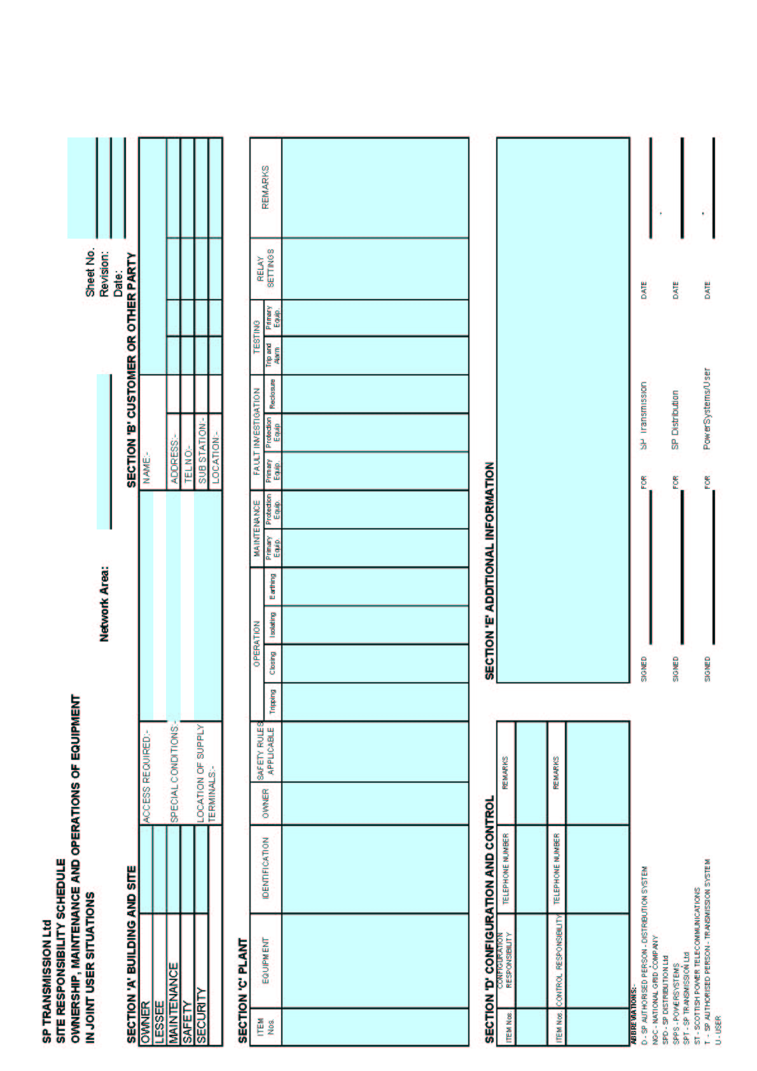

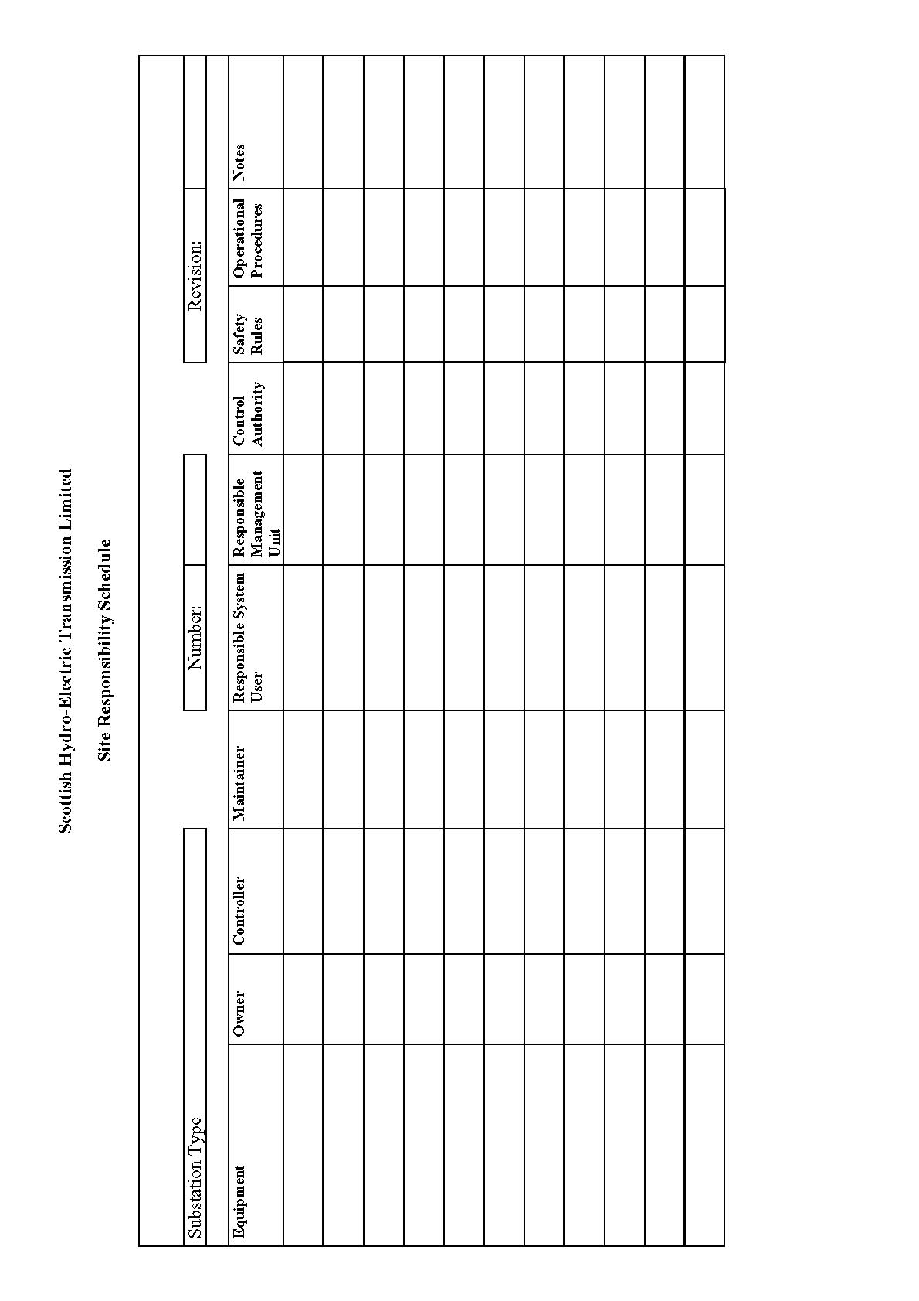

**APPENDIX 2 - OPERATION DIAGRAMS**

**PART 1A - PROCEDURES RELATING TO OPERATION DIAGRAMS**







**PART 1B - PROCEDURES RELATING TO GAS ZONE DIAGRAMS**



**PART 2 - NON-EXHAUSTIVE LIST OF APPARATUS**

**TO BE INCLUDED ON OPERATION DIAGRAMS**

Basic Principles

(1) Where practicable, all the **HV Apparatus** on any **Connection Site** shall be shown on one **Operation Diagram**. Provided the clarity of the diagram is not impaired, the layout shall represent as closely as possible the geographical arrangement on the **Connection Site**.

(2) Where more than one **Operation Diagram** is unavoidable, duplication of identical information on more than one **Operation Diagram** must be avoided.

(3) The **Operation Diagram** must show accurately the current status of the **Apparatus** e.g. whether commissioned or decommissioned. Where decommissioned, the associated switchbay will be labelled "spare bay".

(4) Provision will be made on the **Operation Diagram** for signifying approvals, together with provision for details of revisions and dates.

(5) **Operation Diagrams** will be prepared in A4 format or such other format as may be agreed with **The Company**.

(6) The **Operation Diagram** should normally be drawn single line. However, where appropriate, detail which applies to individual phases shall be shown. For example, some **HV Apparatus** is numbered individually per phase.

Apparatus To Be Shown On Operation Diagram

(1) Busbars

(2) Circuit Breakers

(3) Disconnector (Isolator) and Switch Disconnecters (Switching Isolators)

(4) Disconnectors (Isolators) - Automatic Facilities

(5) Bypass Facilities

(6) Earthing Switches

(7) Maintenance Earths

(8) Overhead Line Entries

(9) Overhead Line Traps

(10) Cable and Cable Sealing Ends

(11) Generating Unit

(12) Generator Transformers

(13) Generating Unit Transformers, Station Transformers, including the lower voltage circuit-breakers.

(14) Synchronous Compensators

(15) Static Variable Compensators

(16) Capacitors (including Harmonic Filters)

(17) Series or Shunt Reactors (Referred to as "Inductors" at nuclear power station sites)

(18) Supergrid and Grid Transformers

(19) Tertiary Windings

(20) Earthing and Auxiliary Transformers

(21) Three Phase VT's

(22) Single Phase VT & Phase Identity

(23) High Accuracy VT and Phase Identity

(24) Surge Arrestors/Diverters

(25) Neutral Earthing Arrangements on HV Plant

(26) Fault Throwing Devices

(27) Quadrature Boosters

(28) Arc Suppression Coils

(29) Single Phase Transformers (BR) Neutral and Phase Connections

(30) Current Transformers (where separate plant items)

(31) Wall Bushings

(32) Combined VT/CT Units

(33) Shorting and Discharge Switches

(34) Thyristor

(35) Resistor with Inherent Non-Linear Variability, Voltage Dependent

(36) Gas Zone

**APPENDIX 3 - MINIMUM FREQUENCY RESPONSE REQUIREMENT PROFILE AND OPERATING RANGE FOR NEW POWER STATIONS AND DC CONVERTER STATIONS**

CC.A.3.1 Scope

The frequency response capability is defined in terms of **Primary Response**, **Secondary Response** and **High Frequency Response**. This appendix defines the minimum frequency response requirement profile for:

(a) each **Onshore** **Generating Unit** and/or **CCGT Module** which has a **Completion Date** after 1 January 2001 in England and Wales and 1 April 2005 in Scotland and **Offshore Generating Unit** in a **Large Power Station**,

(b) each **DC Converter** at a **DC Converter Station** which has a **Completion Date** on or after 1 April 2005 or each **Offshore DC Converter** which is part of a **Large Power Station**.

(c) each **Onshore Power Park Module** in England and Wales with a **Completion Date** on or after 1 January 2006.

(d) each **Onshore Power Park Module** in operation in Scotland after 1 January 2006 with a **Completion Date** after 1 April 2005 and in **Power Stations** with a **Registered Capacity** of 50MW or more.

(e) each **Offshore Power Park Module** in a **Large** **Power Station** with a **Registered Capacity** of 50MW or more.

For the avoidance of doubt, this appendix does not apply to:

(i) **Generating Units** and/or **CCGT Modules** which have a **Completion Date** before 1 January 2001 in England and Wales and before 1 April 2005 in Scotland,

(ii) **DC Converters** at a **DC Converter Station** which have a **Completion Date** before 1 April 2005.

(iii) **Power Park Modules** in England and Wales with a **Completion Date** before 1 January 2006.

(iv) **Power Park Modules** in operation in Scotland before 1 January 2006.

(v) **Power Park Modules** in Scotland with a **Completion Date** before 1 April 2005.

(vi) **Power Park Modules** in **Power Stations** with a **Registered Capacity** less than 50MW.

(vii) **Small Power Stations** or individually to **Power Park Units**; or.

(viii) an **OTSDUW DC Converter** where the **Interface Point Capacity** is less than 50MW.

**OTSDUW Plant and Apparatus** should facilitate the delivery of frequency response services provided by **Offshore Generating Units** and **Offshore Power Park Modules** at the **Interface Point**.

The functional definition provides appropriate performance criteria relating to the provision of Frequency control by means of Frequency sensitive generation in addition to the other requirements identified in CC.6.3.7.

In this Appendix 3 to the **CC**, for a **CCGT Module** or a **Power Park Module** with more than one **Generating Unit**, the phrase **Minimum Generation** applies to the entire **CCGT Module** or **Power Park Module** operating with all **Generating Units Synchronised** to the **System**.

The minimum **Frequency** response requirement profile is shown diagrammatically in Figure CC.A.3.1. The capability profile specifies the minimum required levels of **Primary Response**, **Secondary Response** and **High Frequency Response** throughout the normal plant operating range. The definitions of these **Frequency** response capabilities are illustrated diagrammatically in Figures CC.A.3.2 & CC.A.3.3.

CC.A.3.2 Plant Operating Range

The upper limit of the operating range is the **Registered Capacity** of the **Generating Unit** or **CCGT Module** or **DC Converter** or **Power Park Module**.

The **Minimum Generation** level may be less than, but must not be more than, 65% of the **Registered Capacity**. Each **Generating Unit** and/or **CCGT Module** and/or **Power Park Module** and/or **DC Converter** must be capable of operating satisfactorily down to the **Designed Minimum Operating Level** as dictated by **System** operating conditions, although it will not be instructed to below its **Minimum Generation** level. If a **Generating Unit** or **CCGT Module** or **Power Park Module** or **DC Converter** is operating below **Minimum Generation** because of high **System Frequency**, it should recover adequately to its **Minimum Generation** level as the **System Frequency** returns to **Target Frequency** so that it can provide **Primary** and **Secondary Response** from **Minimum Generation** if the **System Frequency** continues to fall. For the avoidance of doubt, under normal operating conditions steady state operation below **Minimum Generation** is not expected. The **Designed Minimum Operating Level** must not be more than 55% of **Registered Capacity**.

In the event of a **Generating Unit** or **CCGT Module** or **Power Park Module** or **DC Converter** load rejecting down to no less than its **Designed Minimum Operating Level** it should not trip as a result of automatic action as detailed in BC3.7. If the load rejection is to a level less than the **Designed Minimum Operating Level** then it is accepted that the condition might be so severe as to cause it to be disconnected from the **System**.

CC.A.3.3 Minimum Frequency Response Requirement Profile

Figure CC.A.3.1 shows the minimum **Frequency** response requirement profile diagrammatically for a 0.5 Hz change in **Frequency**. The percentage response capabilities and loading levels are defined on the basis of the **Registered Capacity** of the **Generating Unit** or **CCGT Module** or **Power Park Module** or **DC Converter**. Each **Generating Unit** and/or **CCGT Module** and/or **Power Park Module** and/or **DC Converter** must be capable of operating in a manner to provide **Frequency** response at least to the solid boundaries shown in the figure. If the **Frequency** response capability falls within the solid boundaries, the **Generating Unit** or **CCGT Module** or **Power Park Module** or **DC Converter** is providing response below the minimum requirement which is not acceptable. Nothing in this appendix is intended to prevent a **Generating Unit** or **CCGT Module** or **Power Park Module** or **DC Converter** from being designed to deliver a **Frequency** response in excess of the identified minimum requirement.

The **Frequency** response delivered for **Frequency** deviations of less than 0.5 Hz should be no less than a figure which is directly proportional to the minimum **Frequency** response requirement for a **Frequency** deviation of 0.5 Hz. For example, if the **Frequency** deviation is 0.2 Hz, the corresponding minimum **Frequency** response requirement is 40% of the level shown in Figure CC.A.3.1. The **Frequency** response delivered for **Frequency** deviations of more than 0.5 Hz should be no less than the response delivered for a **Frequency** deviation of 0.5 Hz.

Each **Generating Unit** and/or **CCGT Module** and/or **Power Park Module** and/or **DC Converter** must be capable of providing some response, in keeping with its specific operational characteristics, when operating between 95% to 100% of **Registered Capacity** as illustrated by the dotted lines in Figure CC.A.3.1.

At the **Minimum Generation** level, each **Generating Unit** and/or **CCGT Module** and/or **Power Park Module** and/or **DC Converter** is required to provide high and low frequency response depending on the **System Frequency** conditions. Where the **Frequency** is high, the **Active Power** output is therefore expected to fall below the **Minimum Generation** level.

The **Designed Minimum Operating Level** is the output at which a **Generating Unit** and/or **CCGT Module** and/or **Power Park Module** and/or **DC Converter** has no **High Frequency Response** capability. It may be less than, but must not be more than, 55% of the **Registered Capacity**. This implies that a **Generating Unit** or **CCGT Module** or **Power Park Module** or **DC Converter** is not obliged to reduce its output to below this level unless the **Frequency** is at or above 50.5 Hz (cf BC3.7).

CC.A.3.4 Testing Of Frequency Response Capability

The response capabilities shown diagrammatically in Figure CC.A.3.1 are measured by taking the responses as obtained from some of the dynamic response tests specified by **The Company** and carried out by **GB** **Generators** and **DC Converter Station** owners for compliance purposes and to validate the content of **Ancillary Services Agreements** using an injection of a **Frequency** change to the plant control system (i.e. governor and load controller). The injected signal is a linear ramp from zero to 0.5 Hz **Frequency** change over a ten second period, and is sustained at 0.5 Hz **Frequency** change thereafter, as illustrated diagrammatically in figures CC.A.3.2 and CC.A.3.3. In the case of an **Embedded Medium Power Station** not subject to a **Bilateral Agreement** or **Embedded DC Converter Station** not subject to a **Bilateral Agreement**, **The Company** may require the **Network Operator** within whose **System** the **Embedded Medium Power Station** or **Embedded DC Converter Station** is situated, to ensure that the **Embedded Person** performs the dynamic response tests reasonably required by **The Company** in order to demonstrate compliance within the relevant requirements in the **CC**.

The **Primary Response** capability (P) of a **Generating Unit** or a **CCGT Module** or **Power Park Module** or **DC Converter** is the minimum increase in **Active Power** output between 10 and 30 seconds after the start of the ramp injection as illustrated diagrammatically in Figure CC.A.3.2. This increase in **Active Power** output should be released increasingly with time over the period 0 to 10 seconds from the time of the start of the **Frequency** fall as illustrated by the response from Figure CC.A.3.2.

The **Secondary Response** capability (S) of a **Generating Unit** or a **CCGT Module** or **Power Park Module** or **DC Converter** is the minimum increase in **Active Power** output between 30 seconds and 30 minutes after the start of the ramp injection as illustrated diagrammatically in Figure CC.A.3.2.

The **High Frequency Response** capability (H) of a **Generating Unit** or a **CCGT Module** or **Power Park Module** or **DC Converter** is the decrease in **Active Power** output provided 10 seconds after the start of the ramp injection and sustained thereafter as illustrated diagrammatically in Figure CC.A.3.3. This reduction in **Active Power** output should be released increasingly with time over the period 0 to 10 seconds from the time of the start of the **Frequency** rise as illustrated by the response in Figure CC.A.3.2.

CC.A.3.5 Repeatability Of Response

When a **Generating Unit** or **CCGT Module** or **Power Park Module** or **DC Converter** has responded to a significant **Frequency** disturbance, its response capability must be fully restored as soon as technically possible. Full response capability should be restored no later than 20 minutes after the initial change of **System Frequency** arising from the **Frequency** disturbance.

Figure CC.A.3.1 - Minimum Frequency Response Requirement Profile for a 0.5 Hz frequency change from Target Frequency

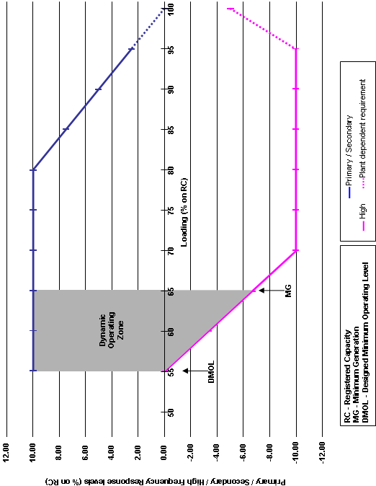

Figure CC.A.3.2 - Interpretation of Primary and Secondary Response Values

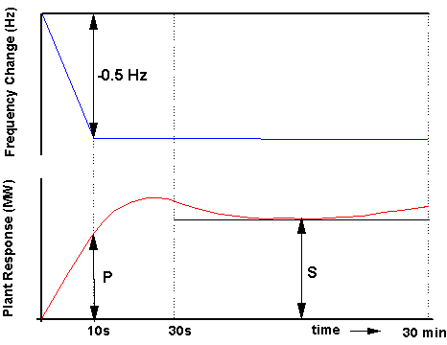

Figure CC.A.3.3 - Interpretation of High Frequency Response Values

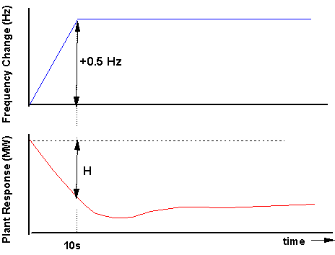

**APPENDIX 4 - FAULT RIDE THROUGH REQUIREMENTS**

**APPENDIX 4A - FAULT RIDE THROUGH REQUIREMENTS FOR ONSHORE SYNCHRONOUS GENERATING UNITS, ONSHORE POWER PARK MODULES, ONSHORE DC CONVERTERS OTSDUW PLANT AND APPARATUS AT THE INTERFACE POINT, OFFSHORE SYNCHRONOUS GENERATING UNITS IN A LARGE POWER STATION, OFFSHORE POWER PARK MODULES IN A LARGE POWER STATION AND OFFSHORE DC CONVERTERS IN A LARGE POWER STATION WHICH SELECT TO MEET THE FAULT RIDE THROUGH REQUIREMENTS AT THE INTERFACE POINT**

CC.A.4A.1 Scope

The fault ride through requirement is defined in CC.6.3.15.1 (a), (b) and CC.6.3.15.3. This Appendix provides illustrations by way of examples only of CC.6.3.15.1 (a) (i) and further background and illustrations to CC.6.3.15.1 (1b) (i) and CC.6.3.15.1 (2b) (i) and is not intended to show all possible permutations.

CC.A.4A.2 Short Circuit Faults At Supergrid Voltage On The Onshore Transmission System Up To 140ms In Duration

For short circuit faults at **Supergrid Voltage** on the **Onshore Transmission System**(which could be at an **Interface Point**) up to 140ms in duration, the fault ride through requirement is defined in CC.6.3.15.1 (a) (i). Figures CC.A.4A.1 (a) and (b) illustrate two typical examples of voltage recovery for short-circuit faults cleared within 140ms by two circuit breakers (a) and three circuit breakers (b) respectively.

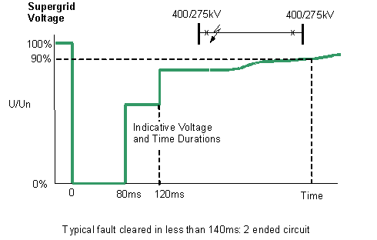

Figure CC.A.4A.1 (a)

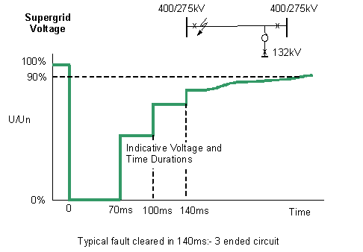

Figure CC.A.4A.1 (b)

CC.A.4A.3 Supergrid Voltage Dips On The Onshore Transmission System Greater Than 140ms In Duration

CC.A.4A3.1 Requirements applicable to **Synchronous Generating Units** subject to **Supergrid Voltage** dips on the **Onshore Transmission System** greater than 140ms in duration.

For balanced **Supergrid Voltage** dips on the **Onshore Transmission System** having durations greater than 140ms and up to 3 minutes, the fault ride through requirement is defined in CC.6.3.15.1 (1b) and Figure 5a which is reproduced in this Appendix as Figure CC.A.4A3.1 and termed the voltage–duration profile.

This profile is not a voltage-time response curve that would be obtained by plotting the transient voltage response at a point on the **Onshore Transmission System** (or **User System** if located **Onshore**) to a disturbance. Rather, each point on the profile (i.e. the heavy black line) represents a voltage level and an associated time duration which connected **Synchronous** **Generating Units** must withstand or ride through.

Figures CC.A.4A3.2 (a), (b) and (c) illustrate the meaning of the voltage-duration profile for voltage dips having durations greater than 140ms.

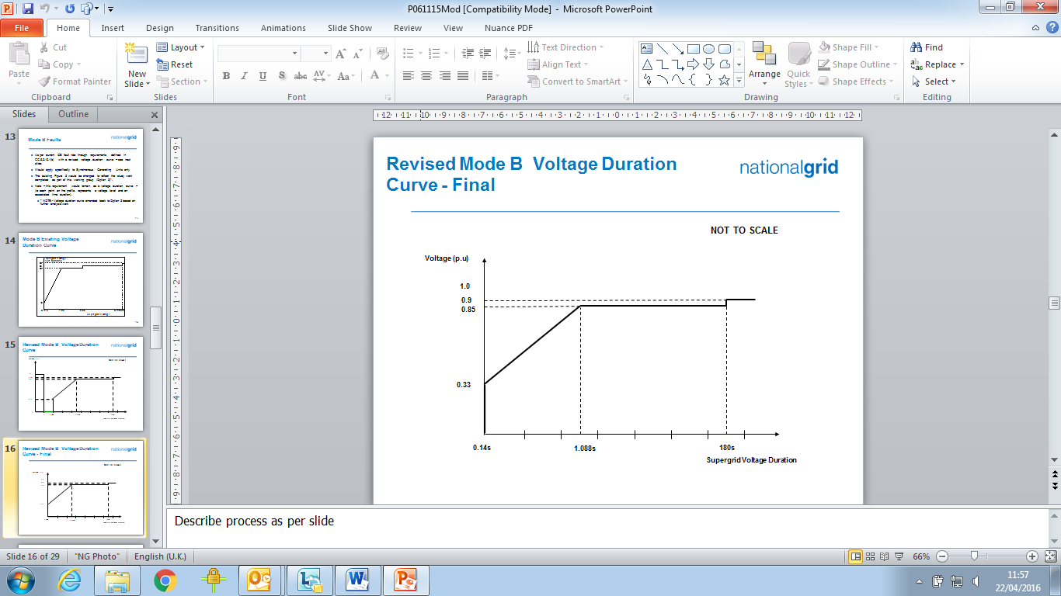

Figure CC.A.4A3.1

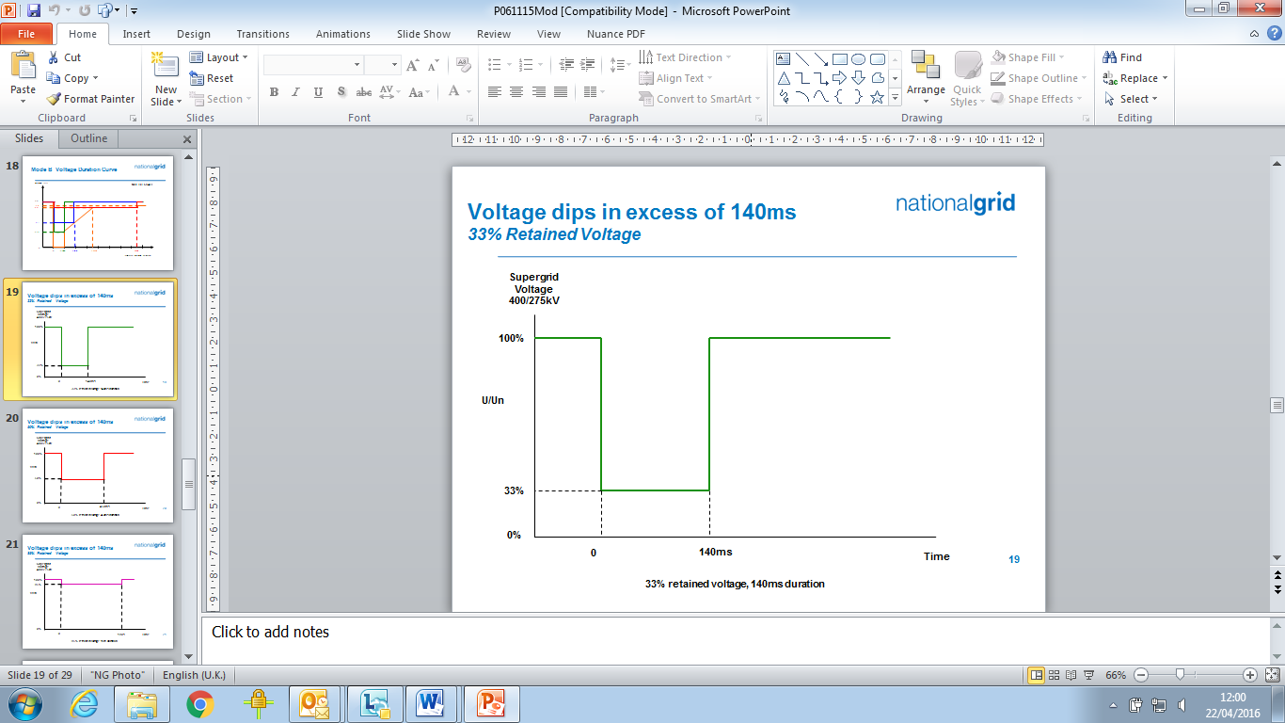

Figure CC.A.4A3.2 (a)

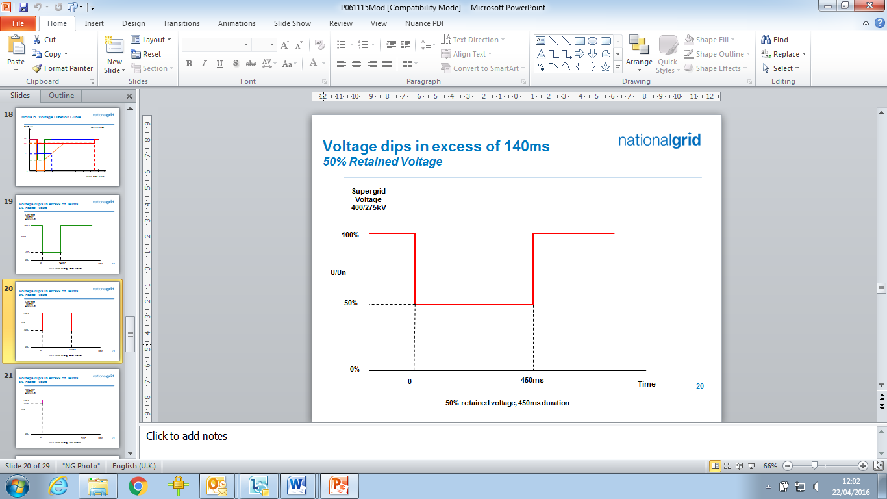

Figure CC.A.4A3.2 (b)

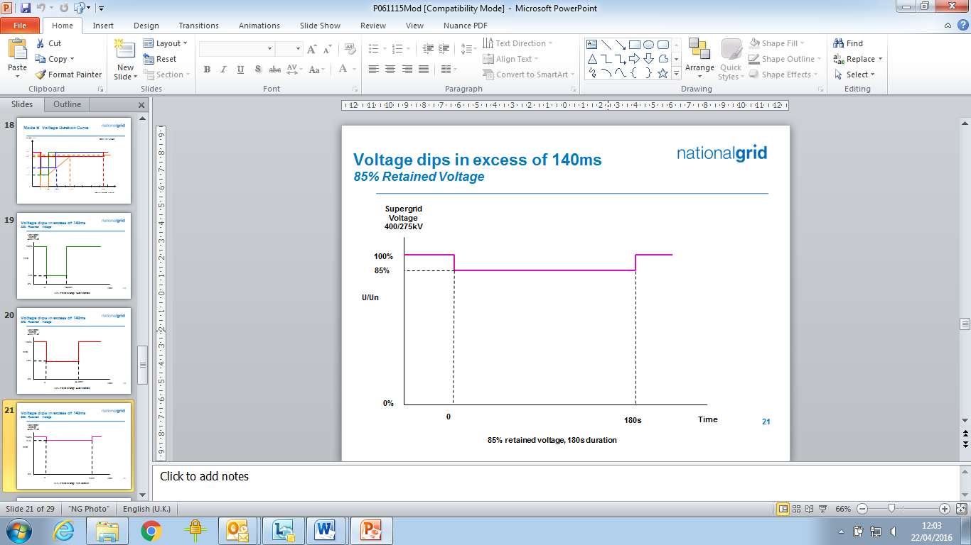

Figure CC.A.4A3.2 (c)

CC.A.4A3.2 Requirements applicable to **Power Park Modules** or **OTSDUW Plant and Apparatus** subject to **Supergrid Voltage** dips on the **Onshore Transmission System** greater than 140ms in duration

For balanced **Supergrid Voltage** dips on the **Onshore Transmission System** (which could be at an **Interface Point**) having durations greater than 140ms and up to 3 minutes the fault ride through requirement is defined in CC.6.3.15.1 (2b) and Figure 5b which is reproduced in this Appendix as Figure CC.A.4A3.3 and termed the voltage–duration profile.

This profile is not a voltage-time response curve that would be obtained by plotting the transient voltage response at a point on the **Onshore Transmission System** (or **User System** if located **Onshore**) to a disturbance. Rather, each point on the profile (i.e. the heavy black line) represents a voltage level and an associated time duration which connected **Power Park Modules**or **OTSDUW Plant and Apparatus** must withstand or ride through.

Figures CC.A.4A.4 (a), (b) and (c) illustrate the meaning of the voltage-duration profile for voltage dips having durations greater than 140ms.

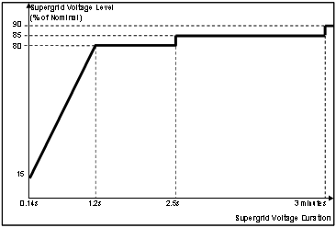

Figure CC.A.4A3.3

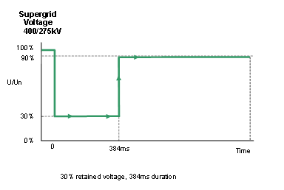

Figure CC.A.4A3.4 (a)

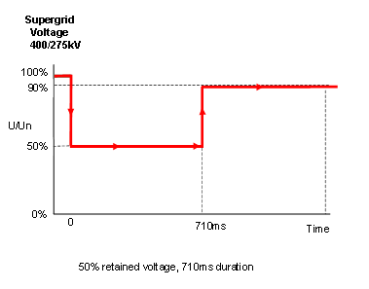

Figure CC.A.4A3.4 (b)

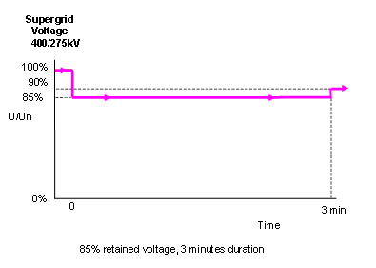

Figure CC.A.4A3.4 (c)

**APPENDIX 4B - FAULT RIDE THROUGH REQUIREMENTS FOR OFFSHORE GENERATING UNITS IN A LARGE POWER STATION, OFFSHORE POWER PARK MODULES IN A LARGE POWER STATION AND OFFSHORE DC CONVERTERS IN A LARGE POWER STATION WHICH SELECT TO MEET THE FAULT RIDE THROUGH REQUIREMENTS AT THE LV SIDE OF THE OFFSHORE PLATFORM AS SPECIFIED IN CC.6.3.15.2**

CC.A.4B.1 Scope

The fault ride through requirement is defined in CC.6.3.15.2 (a), (b) and CC.6.3.15.3. This Appendix provides illustrations by way of examples only of CC.6.3.15.2 (a) (i) and further background and illustrations to CC.6.3.15.2 (1b) and CC.6.3.15.2 (2b) and is not intended to show all possible permutations.

CC.A.4B.2 Voltage Dips On The LV Side Of The Offshore Platform Up To 140ms In Duration

For voltage dips on the **LV Side of the Offshore Platform** which lastup to 140ms in duration, the fault ride through requirement is defined in CC.6.3.15.2 (a) (i). This includes Figure 6 which is reproduced here in Figure CC.A.4B.1. The purpose of this requirement is to translate the conditions caused by a balanced or unbalanced fault which occurs on the **Onshore Transmission System** (which may include the **Interface Point)** at the **LV Side of the Offshore Platform**.

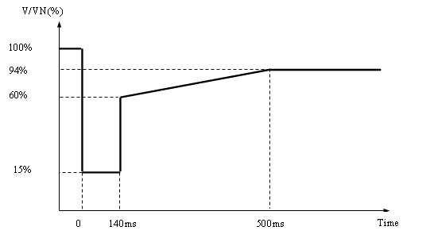

V/VN is the ratio of the voltage at the **LV side of the** **Offshore Platform** to the nominal voltage of the LV side of the **Offshore Platform**.

Figure CC.A.4B.1

Figures CC.A.4B.2 (a) and CC.A.4B.2 (b) illustrate two typical examples of the voltage recovery seen at the **LV Side of the Offshore Platform** for a short circuit fault cleared within 140ms by (a) two circuit breakers and (b) three circuit breakers on the **Onshore Transmission System**.

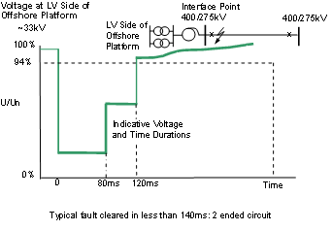

Figure CC.A.4B.2 (a)

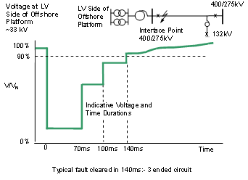

Figure CC.A.4B.2 (b)

CCA.4B.3 Voltage Dips Which Occur On The **LV Side Of The Offshore Platform** Greater Than 140ms In Duration

CC.A.4B.3.1 Requirements applicable to **Offshore** **Synchronous Generating Units** subject tovoltage dips which occuron the **LV Side of the Offshore Platform** greater than 140ms in duration.

In addition to CC.A.4B.2 the fault ride through requirements applicable to **Offshore Synchronous Generating Units** during balanced voltage dips which occur at the **LV Side of the Offshore Platform** and having durations greater than 140ms and up to 3 minutes are defined in CC.6.3.15.2 (1b) and Figure 7a which is reproduced in this Appendix as Figure CC.A.4B3.1 and termed the voltage–duration profile.

This profile is not a voltage-time response curve that would be obtained by plotting the transient voltage response at the **LV Side of the Offshore Platform** to a disturbance. Rather, each point on the profile (i.e. the heavy black line) represents a voltage level and an associated time duration which connected **Offshore Synchronous** **Generating Units** must withstand or ride through.

Figures CC.A.4B3.2 (a), (b) and (c) illustrate the meaning of the voltage-duration profile for voltage dips having durations greater than 140ms.

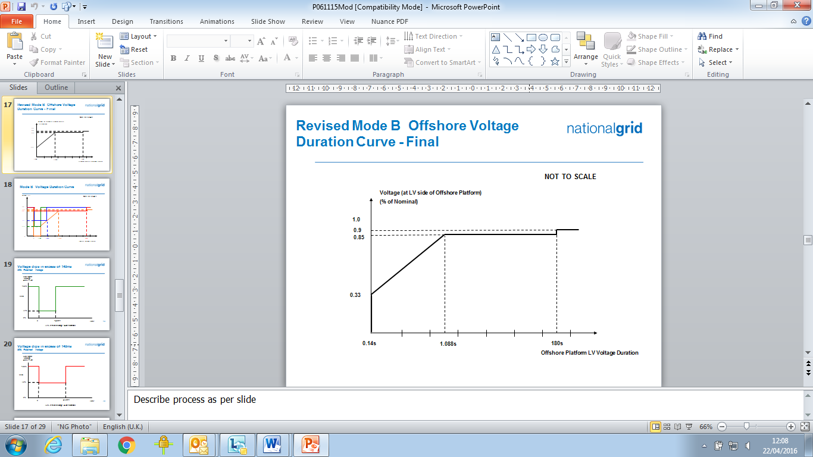

Figure CC.A.4B3.1

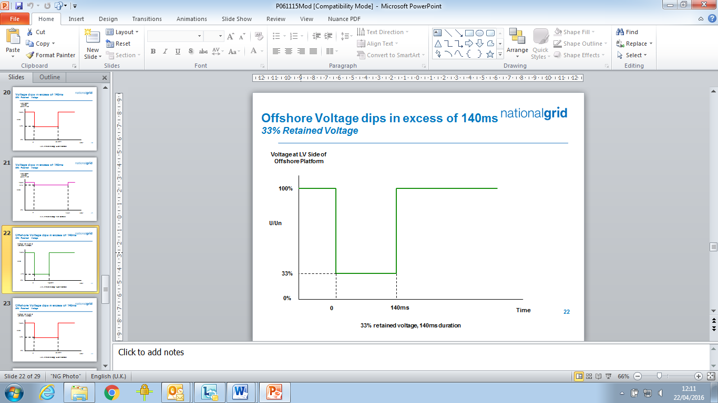

Figure CC.A.4B3.2 (a)

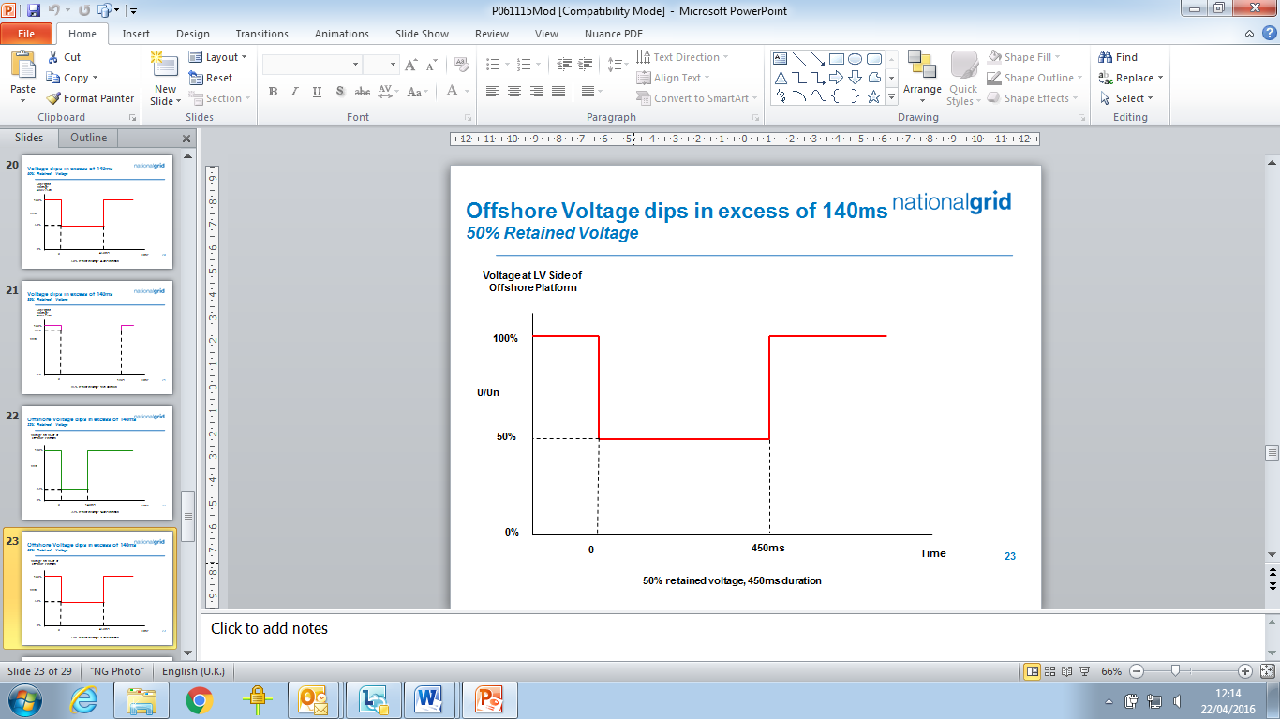

Figure CC.A.4B3.2 (b)

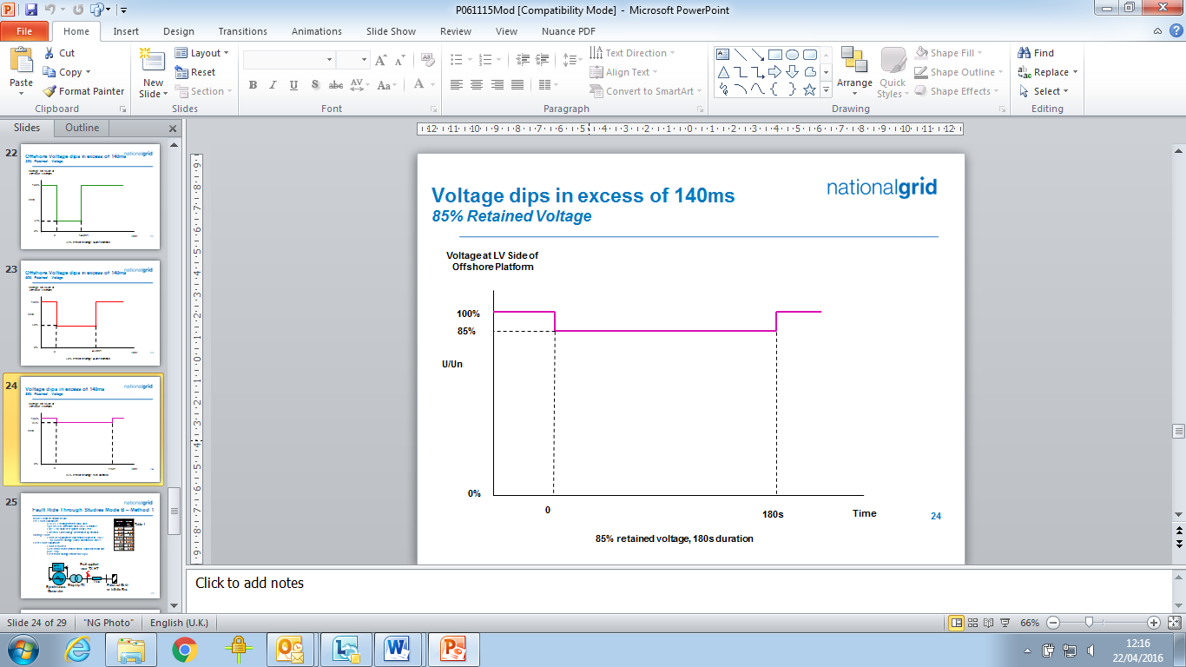

Figure CC.A.4B3.2 (c)

CC.A.4B.3.2 Requirements applicable to **Offshore** **Power Park Modules** subject toVoltage Dips Which OccurOn **The LV Side Of The Offshore Platform** Greater Than 140ms in Duration.

In addition to CCA.4B.2 the fault ride through requirements applicable for **Offshore Power Park Modules** during balancedvoltagedips which occur at the **LV Side of the Offshore Platform** and have durations greater than 140ms and up to 3 minutes are defined in CC.6.3.15.2 (2b) (i) and Figure 7b which is reproduced in this Appendix as Figure CC.A.4B.4 and termed the voltage–duration profile.

This profile is not a voltage-time response curve that would be obtained by plotting the transient voltage response at the **LV Side of the Offshore Platform** to a disturbance. Rather, each point on the profile (i.e. the heavy black line) represents a voltage level and an associated time duration which connected **Offshore Power Park Modules** must withstand or ride through.

Figures CC.A.4B.5 (a), (b) and (c) illustrate the meaning of the voltage-duration profile for voltage dips having durations greater than 140ms.

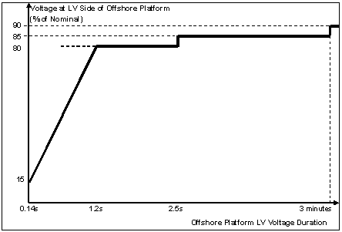

Figure CC.A.4B.4

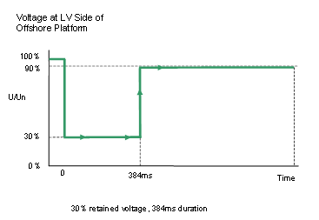

Figure CC.A.4B.5 (a)

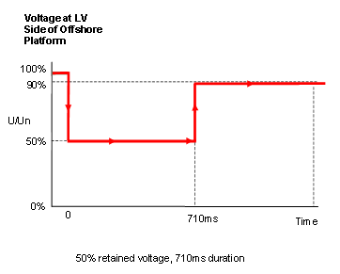

Figure CC.A.4B.5(b)

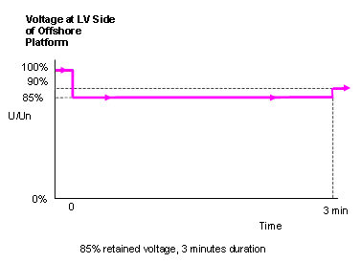

Figure CC.A.4B.5(c)

**APPENDIX 5 - TECHNICAL REQUIREMENTS**

**LOW FREQUENCY RELAYS FOR THE AUTOMATIC**

**DISCONNECTION OF SUPPLIES AT LOW FREQUENCY**

CC.A.5.1 Low Frequency Relays

CC.A.5.1.1 The **Low Frequency Relays** to be used shall have a setting range of 47.0 to 50Hz and be suitable for operation from a nominal AC input of 63.5, 110 or 240V. The following general parameters specify the requirements of approved **Low Frequency Relays** for automatic installations installed and commissioned after 1st April 2007 and provide an indication, without prejudice to the provisions that may be included in a **Bilateral Agreement**, for those installed and commissioned before 1st April 2007:

|  |  |
| --- | --- |
| (a) **Frequency** settings: | 47-50Hz in steps of 0.05Hz or better, preferably 0.01Hz; |
| (b) Operating time: | Relay operating time shall not be more than 150 ms; |
| (c) Voltage lock-out: | Selectable within a range of 55 to 90% of nominal voltage; |
| (d) Facility stages: | One or two stages of **Frequency** operation; |
| (e) Output contacts: | Two output contacts per stage to be capable of repetitively making and breaking for 1000 operations: |
| (f) Accuracy: | 0.01 Hz maximum error under reference environmental and system voltage conditions.  0.05 Hz maximum error at 8% of total harmonic distortion **Electromagnetic Compatibility Level**. |

CC.A.5.2 Low Frequency Relay Voltage Supplies

CC.A.5.2.1 It is essential that the voltage supply to the **Low Frequency Relays** shall be derived from the primary **System** at the supply point concerned so that the **Frequency** of the **Low Frequency Relays** input voltage is the same as that of the primary **System**. This requires either:

(a) the use of a secure supply obtained from voltage transformers directly associated with the grid transformer(s) concerned, the supply being obtained where necessary via a suitable automatic voltage selection scheme; or

(b) the use of the substation 240V phase-to-neutral selected auxiliary supply, provided that this supply is always derived at the supply point concerned and is never derived from a standby supply **Generating Unit** or from another part of the **User System**.

CC.A.5.3 Scheme Requirements

CC.A.5.3.1 The tripping facility should be engineered in accordance with the following reliability considerations:

(a) Dependability

Failure to trip at any one particular **Demand** shedding point would not harm the overall operation of the scheme. However, many failures would have the effect of reducing the amount of **Demand** under low **Frequency** control. An overall reasonable minimum requirement for the dependability of the **Demand** shedding scheme is 96%, i.e. the average probability of failure of each **Demand** shedding point should be less than 4%. Thus the **Demand** under low **Frequency** control will not be reduced by more than 4% due to relay failure.

(b) Outages

Low **Frequency** **Demand** shedding schemes will be engineered such that the amount of **Demand** under control is as specifiedin Table CC.A.5.5.1a and is not reduced unacceptably during equipment outage or maintenance conditions.

CC.A.5.3.2 The total operating time of the scheme, including circuit breakers operating time, shall where reasonably practicable, be less than 200 ms. For the avoidance of doubt, the replacement of plant installed prior to October 2009 will not be required in order to achieve lower total scheme operating times.

CC.A.5.4 Low Frequency Relay Testing

CC.A.5.4.1 **Low Frequency Relays** installed and commissioned after 1st January 2007 shall be type tested in accordance with and comply with the functional test requirements for **Frequency** **Protection** contained in Energy Networks Association Technical Specification 48-6-5 Issue 1 dated 2005 “ENA **Protection** Assessment Functional Test Requirements – Voltage and Frequency **Protection**”.

For the avoidance of doubt, **Low Frequency Relays** installed and commissioned before 1st January 2007 shall comply with the version of CC.A.5.1.1 applicable at the time such **Low Frequency Relays** were commissioned.

CC.A.5.5 Scheme Settings

CC.A.5.5.1 Table CC.A.5.5.1a shows, for each **Transmission Area**, the percentage of **Demand** (based on **Annual ACS Conditions**) at the time of forecast **National Electricity Transmission System** peak **Demand** that each **Network Operator** whose **System** is connected to the **Onshore Transmission System** within such **Transmission Area** shall disconnect by **Low Frequency Relays** at a range of frequencies. Where a **Network Operator’s System** is connected to the **National Electricity Transmission System** in more than one **Transmission Area**, the settings for the **Transmission Area** in which the majority of the **Demand** is connected shall apply.

|  |  |  |  |
| --- | --- | --- | --- |
| Frequency Hz | % **Demand** disconnection for each Network Operator in Transmission Area | | |
| NGET | SPT | SHETL |
| 48.8 | 5 |  |  |
| 48.75 | 5 |  |  |
| 48.7 | 10 |  |  |
| 48.6 | 7.5 |  | 10 |
| 48.5 | 7.5 | 10 |  |
| 48.4 | 7.5 | 10 | 10 |
| 48.2 | 7.5 | 10 | 10 |
| 48.0 | 5 | 10 | 10 |
| 47.8 | 5 |  |  |
| Total % **Demand** | 60 | 40 | 40 |

Table CC.A.5.5.1a

Note – the percentages in table CC.A.5.5.1a are cumulative such that, for example, should the frequency fall to 48.6 Hz in the **NGET Transmission Area**,27.5% of the total **Demand** connected to the **National Electricity Transmission System** in the **NGET Transmission Area** shall be disconnected by the action of **Low Frequency Relays**.

The percentage **Demand** at each stage shall be allocated as far as reasonably practicable. The cumulative total percentage **Demand** is a minimum.

**APPENDIX 6 - PERFORMANCE REQUIREMENTS FOR CONTINUOUSLY ACTING AUTOMATIC EXCITATION CONTROL SYSTEMS FOR ONSHORE SYNCHRONOUS GENERATING UNITS**

CC.A.6.1 Scope

CC.A.6.1.1 This Appendix sets out the performance requirements of continuously acting automatic excitation control systems for **Onshore** **Synchronous Generating Units** that must be complied with by the **GB Code** **User**. This Appendix does not limit any site specific requirements that may be included in a **Bilateral Agreement** where in **The Company's** reasonable opinion these facilities are necessary for system reasons.

CC.A.6.1.2 Where the requirements may vary the likely range of variation is given in this Appendix. It may be necessary to specify values outside this range where **The Company** identifies a system need, and notwithstanding anything to the contrary **The Company** may specify in the **Bilateral Agreement** values outside of the ranges provided in this Appendix 6. The most common variations are in the on-load excitation ceiling voltage requirements and the response time required of the **Exciter**. Actual values will be included in the **Bilateral Agreement**.

CC.A.6.1.3 Should a **GB** **Generator** anticipate making a change to the excitation control system it shall notify **The Company** under the **Planning Code** (PC.A.1.2(b) and (c)) as soon as the **GB** **Generator** anticipates making the change. The change may require a revision to the **Bilateral Agreement**.

CC.A.6.2 Requirements

CC.A.6.2.1 The **Excitation System** of an **Onshore** **Synchronous Generating Unit** shall include an excitation source (**Exciter**), a **Power System Stabiliser** and a continuously acting **Automatic Voltage Regulator** (**AVR**) and shall meet the following functional specification.

CC.A.6.2.2 In respect of **Onshore** **Synchronous Generating Units** with a **Completion Date** on or after 1January 2009, and **Onshore** **Synchronous Generating Units** with a **Completion Date** before 1 January 2009 subject to a **Modification** to the excitation control facilities where the **Bilateral Agreement** does not specify otherwise, the continuously acting automatic excitation control system shall include a **Power System Stabiliser (PSS)** as a means of supplementary control. The functional specification of the **Power System Stabiliser** is included in CC.A.6.2.5.

CC.A.6.2.3 Steady State Voltage Control

CC.A.6.2.3.1 An accurate steady state control of the **Onshore** **Generating Unit** pre-set terminal voltage is required. As a measure of the accuracy of the steady-state voltage control, the **Automatic Voltage Regulator** shall have static zero frequency gain, sufficient to limit the change in terminal voltage to a drop not exceeding 0.5% of rated terminal voltage, when the **Onshore** **Generating Unit** output is gradually changed from zero to rated MVA output at rated voltage, **Active Power** and **Frequency**.

CC.A.6.2.4 Transient Voltage Control

CC.A.6.2.4.1 For a step change from 90% to 100% of the nominal **Onshore** **Generating Unit** terminal voltage, with the **Onshore** **Generating Unit** on open circuit, the **Excitation System** response shall have a damped oscillatory characteristic. For this characteristic, the time for the **Onshore** **Generating Unit** terminal voltage to first reach 100% shall be less than 0.6 seconds. Also, the time to settle within 5% of the voltage change shall be less than 3 seconds.

CC.A.6.2.4.2 To ensure that adequate synchronising power is maintained, when the **Onshore** **Generating Unit** is subjected to a large voltage disturbance, the **Exciter** whose output is varied by the **Automatic Voltage Regulator** shall be capable of providing its achievable upper and lower limit ceiling voltages to the **Onshore** **Generating Unit** field in a time not exceeding that specified in the **Bilateral Agreement**. This will normally be not less than 50 ms and not greater than 300 ms. The achievable upper and lower limit ceiling voltages may be dependent on the voltage disturbance.

CC.A.6.2.4.3 The **Exciter** shall be capable of attaining an **Excitation System On Load Positive Ceiling Voltage** of not less than a value specified in the **Bilateral Agreement** that will be:

not less than 2 per unit (pu)

normally not greater than 3 pu

exceptionally up to 4 pu

of **Rated Field Voltage** when responding to a sudden drop in voltage of 10 percent or more at the **Onshore** **Generating Unit** terminals. **The Company** may specify a value outside the above limits where **The Company** identifies a system need.

CC.A.6.2.4.4 If a static type **Exciter** is employed:

(i) the field voltage should be capable of attaining a negative ceiling level specified in the **Bilateral Agreement** after the removal of the step disturbance of CC.A.6.2.4.3. The specified value will be 80% of the value specified in CC.A.6.2.4.3. **The Company** may specify a value outside the above limits where **The Company** identifies a system need.

(ii) the **Exciter** must be capable of maintaining free firing when the **Onshore** **Generating Unit** terminal voltage is depressed to a level which may be between 20% to 30% of rated terminal voltage

(iii) the **Exciter** shall be capable of attaining a positive ceiling voltage not less than 80% of the **Excitation System On Load Positive Ceiling Voltage** upon recovery of the **Onshore** **Generating Unit** terminal voltage to 80% of rated terminal voltage following fault clearance. **The Company** may specify a value outside the above limits where **The Company** identifies a system need.

(iv) The requirement to provide a separate power source for the **Exciter** will be specified in the **Bilateral Agreement** if **The Company**, in accordance with the **Relevant Transmission Licensee,** identifies a **Transmission System** need.

CC.A.6.2.5 Power Oscillations Damping Control

CC.A.6.2.5.1 To allow the **Onshore** **Generating Unit** to maintain second and subsequent swing stability and also to ensure an adequate level of low frequency electrical damping power, the **Automatic Voltage Regulator** shall include a **Power System Stabiliser** as a means of supplementary control.

CC.A.6.2.5.2 Whatever supplementary control signal is employed, it shall be of the type which operates into the **Automatic Voltage Regulator** to cause the field voltage to act in a manner which results in the damping power being improved while maintaining adequate synchronising power.

CC.A.6.2.5.3 The arrangements for the supplementary control signal shall ensure that the **Power System Stabiliser** output signal relates only to changes in the supplementary control signal and not the steady state level of the signal. For example, if generator electrical power output is chosen as a supplementary control signal then the **Power System**  **Stabiliser** output should relate only to changes in generator electrical power output and not the steady state level of power output. Additionally the **Power System Stabiliser** should not react to mechanical power changes in isolation for example during rapid changes in steady state load or when providing frequency response.

CC.A.6.2.5.4 The output signal from the **Power System Stabiliser** shall be limited to not more than ±10% of the **Onshore** **Generating Unit** terminal voltage signal at the **Automatic Voltage Regulator** input. The gain of the **Power System Stabiliser** shall be such that an increase in the gain by a factor of 3 shall not cause instability.

CC.A.6.2.5.5 The **Power System Stabiliser** shall include elements that limit the bandwidth of the output signal. The bandwidth limiting must ensure that the highest frequency of response cannot excite torsional oscillations on other plant connected to the network. A bandwidth of 0-5Hz would be judged to be acceptable for this application.

CC.A.6.2.5.6 The **GB** **Generator** will agree **Power System Stabiliser** settings with **NGET**  prior to the on-load commissioning detailed in BC2.11.2(d). To allow assessment of the performance before on-load commissioning the **GB** **Generator** will provide to **The Company** a report covering the areas specified in CP.A.3.2.1.

CC.A.6.2.5.7 The **Power System Stabiliser** must be active within the **Excitation System** at all times when **Synchronised** including when the **Under Excitation Limiter** or **Over Excitation Limiter** are active. When operating at low load when **Synchronising** or **De-Synchronising** an **Onshore** **Generating Unit**, the **Power System Stabiliser** may be out of service.

CC.A.6.2.5.8 Where a **Power System Stabiliser** is fitted to a **Pumped Storage Unit** it must function when the **Pumped Storage Unit** is in both generating and pumping modes.

CC.A.6.2.6 Overall **Excitation System** Control Characteristics

CC.A.6.2.6.1 The overall **Excitation System** shall include elements that limit the bandwidth of the output signal. The bandwidth limiting must be consistent with the speed of response requirements and ensure that the highest frequency of response cannot excite torsional oscillations on other plant connected to the network. A bandwidth of 0-5 Hz will be judged to be acceptable for this application.

CC.A.6.2.6.2 The response of the **Automatic Voltage Regulator** combined with the **Power System Stabiliser** shall be demonstrated by injecting similar step signal disturbances into the **Automatic Voltage Regulator** reference as detailed in OC5A.2.2 and OC5.A.2.4. The **Automatic Voltage Regulator** shall include a facility to allow step injections into the **Automatic Voltage Regulator** voltage reference, with the **Onshore** **Generating Unit** operating at points specified by **The Company** (up to rated MVA output).  The damping shall be judged to be adequate if the corresponding **Active Power** response to the disturbances decays within two cycles of oscillation.

CC.A.6.2.6.3 A facility to inject a band limited random noise signal into the **Automatic Voltage Regulator** voltage reference shall be provided for demonstrating the frequency domain response of the **Power System Stabiliser**. The tuning of the **Power System Stabiliser** shall be judged to be adequate if the corresponding **Active Power** response shows improved damping with the **Power System Stabiliser** in combination withthe **Automatic Voltage Regulator** compared with the **Automatic Voltage Regulator** alone over the frequency range 0.3Hz – 2Hz.

CC.A.6.2.7 Under-Excitation Limiters

CC.A.6.2.7.1 The security of the power system shall also be safeguarded by means of MVAr **Under Excitation Limiters** fitted to the generator **Excitation System**. The **Under Excitation Limiter** shall prevent the **Automatic Voltage Regulator** reducing the generator excitation to a level which would endanger synchronous stability. The **Under Excitation Limiter** shall operate when the excitation system is providing automatic control. The **Under Excitation Limiter** shall respond to changes in the **Active Power** (MW) and the **Reactive Power** (MVAr), and to the square of the generator voltage in such a direction that an increase in voltage will permit an increase in leading MVAr. The characteristic of the **Under Excitation Limiter** shall be substantially linear from no-load to the maximum **Active Power** output of the **Onshore** **Generating Unit** at any setting and shall be readily adjustable.

CC.A.6.2.7.2 The performance of the **Under Excitation Limiter** shall be independent of the rate of change of the **Onshore** **Generating Unit** load and shall be demonstrated by testing as detailed in OC5.A.2.5. The resulting maximum overshoot in response to a step injection which operates the **Under Excitation Limiter** shall not exceed 4% of the **Onshore** **Generating Unit** rated MVA. The operating point of the **Onshore** **Generating Unit** shall be returned to a steady state value at the limit line and the final settling time shall not be greater than 5 seconds. When the step change in **Automatic Voltage Regulator** reference voltage is reversed, the field voltage should begin to respond without any delay and should not be held down by the **Under Excitation Limiter**. Operation into or out of the preset limit levels shall ensure that any resultant oscillations are damped so that the disturbance is within 0.5% of the **Onshore** **Generating Unit** MVA rating within a period of 5 seconds.

CC.A.6.2.7.3 The **GB** **Generator** shall also make provision to prevent the reduction of the **Onshore** **Generating Unit** excitation to a level which would endanger synchronous stability when the **Excitation System** is under manual control.

CC.A.6.2.8 Over-Excitation Limiters

CC.A.6.2.8.1 The settings of the **Over-Excitation Limiter**, where it exists, shall ensure that the generator excitation is not limited to less than the maximum value that can be achieved whilst ensuring the **Onshore** **Generating Unit** is operating within its design limits. If the generator excitation is reduced following a period of operation at a high level, the rate of reduction shall not exceed that required to remain within any time dependent operating characteristics of the **Onshore** **Generating Unit**.

CC.A.6.2.8.2 The performance of the **Over-Excitation Limiter**, where it exists, shall be demonstrated by testing as described in OC5.A.2.6. Any operation beyond the **Over-Excitation Limit** shall be controlled by the **Over-Excitation Limiter** without the operation of any **Protection** that could trip the **Onshore** **Generating Unit**.

CC.A.6.2.8.3 The **GB** **Generator** shall also make provision to prevent any over-excitation restriction of the generator when the **Excitation System** is under manual control, other than that necessary to ensure the **Onshore** **Generating Unit** is operating within its design limits.

**APPENDIX 7 - PERFORMANCE REQUIREMENTS FOR CONTINUOUSLY ACTING AUTOMATIC VOLTAGE CONTROL SYSTEMS FOR ONSHORE NON-SYNCHRONOUS GENERATING UNITS, ONSHORE DC CONVERTERS, ONSHORE POWER PARK MODULES AND OTSDUW PLANT AND APPARATUS AT THE INTERFACE POINT**

CC.A.7.1 Scope

CC.A.7.1.1 This Appendix sets out the performance requirements of continuously acting automatic voltage control systems for **Onshore** **Non-Synchronous Generating Units**, **Onshore** **DC Converters**, **Onshore** **Power Park Modules** and **OTSDUW Plant and Apparatus** at the **Interface Point** that must be complied with by the **GB Code**  **User**. This Appendix does not limit any site specific requirements that may be included in a **Bilateral Agreement** where in **The Company's** reasonable opinion these facilities are necessary for system reasons.

CC.A.7.1.2 Proposals by **GB** **Generators** to make a change to the voltage control systems are required to be notified to **The Company** under the **Planning Code** (PC.A.1.2(b) and (c)) as soon as the **GB** **Generator** anticipates making the change. The change may require a revision to the **Bilateral Agreement**.

CC.A.7.2 Requirements

CC.A.7.2.1 **The Company** requires that the continuously acting automatic voltage control system for the **Onshore** **Non-Synchronous Generating Unit**, **Onshore** **DC Converter** or **Onshore** **Power Park Module** or **OTSDUW Plant and Apparatus** shall meet the following functional performance specification. If a **Network Operator** has confirmed to **The Company** that its network to which an **Embedded** **Onshore** **Non-Synchronous Generating Unit**, **Onshore** **DC Converter**, **Onshore** **Power Park Module** or **OTSDUW Plant and Apparatus** is connected is restricted such that the full reactive range under the steady state voltage control requirements (CC.A.7.2.2) cannot be utilised, **The Company** may specify in the **Bilateral Agreement** alternative limits to the steady state voltage control range that reflect these restrictions. Where the **Network Operator** subsequently notifies **The Company** that such restriction has been removed, **The Company** may propose a **Modification** to the **Bilateral Agreement** (in accordance with the **CUSC** contract) to remove the alternative limits such that the continuously acting automatic voltage control system meets the following functional performance specification. All other requirements of the voltage control system will remain as in this Appendix.

CC.A.7.2.2 Steady State Voltage Control

CC.A.7.2.2.1 The **Onshore** **Non-Synchronous Generating Unit**, **Onshore** **DC Converter**, **Onshore** **Power Park Module** or **OTSDUW Plant and Apparatus** shall provide continuous steady state control of the voltage at the **Onshore** **Grid Entry Point** (or **Onshore** **User System Entry Point** if **Embedded**) (or the **Interface Point** in the case of **OTSDUW Plant and Apparatus**) with a **Setpoint Voltage** and **Slope** characteristic as illustrated in Figure CC.A.7.2.2a. It should be noted that where the **Reactive Power** capability requirement of a directly connected **Onshore Non-Synchronous Generating Unit**, **Onshore** **DC Converter**, **Onshore** **Power Park Module** in Scotland, or **OTSDUW Plant and Apparatus** in Scotland as specified in CC.6.3.2 (c), is not at the **Onshore** **Grid Entry Point**or **Interface Point**, the values of Qmin and Qmax shown in this figure will be as modified by the 33/132kV or 33/275kV or 33/400kV transformer.

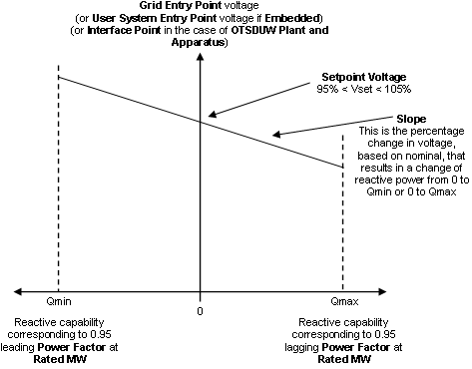

Figure CC.A.7.2.2a

CC.A.7.2.2.2 The continuously acting automatic control system shall be capable of operating to a **Setpoint Voltage** between 95% and 105% with a resolution of 0.25% of the nominal voltage. For the avoidance of doubt values of 95%, 95.25%, 95.5% … may be specified, but not intermediate values. The initial **Setpoint Voltage** will be 100%. The tolerance within which this **Setpoint Voltage** shall be achieved is specified in BC2.A.2.6. For the avoidance of doubt, with a tolerance of 0.25% and a Setpoint Voltage of 100%, the achieved value shall be between 99.75% and 100.25%. **The Company** may request the **GB** **Generator** to implement an alternative **Setpoint Voltage** within the range of 95% to 105%. For **Embedded GB Generators** the **Setpoint Voltage** will be discussed between **The Company** and the relevant **Network Operator** and will be specified to ensure consistency with CC.6.3.4.

CC.A.7.2.2.3 The **Slope** characteristic of the continuously acting automatic control system shall be adjustable over the range 2% to 7% (with a resolution of 0.5%). For the avoidance of doubt values of 2%, 2.5%, 3% may be specified, but not intermediate values. The initial **Slope** setting will be 4%. The tolerance within which this **Slope** shall be achieved is specified in BC2.A.2.6. For the avoidance of doubt, with a tolerance of 0.5% and a **Slope** setting of 4%, the achieved value shall be between 3.5% and 4.5%. **The Company** may request the **GB** **Generator** to implement an alternative slope setting within the range of 2% to 7%. For **Embedded GB Generators** the **Slope** setting will be discussed between **The Company** and the relevant **Network Operator** and will be specified to ensure consistency with CC.6.3.4.

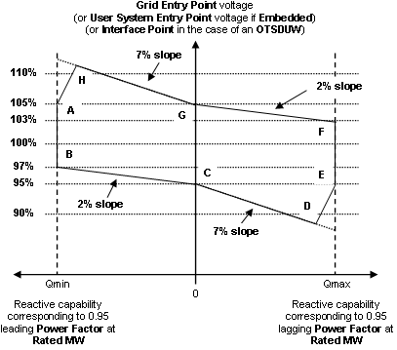

Figure CC.A.7.2.2b

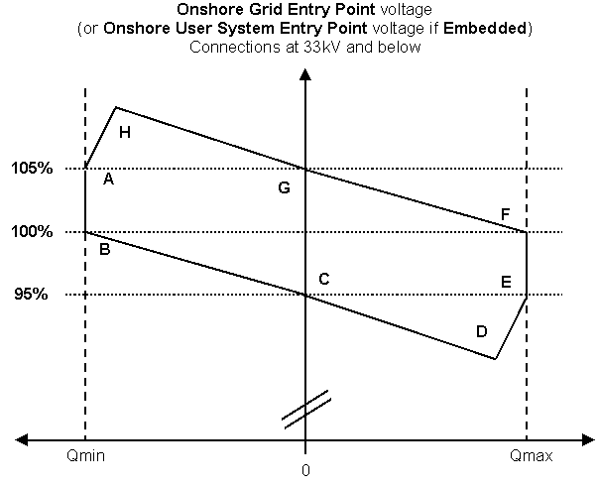

Figure CC.A.7.2.2c

CC.A.7.2.2.4 Figure CC.A.7.2.2b shows the required envelope of operation for **Onshore** **Non-Synchronous Generating Units**, **Onshore** **DC Converters**, **OTSDUW Plant and Apparatus** and **Onshore** **Power Park Modules** except for those **Embedded** at 33kV and below or directly connected to the **National Electricity Transmission System** at 33kV and below. Figure CC.A.7.2.2c shows the required envelope of operation for **Onshore** **Non-Synchronous Generating Units**, **Onshore** **DC Converters** and **Onshore** **Power Park Modules Embedded** at 33kV and below or directly connected to the **National Electricity Transmission System** at 33kV and below. Where the **Reactive Power** capability requirement of a directly connected **Onshore** **Non-Synchronous Generating Unit**, **Onshore** **DC Converter**, **OTSDUW Plant and Apparatus** or **Onshore** **Power Park Module** in Scotland, as specified in CC.6.3.2 (c), is not at the **Onshore** **Grid Entry Point** or **Interface Point** in the case of **OTSDUW Plant and Apparatus**, the values of Qmin and Qmax shown in this figure will be as modified by the 33/132kV or 33/275kV or 33/400kV transformer. The enclosed area within points ABCDEFGH is the required capability range within which the **Slope** and **Setpoint Voltage** can be changed.

CC.A.7.2.2.5 Should the operating point of the **Onshore** **Non-Synchronous Generating Unit**, **Onshore** **DC Converter**, **OTSDUW Plant and Apparatus** or **Onshore** **Power Park Module** deviate so that it is no longer a point on the operating characteristic (figure CC.A.7.2.2a) defined by the target **Setpoint Voltage** and **Slope**, the continuously acting automatic voltage control system shall act progressively to return the value to a point on the required characteristic within 5 seconds.

CC.A.7.2.2.6 Should the **Reactive Power** output of the **Onshore** **Non-Synchronous Generating Unit**, **Onshore** **DC Converter**, **OTSDUW Plant and Apparatus** or **Onshore** **Power Park Module** reach its maximum lagging limit at a **Onshore** **Grid Entry Point** voltage (or **Onshore** **User System Entry Point** voltage if **Embedded** or **Interface Point** in the case of **OTSDUW Plant and Apparatus**) above 95%, the **Onshore** **Non-Synchronous Generating Unit**, **Onshore** **DC Converter**, **OTSDUW Plant and Apparatus** or **Onshore** **Power Park Module** shall maintain maximum lagging **Reactive Power** output for voltage reductions down to 95%. This requirement is indicated by the line EF in figures CC.A.7.2.2b and CC.A.7.2.2c. Should the **Reactive Power** output of the **Onshore** **Non-Synchronous Generating Unit**, **Onshore** **DC Converter**, **OTSDUW Plant and Apparatus** or **Onshore** **Power Park Module** reach its maximum leading limit at a **Onshore** **Grid Entry Point** voltage (or **Onshore** **User System Entry Point** voltage if **Embedded**or **Interface Point** in the case of **OTSDUW Plant and Apparatus**) below 105%, the **Onshore** **Non-Synchronous Generating Unit**, **Onshore** **DC Converter**, **OTSDUW Plant and Apparatus** or **Onshore** **Power Park Module** shall maintain maximum leading **Reactive Power** output for voltage increases up to 105%. This requirement is indicated by the line AB in figures CC.A.7.2.2b and CC.A.7.2.2c.

CC.A.7.2.2.7 For **Onshore** **Grid Entry Point** voltages (or **Onshore** **User** **System** **Entry** **Point** voltages if Embeddedor **Interface Point** voltages) below 95%, the lagging **Reactive Power** capability of the **Onshore Non-Synchronous Generating Unit**, **Onshore DC Converter**, **OTSDUW Plant and Apparatus** or **Onshore Power Park Module** should be that which results from the supply of maximum lagging reactive current whilst ensuring the current remains within design operating limits. An example of the capability is shown by the line DE in figures CC.A.7.2.2b and CC.A.7.2.2c. For **Onshore** **Grid Entry Point** voltages (or **User** **System Entry Point** voltages if **Embedded** or **Interface Point**voltages) above 105%, the leading **Reactive Power** capability of the **Onshore Non-Synchronous Generating Unit**, **Onshore DC Converter**, **OTSDUW Plant and Apparatus** or **Onshore Power Park Module** should be that which results from the supply of maximum leading reactive current whilst ensuring the current remains within design operating limits. An example of the capability is shown by the line AH in figures CC.A.7.2.2b and CC.A.7.2.2c. Should the **Reactive Power** output of the **Onshore Non-Synchronous Generating Unit**, **Onshore DC Converter**, **OTSDUW Plant and Apparatus** or **Onshore Power Park Module** reach its maximum lagging limit at an **Onshore** **Grid Entry Point** voltage (or **Onshore** **User** **System** **Entry** **Point** voltage if **Embedded** or **Interface Point** in the case of **OTSDUW Plant and Apparatus**) below 95%, the **Onshore Non-Synchronous Generating Unit**, **Onshore DC Converter** or **Onshore Power Park** **Module** shall maintain maximum lagging reactive current output for further voltage decreases. Should the **Reactive Power** output of the **Onshore Non-Synchronous Generating Unit**, **Onshore DC Converter**, **OTSDUW Plant and Apparatus** or **Onshore Power Park Module** reach its maximum leading limit at a **Onshore** **Grid Entry Point** voltage (or **User** **System** **Entry** **Point** voltage if **Embedded**or **Interface Point** voltagein the case of an **OTSDUW Plant and Apparatus**) above 105%, the **Onshore Non-Synchronous Generating Unit**, **Onshore DC Converter**, **OTSDUW Plant and Apparatus** or **Onshore Power Park Module** shall maintain maximum leading reactive current output for further voltage increases.

CC.A.7.2.2.8 All **OTSDUW Plant and Apparatus** must be capable of enabling **GB Code** **Users** undertaking **OTSDUW** to comply with an instruction received from **The Company** relating to a variation of the **Setpoint Voltage** at the **Interface Point** within 2 minutes of such instruction being received.

CC.A.7.2.2.9 For **OTSDUW Plant and Apparatus** connected to a **Network Operator’s System** where the **Network Operator** has confirmed to **The Company** that its **System** is restricted in accordance with CC.A.7.2.1, clause CC.A.7.2.2.8 will not apply unless **The Company** can reasonably demonstrate that the magnitude of the available change in **Reactive Power** has a significant effect on voltage levels on the **Onshore National Electricity Transmission System**.

CC.A.7.2.3 Transient Voltage Control

CC.A.7.2.3.1 For an on-load step change in **Onshore** **Grid Entry Point** or **Onshore** **User System Entry Point** voltage, or in the case of **OTSDUW Plant and Apparatus** an on-load step change in **Transmission Interface Point** voltage, the continuously acting automatic control system shall respond according to the following minimum criteria:

(i) the **Reactive Power** output response of the **Onshore Non-Synchronous Generating Unit**, **Onshore** **DC Converter**, **OTSDUW Plant and Apparatus** or **Onshore** **Power Park Module** shall commence within 0.2 seconds of the application of the step. It shall progress linearly although variations from a linear characteristic shall be acceptable provided that the MVAr seconds delivered at any time up to 1 second are at least those that would result from the response shown in figure CC.A.7.2.3.1a.

(ii) the response shall be such that 90% of the change in the **Reactive Power** output of the **Onshore** **Non-Synchronous Generating Unit**, **Onshore** **DC Converter**, **OTSDUW Plant and Apparatus** or **Onshore Power Park Module**, will be achieved within

* + - 1 second, where the step is sufficiently large to require a change in the steady state **Reactive Power** output from zero to its maximum leading value or maximum lagging value, as required by CC.6.3.2 (or, if appropriate, CC.A.7.2.2.6 or CC.A.7.2.2.7); and
    - 2 seconds, for **Plant and Apparatus** installed on or after 1 December 2017, where the step is sufficiently large to require a change in the steady state **Reactive Power** output from its maximum leading value to its maximum lagging value or vice versa.

(iii) the magnitude of the **Reactive Power** output response produced within 1 second shall vary linearly in proportion to the magnitude of the step change.

(iv) within 2 seconds from achieving 90% of the response as defined in CC.A.7.2.3.1 (ii), the peak to peak magnitude of any oscillations shall be less than 5% of the change in steady state **Reactive Power**.

(v) following the transient response, the conditions of CC.A.7.2.2 apply.

MVArs

Seconds

Required response at 1 second

0.2

1

Figure CC.A.7.2.3.1a

CC.A.7.2.3.2 An **Onshore Non-Synchronous Generating Unit, Onshore DC Converter, OTSDUW Plant and Apparatus** or **Onshore Power Park Module** installed on or after 1 December 2017 shall be capable of

##### changing its **Reactive Power** output from its maximum lagging value to its maximum leading value, or vice versa, then reverting back to the initial level of **Reactive Power** output once every 15 seconds for at least 5 times within any 5 minute period; and

##### changing its **Reactive Power** output from zero to its maximum leading value then reverting back to zero **Reactive Power** output at least 25 times within any 24 hour period and from zero to its maximum lagging value then reverting back to zero **Reactive Power** output at least 25 times within any 24 hour period. Any subsequent restriction on reactive capability shall be notified to **The Company** in accordance with BC2.5.3.2, and BC2.6.1.

##### In all cases, the response shall be in accordance to CC.A.7.2.3.1 where the change in **Reactive Power** output is in response to an on-load step change in **Onshore Grid Entry Point** or **Onshore User System Entry Point** voltage, or in the case of **OTSDUW Plant and Apparatus** an on-load step change in **Transmission Interface Point** voltage.

CC.A.7.2.4 Power Oscillation Damping

CC.A.7.2.4.1 The requirement for the continuously acting voltage control system to be fitted with a **Power System Stabiliser (PSS)** shall be specified in the **Bilateral Agreement** if, in **The Company’s** view, this is required for system reasons. However if a **Power System Stabiliser** is included in the voltage control system its settings and performance shall be agreed with **The Company** and commissioned in accordance with BC2.11.2. To allow assessment of the performance before on-load commissioning the **GB** **Generator** will provide to **The Company** a report covering the areas specified in CP.A.3.2.2.

CC.A.7.2.5 Overall Voltage Control System Characteristics

CC.A.7.2.5.1 The continuously acting automatic voltage control system is required to respond to minor variations, steps, gradual changes or major variations in **Onshore Grid Entry Point** voltage (or **Onshore User System Entry Point** voltage if **Embedded** or **Interface Point** voltage in the case of **OTSDUW Plant and Apparatus**).

CC.A.7.2.5.2 The overall voltage control system shall include elements that limit the bandwidth of the output signal. The bandwidth limiting must be consistent with the speed of response requirements and ensure that the highest frequency of response cannot excite torsional oscillations on other plant connected to the network. A bandwidth of 0-5Hz would be judged to be acceptable for this application. All other control systems employed within the **Onshore** **Non-Synchronous Generating Unit**, **Onshore** **DC Converter**, **OTSDUW Plant and Apparatus** or **Onshore Power Park Module** should also meet this requirement

CC.A.7.2.5.3 The response of the voltage control system (including the **Power System Stabiliser** if employed) shall be demonstrated by testing in accordance with OC5A.A.3.

**< END OF CONNECTION CONDITIONS >**

1. Details of circuits traversing the **Connection Site** are only needed from the date which is the earlier of the date when the **Site Responsibility Schedule** is first updated and 15th October 2004. In Scotland or **Offshore**, from a date to be agreed between **The Company** and **the Relevant Transmission Licensee**.