**Frequency Response Auction Trial**

Test Guidance for Low Frequency Non-Dynamic Service

(“Testing Guidelines”)

|  |  |
| --- | --- |
| Last Updated: | 03/04/2019 |

## **Introduction**

**Phase 1 of the Frequency Response auction trial will commence on 25th April 2019. These Testing Guidelines describes the pre-registration testing requirements required for prospective response providers to demonstrate they can deliver the response being procured.**

The Testing Guidelines shall be published and modified by or on behalf of NGESO from time to time. The version of the Testing Guidelines which shall govern an Auction and a Related Balancing Services Document shall be the version prevailing at 12:00 hours ten (10) days prior to the Auction Opening Time in respect of the applicable Auction (clarifications are not included within this).

Any changes to these Testing Guidelines shall be communicated by NGESO on its website. Where NGESO also publish a consolidated version of the Testing Guidelines showing changes made, the prospective response provider agrees and acknowledges that the consolidated version is an informal version of the changes and may not be relied upon in any way.

**Pre-registration testing requirements**

In order for the prospective response provider to complete the pre-registration requirement, the following information must be submitted to National Grid Electricity System Operator (NGESO) by no later than 48 hours before the Sell Order deadline:

* The test data, in the format outlined in Appendix A
* A Test Certificate from the ITE, in the format outlined in Appendix C
* A CV, setting out the qualifications and experience of the ITE.

**Service description**

* Service activation at 49.6Hz
* Full response within 1 second
* Duration is 30 minutes for testing purposes. (Duration may be advised to be lower than 30minutes ahead of each weekly trial).

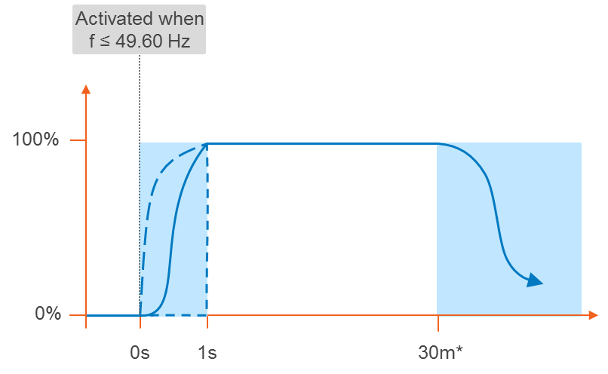

Delivery profiles

Activation: monotonically increasing

Deactivation: monotonically decreasing

## **Test Requirements**

The non-dynamic low frequency test is designed to assess the capability of the provider to deliver the contracted Service described above.

The minimum sample rate for the Test is 10Hz. Simulations / simulated tests are not permitted. Each test submitted must record real time data from the plant and sites under test. The test data submitted must come from the specific site to be contracted; substituted data will not be accepted. See Appendix A for information on test signals.

The pass criteria for the test are as follows.

* An acceptable frequency injection profile is used (see Table/Figure 1)
* The relay (or equivalent) activates at the correct contracted trigger frequency and within the permitted tolerance (±0.01Hz)
* Sustain the response for the 30 minutes. Response volume is assessed as the minimum response observed from 1 second to 30 minutes following relay trigger.
* The standard deviation of active power error over a 30 minute period must not exceed 2.5% of the contracted active power change. (Standard deviation is calculated from 1 seconds to 30 minutes following relay trigger).

## **Table 1 -** Injected Frequency against Time for Low Frequency Non-Dynamic Response Testing



## **Figure 1 -** Injected Frequency against Time for Low Frequency Non-Dynamic Response Testing

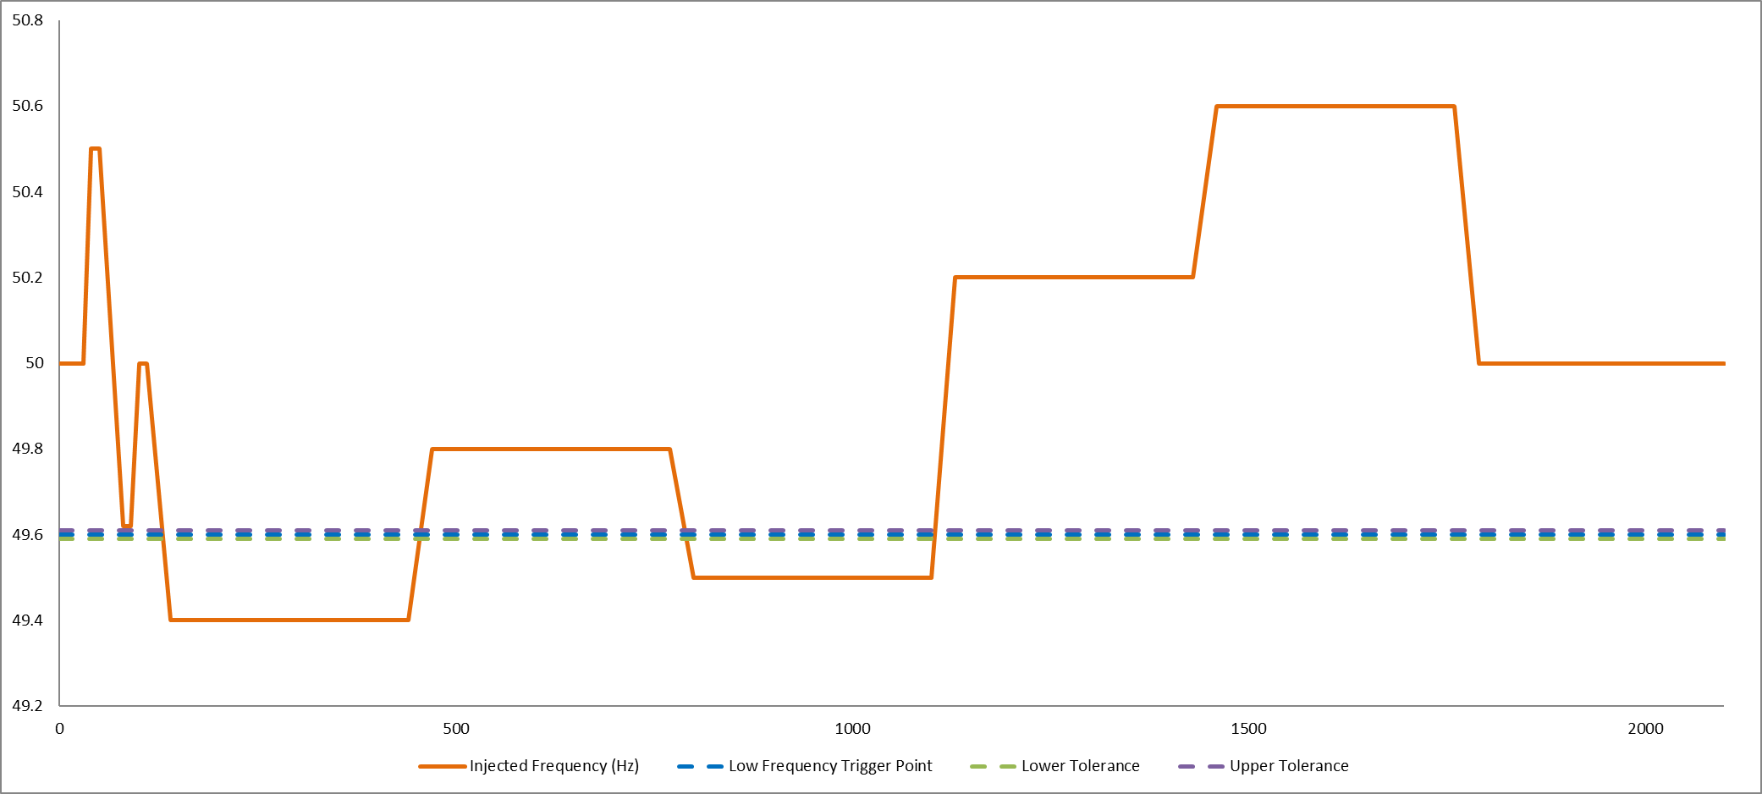

## Appendix A – Test Signals and Data Format

The data for the following signals will need to be provided

a) Time

b) Active power

c) Injected frequency

d) Relay logic – enter 1 for the period at which the relay triggers.

Data should be recorded for at least 30 seconds BEFORE the application of the frequency injection signal and for at least 30 seconds AFTER the completion of the test.

The data should be sent to National Grid ESO along with the ITE report described below.

Sample Test Data Format



## Appendix B – Requirement for Test Certificate

For the purposes of this Appendix B, the following definitions shall apply:

**Group** means, for any person, another person who is the direct or indirect Holding Company of that person and any Subsidiary of that Holding Company Holding Company means, in relation to a company, any other company in respect of which it is a Subsidiary.

**Holding Company** means, in relation to a company, any other company in respect of which it us a Subsidiary.

**Independent Technical Expert** means an experienced technical expert with expertise in the operation of DSR or generating units or electricity Interconnectors (as the case may be), Independent of the prospective response provider, engaged by the prospective response provider at its expense to carry out a technical assessment and prepare a Test Certificate.

**Independent** means, for any technical expert and the applicable prospective response provider, that the technical expert is: (a) not in the same Group as the prospective response provider; and (b) neither engaged on terms, nor party to any other arrangements, which could allow the prospective response provider or any member of its Group to exercise undue influence on any assessment of the Test Certificate prepared by that technical expert or otherwise compromise the objectivity of any such assessment and test certificate to the **Required Technical Standard**.

**Required Technical Standard** means, with respect to any assessment and Test Certificate prepared by an Independent Technical Expert that: (a) to the best of the Independent Technical Expert’s knowledge and belief all information provided in it is accurate, complete and not misleading; and (b) any opinions or forecasts in the assessment have been conservatively prepared on assumptions which it considers to be fair and reasonable.

**Test Certificate** means a certificate in the form set out in Appendix C prepared by an Independent Technical Expert.

**Subsidiary** means a subsidiary within the meaning of section 1159 of the Companies Act 2006 (but relation to an Interconnector, or shareholder in such provider, subsection (1)(a) of that section shall apply as if a “majority of the voting rights” included 50% only of those rights).

The Independent Technical Expert will assess the response capability of the applicable asset in accordance with the testing profiles in Appendix A and shall prepare a Test Certificate for onward submission to NGESO.

## Appendix C

Please use this sample test report format and submit to NGESO, along with the test data and CV of the ITE employed by the prospective response provider.

## Prospective Response Provider Company Details

|  |  |
| --- | --- |
| Prospective Response Provider Company name |  |
| Primary contact name |  |
| Contact number /s |  |
| Email address |  |

## Contract Details

|  |  |
| --- | --- |
| Contract ID |  |
| Service type |  |
| Asset type, e.g. diesel generator, battery etc |  |
| Unit make up, e.g. single or aggregated |  |
| Aggregation methodology (if appropriate) |  |
| Unit location / ID |  |
| Test date |  |

## Static Service Details

|  |  |
| --- | --- |
| Contracted MW |  |
| Contracted response time | 1 second |
| Contracted duration | 30 mins |
| Trigger Frequency Setting | 49.6Hz |

## Test Results

| Pass Criteria | Pass / Fail | Comment |
| --- | --- | --- |
| An acceptable frequency injection profile is used. | Pass / Fail |  |
| The relay operating point of the plant/unit(s) occurs at the correct contracted trigger frequency and within the permitted tolerance (±0.01Hz). | Pass / Fail | See Figure 1 for sample showing close up of the frequency at which relay operates |
| The response is sustained for 30 minutes. | Pass / Fail |  |
| The standard deviation of active power error over a 30 minute period does not exceed 2.5% of the contracted active power change. | Pass / Fail | Insert test SD value here |
| Response volume is assessed as the minimum response observed from 1 second to 30 minutes following relay trigger | Pass / Fail | Can be shown in Figure 2 below. |
| **Overall Test Result** | **Pass / Fail** | **<Confirm volume validated by test>** |

Figure 1 – Relay Operation (sample, to be replaced with test data)

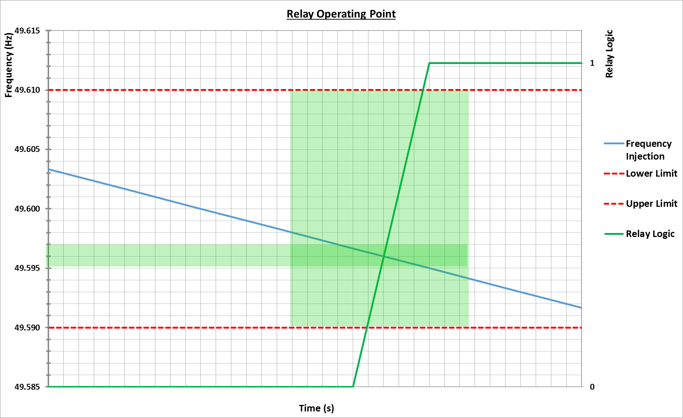

Figure 2 – Overall Response (sample, to be replaced with test data)

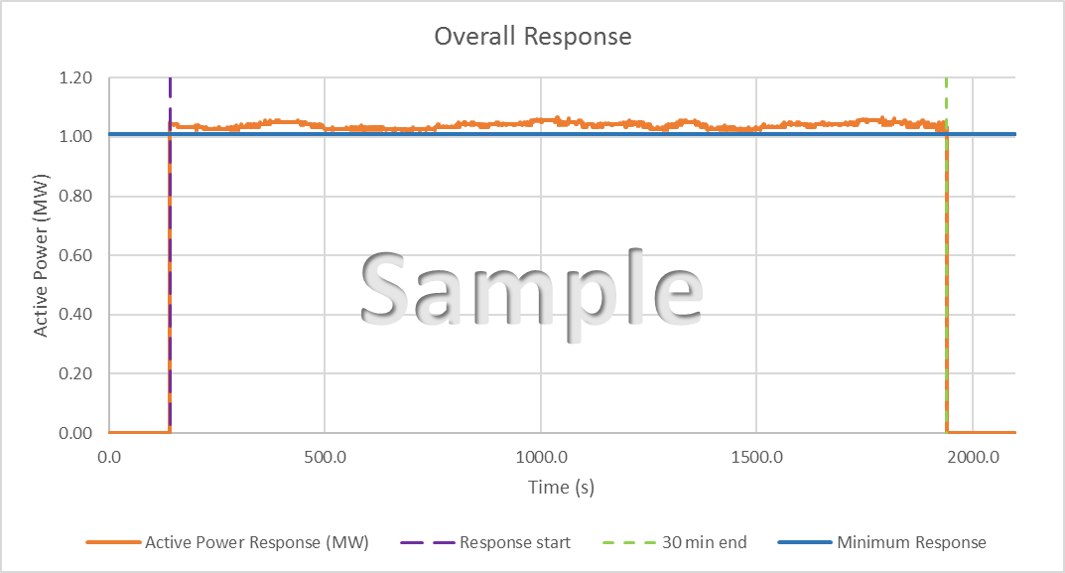

## Independent Technical Expert (ITE) Details

|  |  |
| --- | --- |
| Company name |  |
| Primary contact name |  |
| Contact number /s |  |
| Email address |  |
| **I / We confirm that I / We the following:**   1. **I/We am a/are Independent Technical Expert(s) (as defined in Appendix B of the NGESO’s prevailing Testing Guidelines;** 2. **I/We have carried out an assessment of the [asset] described above in accordance with the testing guidelines set out in the Testing Guidelines;** 3. **the above details are, to my/our best knowledge and belief, true, accurate, complete and not misleading; and** 4. **the CV attached of my/our experience is to my/our best knowledge and belief, true, accurate, complete and not misleading.** | |
| Signed: |  |
|  |  |
|  |  |