Small Network Analysis
The network
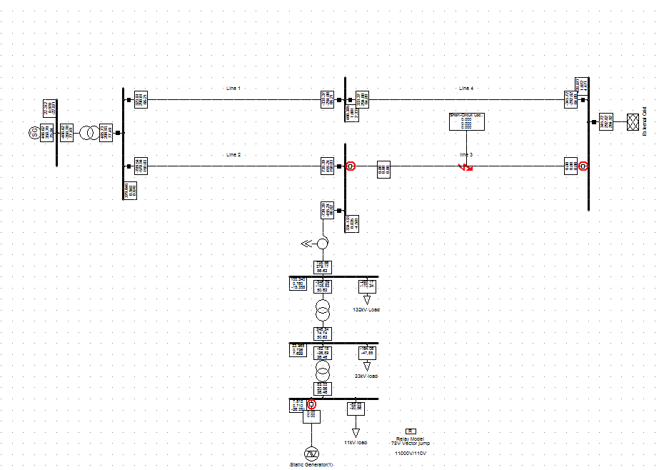
Fig 1

For a Fault on line 3 with a fault clearing time of 140ms the following were observed on the 11kV busbar

- Result Using EMT simulation
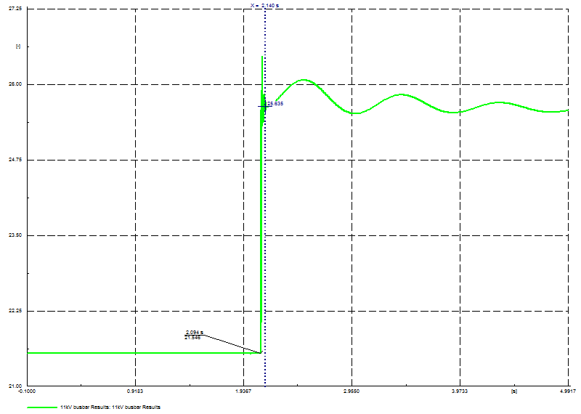

- Results From RMS simulation
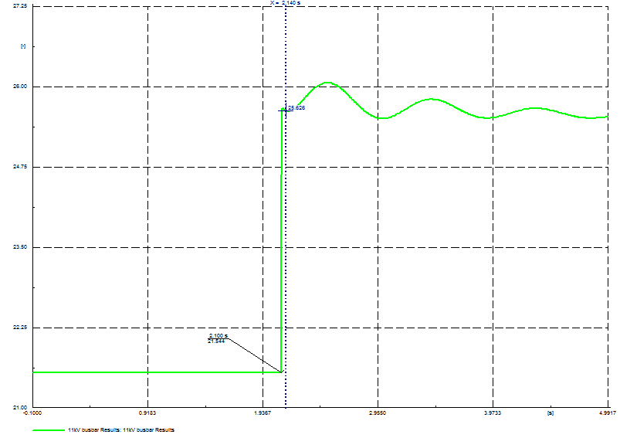

Result summary

Study | EMT | RMS
Three phase fault | 4.082 | 4.079

Conclusion.
EMT studies include in their simulation the impact of fast electromagnetic transients e.g. stator transients of an induction machine. These are ignored in the RMS simulation. From the various analyses on this network, the change in angle is almost the same. We have concluded that the use of the RMS simulation will be a good indicator of the changes in the angle.

GB Network Analysis

The network used is composed the GB transmission network modelled explicitly with all the components while the DNO is as submitted by the DNO in line with their Grid Code obligation. Small and medium embedded generations in England and Wales have been netted of the demand.
Network k Background

Demand[MW]* | Synchronous Generation | Non synchronous | HVDC(imports)
27350 | 24790 | 540 | 2800
*This is net of embedded generation for England and wales
The following is the network Use to analyse Case 1 to 4

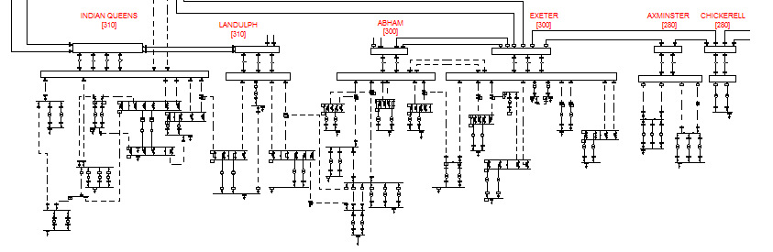

Case A: Three phase fault at Landulph substation on the line A83B toward Language, with Language Power station on and monitored the changes at Landulph 400kV and 132kV, Plymouth, Hayle, Exmouth and Barnstaple.

Voltage Waveforms in Different Parts of the network
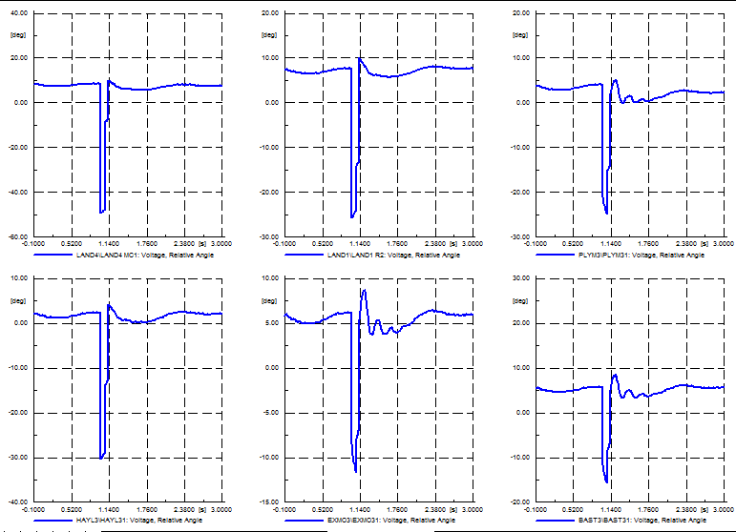

Case B: Repeat Case A with Language Power Station switched off

Case B involve switching out a generator at Language

Case D involves switching out a transformer at Landulph 400kV

Below is a summary of the result
 |  | Case A | Case B | Case C | Case D
Substation | Busbar short Name | Change in angle | Change in angle | Change in angle | Change in angle
Landulph 400kV | LAND4 MC2 | 57.418 | 61.163 | 1.453 | 0.017
Landulph 132kV | LAND1 R1 | 32.973 | 36.295 | 1.436 | 5.633
Plymouth 33kV | PLYM31 | 25.291 | 24.063 | 1.230 | 0.130
Hayle 33kV | HAYL31 | 32.366 | 32.584 | 1.299 | 0.580
Exmouth 33kV | EXMO31 | 14.792 | 13.027 | 0.997 | 0.025
Barnstaple 33kV | BAST31 | 17.940 | 15.796 | 1.037 | 0.349
Langage 400kV | LAGA4 M1 | 33.294 | 38.451 | 1.514 | -0.201

From the above, Case A and Case B result is a significant change in the voltage angle. When Language Power Station is out, the vector shift is higher as the fault level at the point of fault decreases.

Three phase Fault at Pentir substation on the circuit 2, A256, toward Wylfa and vector shift was monitored at the following substations.
Substation | Busbar short Name | Change in angle
Pentir 400kV | PENT4 M1 | 50.37088688
Pentir 132kV | PENT1 M2 | 38.02289024
Caernarvon 33kV | CANA31 | 40.00634941
Rhyl Flats 132kV | RHYF11 | 28.95458762
Dolgarrog 33kV | DOLG31 | 31.75623118
Wylfa 132kV | WYLF1 R2 | 49.90373662
Wylfa 400kV | WYLF4 R2 | 50.32591458
Wylfa 132kV | WYLF1 M1 | 49.90373662
Trawsfynydd 400kV | TRAW4 MC2 | 31.75954547
Trawsfynydd 132kV | TRAW1 R1 | 27.8461986
Maentwrog 33kV | MAEN31 | 28.9396674
Cwm Dyli 33kV | CWMD31 | 28.79272107
Deeside 400kV | DEES4 R2 | 22.70928399
Connahs Quay 132kV | CONQ1 R2 | 24.19520133
Dinorwig 400kV | DINO4R3 | 46.73011039

Further actions
- Carry out the same simulations using another scenario e.g. winter peak
- Replicate studies for a different generation mix
- Analyse the impact of QB switching
- Carry out more simulations for different DNO sites

Questions asked by the Workgroup for further assessment
For EMT Studies
- Voltage waveforms for EMT and RMS studies, for comparison purposes, to be sent out
- Include information about angle comparisons at all system voltages
For GB network
- Show angles and fault levels against a map of the GB network and/or system diagram
- Provide fault result on more meshed Transmission network (west midland for example)
- Show the vector shift on 11 kV bus bar by using typical 33/11kV parameters

